

**COMPUTER E-COMMERCE SYSTEM** **PROJECT**

**Software Design Specification**

**Giang Hiếu Minh**

**Lead software engineering**

– Hanoi, Summer 2023 –

# Revision History

| **Date** | **Description** | **Author** | **Comments** |
| --- | --- | --- | --- |
| 15/05/2023 | Version 1 | Giang Hiếu Minh,  Đặng Quốc Việt,  Hoàng Tuấn Đạt,  Đinh Bảo Ninh |  |
| 25/05/2023 | Version 2 | Giang Hiếu Minh,  Đặng Quốc Việt,  Hoàng Tuấn Đạt,  Đinh Bảo Ninh |  |
| 17/06/2023 | Version 3 | Giang Hiếu Minh,  Đặng Quốc Việt,  Hoàng Tuấn Đạt,  Đinh Bảo Ninh |  |
|  |  |  |  |

# Document Approval

The following Software Requirements Specification has been accepted and approved by the following:

| **Signature** | **Printed Name** | **Title** | **Date** |
| --- | --- | --- | --- |
|  | Giang Hiếu Minh | Leader |  |
|  | Nguyễn Thành Ý | Instructor, SWP 391 |  |
|  |  |  |  |

# 

# 

# Table of Contents

**Revision History 2**

**Document Approval 2**

**I. Introduction 5**

1.1 Overview 5

1.2 Purpose 5

1.3 Scope 6

1.4 Definitions, Acronyms, and Abbreviations 6

II. Overview 7

1. Code Packages 7

2. Database Design 8

a. Database Schema 8

b. Table Description 8

III. Code Designs 13

1. Public Customer 13

a. Class Diagram 13

b. Class Specifications 13

c. Sequence Diagram(s) 14

2. Public Account 20

a. Class Diagram 20

b. Class Specifications 20

c. Sequence Diagram(s) 21

3. Public Order 26

a. Class Diagram 26

b. Class Specifications 26

c. Sequence Diagram(s) 29

4. Public Series 33

a. Class Diagram 33

b. Class Specifications 33

c. Sequence Diagram(s) 35

5. Public Products 37

a. Class Diagram 37

b. Class Specifications 39

c. Sequence Diagram(s) 39

6. Public News 42

a. Class Diagram 42

b. Class Specifications 43

c. Sequence Diagram(s) 46

7. Public Category 51

a. Class Diagram 51

b. Class Specifications 53

c. Sequence Diagram(s) 53

8.Public Warranty 54

a. Class Diagram 54

b. Class Specifications 55

c. Sequence Diagram(s) 56

9.Public News Group 59

b. Class Specifications 59

c. Sequence Diagram(s) 60

10.Public Error 63

b. Class Specifications 63

c. Sequence Diagram(s) 64

# I. Introduction

## **1.1 Overview**

CECS is an online computer store website which supports a number of functions for both the consumer and store's management.

The website must be available to anyone who is provided authority to experience project’s resources from GitLab project archives . As stated by the customer, there are no hardware or software requirements beyond these including, but not limited to, memory or specific software packages that need to be utilized nor software packages that need not be utilized.

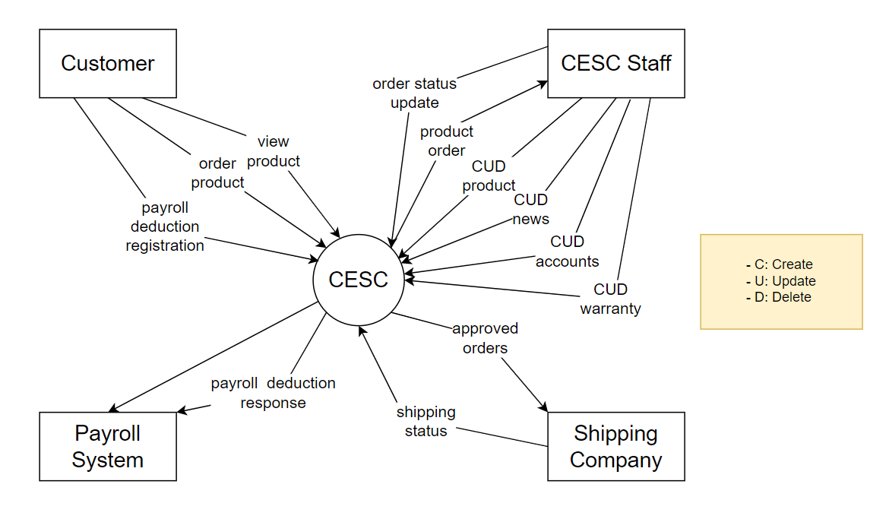

## **1.2 Purpose**

The Computer E-Commerce System (CECS) consist of Administrator Web page and Client Web page. Administrator Web page support Administrator and Employees as CMS webpage with full functionality in CRUD to Products, Account,...

Client Web page will have various software components, such as the main page, product listing, shopping cart, payment process, and user profile management. The user interfaces should be created to be easy to use, intuitive, and in line with contemporary web design norms. Additionally, they should be responsive to different devices and ensure a consistent experience throughout the website.

This Software Requirements Specification illustrates, in clear terms, the system’s primary uses and required functionality as specified by our customer. The intended audience of this document is our

primary Computer E-Commerce System customer: Mr. Nguyen Thanh Y - the SWP391 instructor and the 2023 SUMMER semester of class SE1706 Group 5 members, as well as the other students attending SE1706 that will require access to such documentation.

## **1.3 Scope**

The software system being produced is called Computer E-Commerce System or CECS. It is being produced for a customer interested in selling Computer via the Internet. This system is designed to “provide automation support” for the process of placing Computers for sale on the Internet and facilitating the actual sale. This system is largely cross-platform and is available to anyone using the Computer Science Department’s provided computer resources in the MSU Engineering Building. The system will be run on a localhost server with class’s attendances to interact with it.

The Computer E-Commerce System will allow any user to create an account to become a Buyer. The system will allow Buyer to browse, search, select, and add Computers to a shopping cart. Then, provided they have Computers in their shopping cart, check out Computers in shopping cart and decrement the stock that the inventory the system maintains

The Employee, through the process of account creation, will have the option to become a admin member – functional manager of the site. The system allows the main administrator to provide roles to an individual manager account, to assign staff with specific right to edit, and create assigned filed. The CECS also allows a manager to manage the inventory with full create, retrieve, update and delete (CRUD) functionality with regards to computers in the system. It will also allow, on an inventory wide basis, customers and managers to interact with a promotion system that handles percentage-off promotions that can be applied to member’s orders. This interaction includes the creation (by managers) and the application to orders (by customers) of the promotions. The CECS has full email capabilities; the automated email functionality will be used to send verified code to members of the system as well as provide the managers with notifications.

The CECS will have numerous constraints on what it can do. The manager will be a hard-coded user and only a single manager will exist. There will be order completion and the system will provide the customer with a receipt and it will log the transaction details. The system will not allow multiple promotions to be added to a single shopping cart nor will it allow a customer to add more than one of each item to their cart. The system also will allow users to retrieve passwords or edit their user details.

## **1.4 Definitions, Acronyms, and Abbreviations**

| CECS | Laptop E-Commerce System |
| --- | --- |
| CMS | Content Management System |
| SRS | Software Requirements Specifications |
| BR | Business Rule |
| UI | User Interface |
| N/A | Not applicable, not available |
| Use Case(s) | Diagram describe system requirements |

# II. Overview

## 1. Code Packages

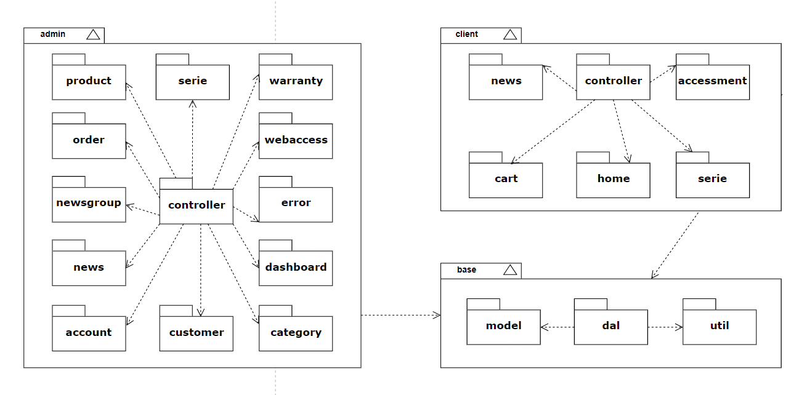

***Package descriptions***

| **No** | **Package** | **Description** |
| --- | --- | --- |
| 1 | dal | Util package helps connect to database to get, process and save data. |
| 2 | model | Entity package is package return to API of objects, contains all objects in the project. |
| 3 | controller | Controller package contains APIs, servlet files to process data and show in the website. |
| 4 | util | Contain utilities classes to help provides static methods that are accessible for use across an application |

## 2. Database Design

### a. Database Schema

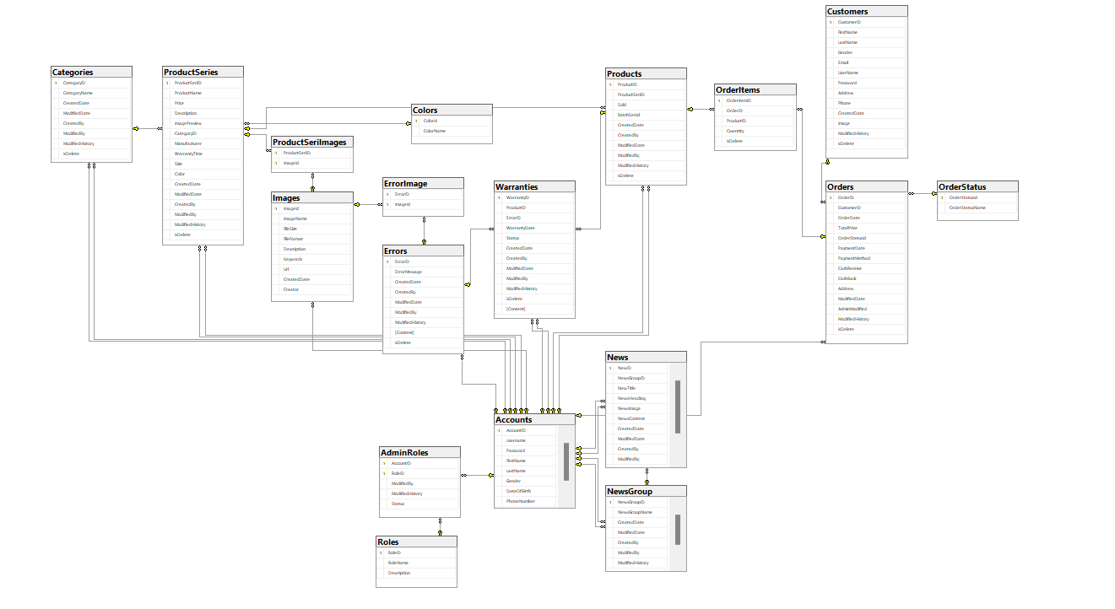

### b. Table Description

Customer:

| **No** | **Field name** | **Type** | **Size** | **Unique** | **Not null** | **PK/ FK** | **Notes** |
| --- | --- | --- | --- | --- | --- | --- | --- |
| 1 | CustomerID | int |  | x |  | x | PK |
| 2 | FirstName | nvarchar | 50 |  |  |  |  |
| 3 | LastName | nvarchar | 50 |  |  |  |  |
| 4 | Gender | bit |  |  |  |  |  |
| 5 | Email | nvarchar | 100 |  |  |  |  |
| 6 | UserName | nvarchar | 100 |  |  |  |  |
| 7 | Password | nvarchar | 100 |  |  |  |  |
| 8 | Address | varchar | 100 |  |  |  |  |
| 9 | Phone | nvarchar | 15 |  |  |  |  |
| 10 | CreatedDate | datetime |  |  | x |  |  |
| 11 | Image | nvarchar | 255 |  | x |  |  |
| 12 | ModifiedHistory | ntext |  |  | x |  |  |
| 13 | IsDelete | bit |  |  | x |  |  |

Account:

| **No** | **Field name** | **Type** | **Size** | **Unique** | **Not null** | **PK/ FK** | **Notes** |
| --- | --- | --- | --- | --- | --- | --- | --- |
| 1 | AccountID | int |  | x |  | x | PK |
| 2 | Username | nvarchar | 50 |  |  |  |  |
| 3 | Password | nvarchar | 50 |  |  |  |  |
| 4 | FirstName | nvarchar | 50 |  |  |  |  |
| 5 | LastName | nvarchar | 50 |  |  |  |  |
| 6 | Gender | bit |  |  | x |  |  |
| 7 | DateOfBirth | datetime |  |  | x |  |  |
| 8 | PhoneNumber | char | 10 |  | x |  |  |
| 9 | Image | nvarchar | 255 |  | x |  |  |
| 10 | IsDelete | bit |  |  | x |  |  |

News:

| **No** | **Field name** | **Type** | **Size** | **Unique** | **Not null** | **PK/ FK** | **Notes** |
| --- | --- | --- | --- | --- | --- | --- | --- |
| 1 | NewsId | int identity |  | x |  | x | PK |
| 2 | NewsGroupId | int |  | x |  | x | FK |
| 3 | NewsTitle | nvarchar | max |  |  |  |  |
| 4 | NewsHeading | nvarchar | max |  |  |  |  |
| 5 | NewsImage | nvarchar |  |  |  |  |  |
| 6 | NewsContent | ntext |  |  |  |  |  |
| 7 | CreatedDate | datetime |  |  | x |  |  |
| 8 | ModifiedDate | datetime |  |  | x |  |  |
| 9 | CreatedBy | int |  |  | x | x | FK |
| 11 | ModifiedBy | int |  |  | x | x | FK |
| 12 | ModifiedHistory | ntext |  |  |  |  |  |
| 13 | IsDelete | bit |  |  |  |  |  |

NewsGroup:

| **No** | **Field name** | **Type** | **Size** | **Unique** | **Not null** | **PK/ FK** | **Notes** |
| --- | --- | --- | --- | --- | --- | --- | --- |
| 1 | NewsGroupID | int |  | x |  | x | PK |
| 2 | NewsGroupName | nvarchar | 100 |  |  |  |  |
| 3 | CreatedDate | datetime |  |  | x |  |  |
| 4 | ModifiedDate | datetime |  |  | x |  |  |
| 5 | CreatedBy | int |  |  | x | x | FK |
| 6 | ModifiedBy | int |  |  | x | x | FK |
| 7 | ModifiedHistory | ntext |  |  |  |  |  |
| 8 | IsDelete | bit |  |  |  |  |  |

Errors:

| **No** | **Field name** | **Type** | **Size** | **Unique** | **Not null** | **PK/ FK** | **Notes** |
| --- | --- | --- | --- | --- | --- | --- | --- |
| 1 | ErrorID | int |  | x |  | x | PK |
| 2 | ErrorMessage | nvarchar | max |  |  |  |  |
| 3 | CreatedDate | datetime |  |  | x |  |  |
| 4 | ModifiedDate | datetime |  |  | x |  |  |
| 5 | CreatedBy | int |  |  | x | x | FK |
| 6 | ModifiedBy | int |  |  | x | x | FK |
| 7 | ModifiedHistory | ntext |  |  |  |  |  |
| 8 | Content | ntext |  |  |  |  |  |
| 9 | IsDelete | bit |  |  |  |  |  |

Warranties:

| **No** | **Field name** | **Type** | **Size** | **Unique** | **Not null** | **PK/ FK** | **Notes** |
| --- | --- | --- | --- | --- | --- | --- | --- |
| 1 | WarrantyID | int |  | x |  | x | PK |
| 2 | ProductID | int |  | x |  | x | FK |
| 3 | ErrorID | int |  | x |  | x | FK |
| 4 | WarrantyDate | datetime |  |  |  |  |  |
| 5 | [Status] | bit |  |  |  |  |  |
| 6 | CreatedDate | datetime |  |  |  |  |  |
| 7 | CreatedBy | int |  | x |  | x | FK |
| 8 | ModifiedDate | datetime |  |  |  |  |  |
| 9 | ModifiedBy | int |  | x |  | x | FK |
| 10 | ModifiedHistory | ntext |  |  |  |  |  |
| 11 | IsDelete | bit |  |  |  |  |  |
| 12 | Content | ntext |  |  |  |  |  |

# III. Code Designs

## 1. Public Customer

## a. Class Diagram

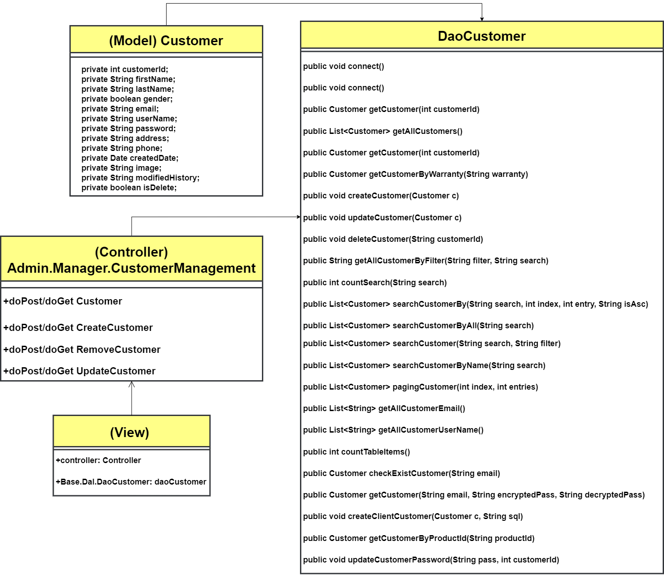

## b. Class Specifications

#### **DaoCustomer.java**

| **No** | **Method** | **Description** |
| --- | --- | --- |
| 01 | public void connect() | Handle request create new connection to database |
| 02 | public Customer getCustomer(int customerId) | Handle request get Customer by customerId |
| 03 | public List<Customer> getAllCustomers() | Handle request get all Customers |
| 04 | public Customer getCustomerByWarranty(String warranty) | Handle request get Customer by warranty of bought product |
| 05 | public void createCustomer(Customer c) | Handle request create new Customer with passed Customer |
| 06 | public void updateCustomer(Customer c) | Handle request update existed Customer by passed Customer |
| 07 | public void deleteCustomer(String customerId) | Handle request delete a Customer by customerId |
| 08 | public String getAllCustomerByFilter(String filter, String search) | Handle request get Customers by filter and searched keywords |
| 09 | public int countSearch(String search) | Handle request count number of Customers got by search string |
| 10 | public List<Customer> searchCustomerBy(String search, int index, String isAsc) | Handle request get Customer by string search with ‘offset’ location and arrange option such as increase or decrease |
| 11 | public List<Customer> searchCustomerByAll(String search) | Handle request get list of Customers with searched keywords |
| 12 | public List<Customer> searchCustomer(String search, String filter) | Handle request get list of Customers by filter and searched keyword |
| 13 | public List<Customer> searchCustomerByName(String search) | Handle request get list of Customers with searched name |
| 14 | public List<Customer> pagingCustomer(int index, int entries) | Handle request get list of Customers by its index and number of entries requested in list |
| 15 | public List<String> getAllCustomerEmail() | Handle request get all Emails of every Customers |
| 16 | public List<String> getAllCustomerUserName() | Handle request get all Usernames of every Customers |
| 17 | public int countTableItems() | Handle request count number of all Customers |
| 18 | public Customer checkExistCustomer(String email) | Handle request check if a Customer existed by email |
| 19 | public Customer getCustomer(String email, String encryptedPass, String decryptedPass) | Handle request get Customer by email, encoded and decoded password |
| 20 | public void createClientCustomer(Customer c, String sql) | Handle request create Customer by passed Customer data with query |

### 

## c. Sequence Diagram(s)

#### **Login**

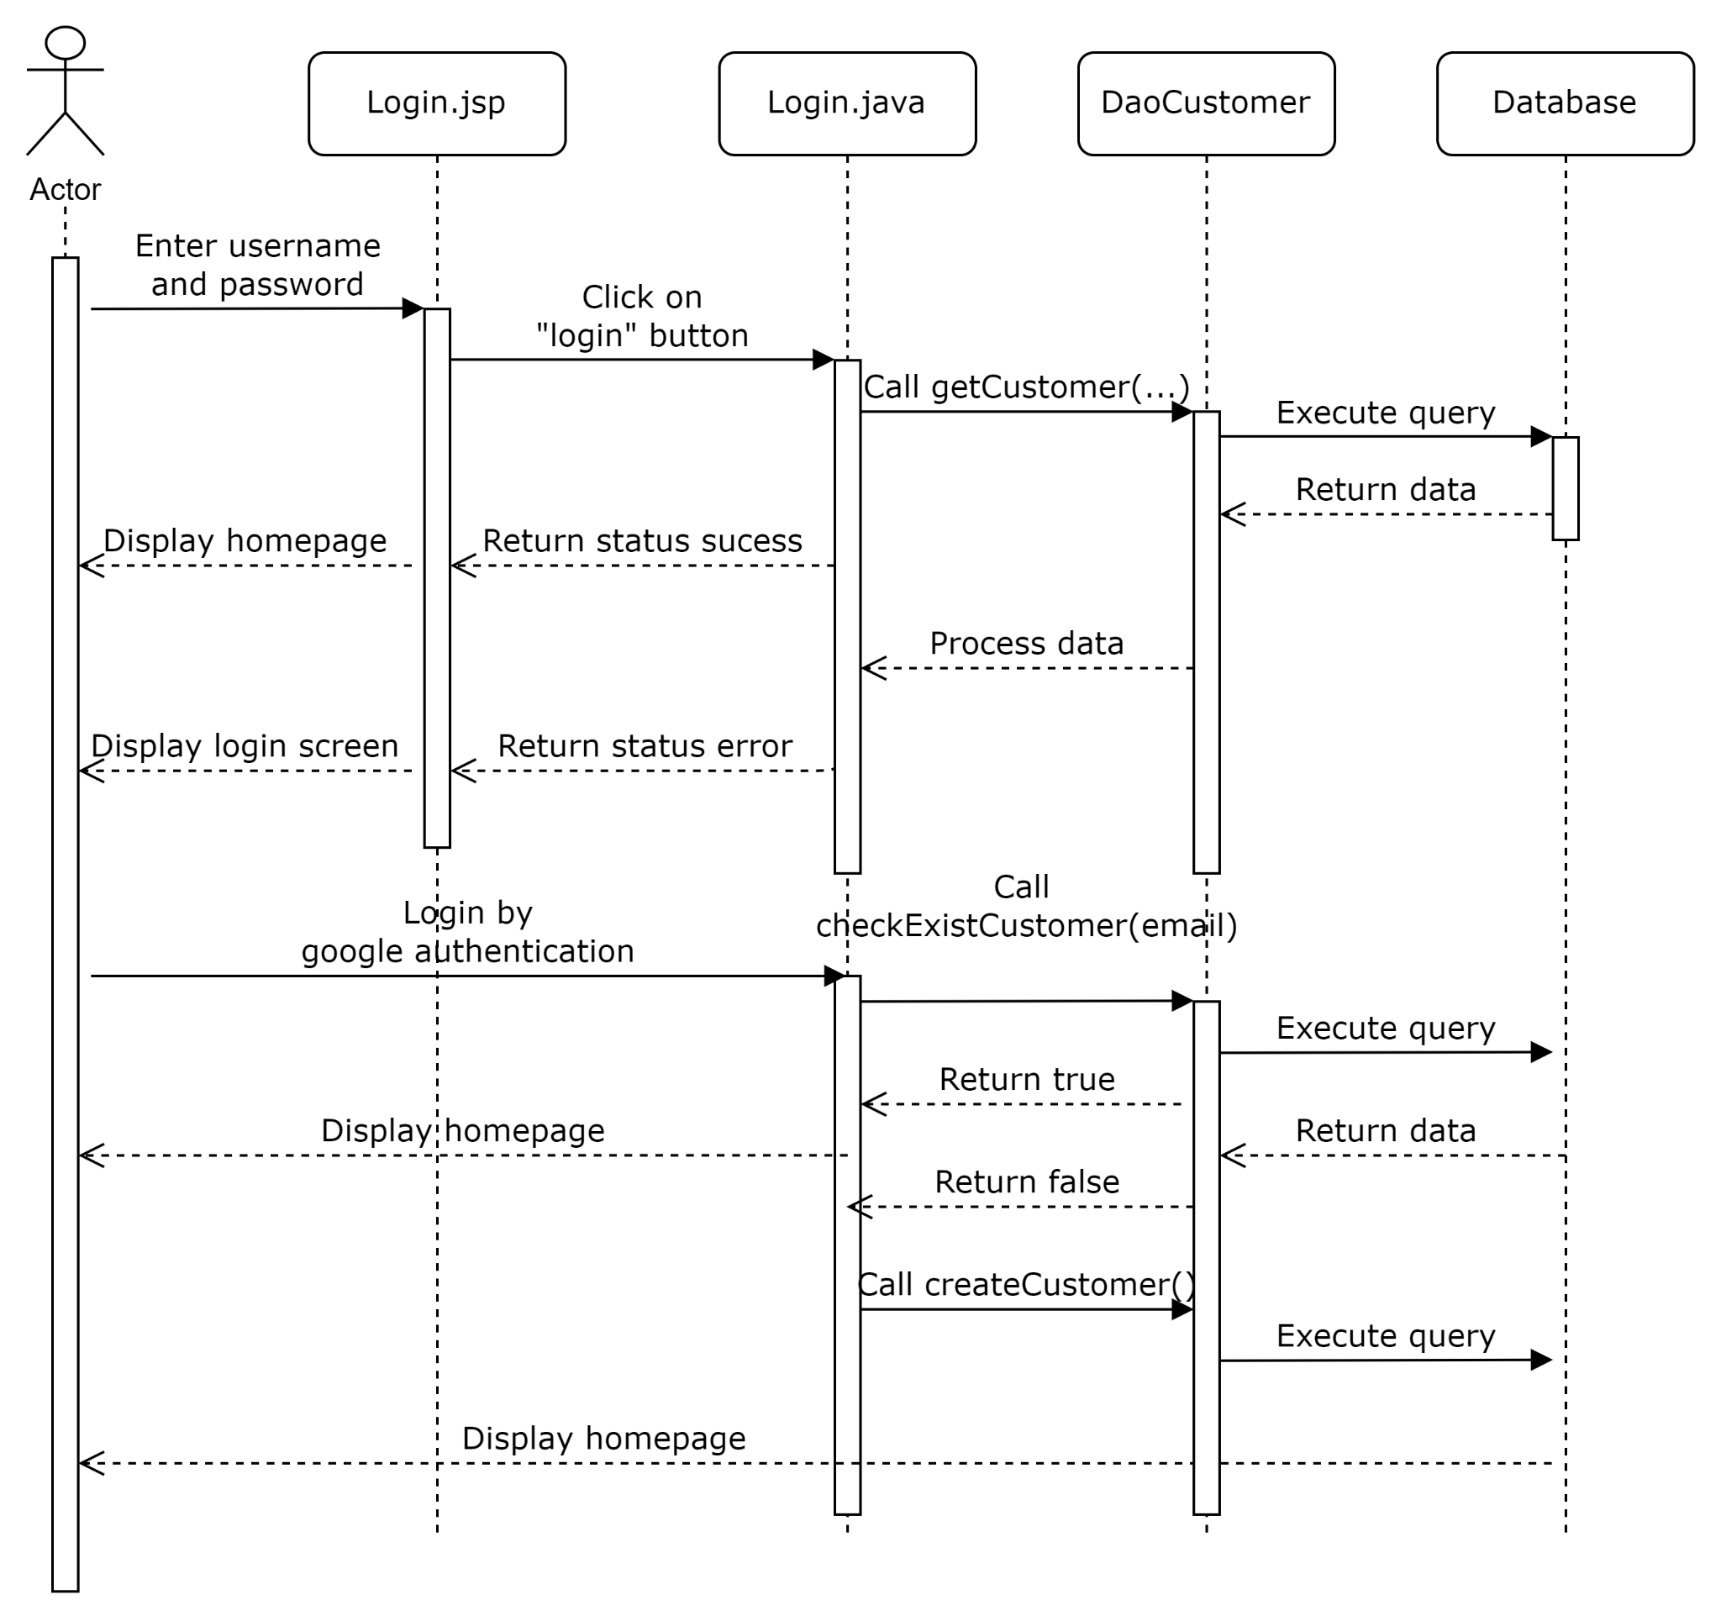

#### 

#### 

#### **Logout**

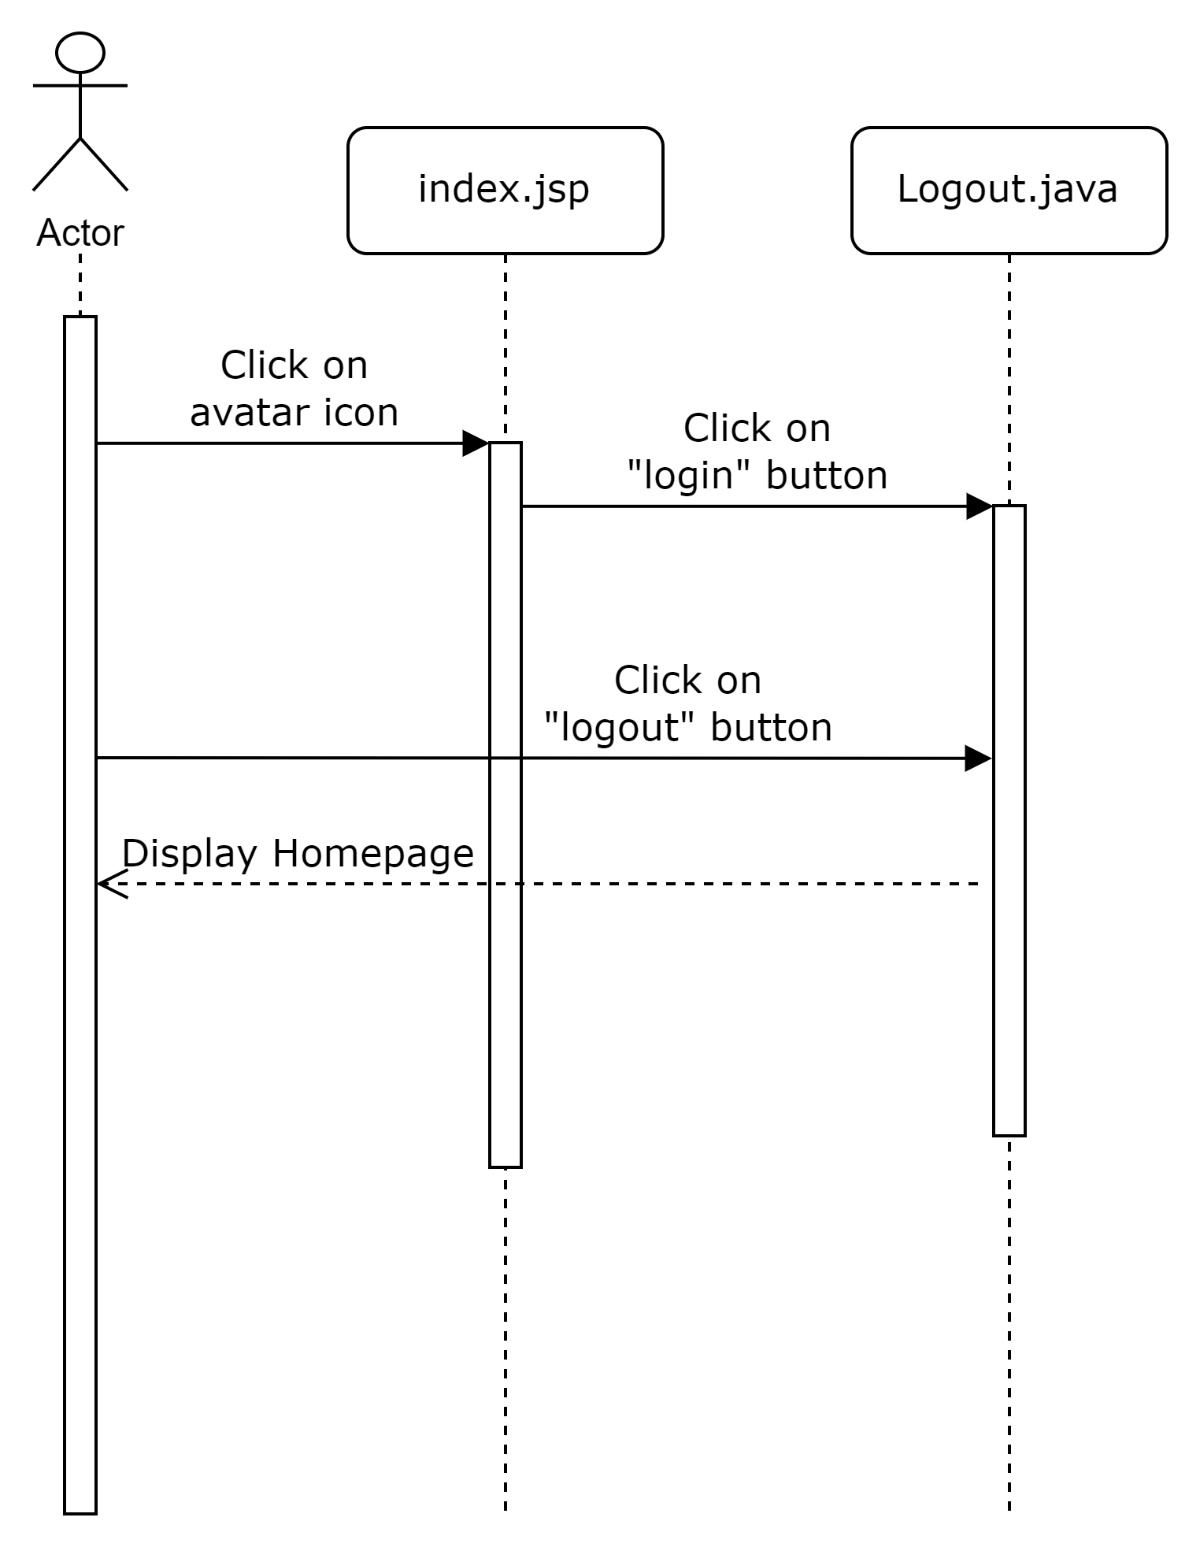

#### **Signup**

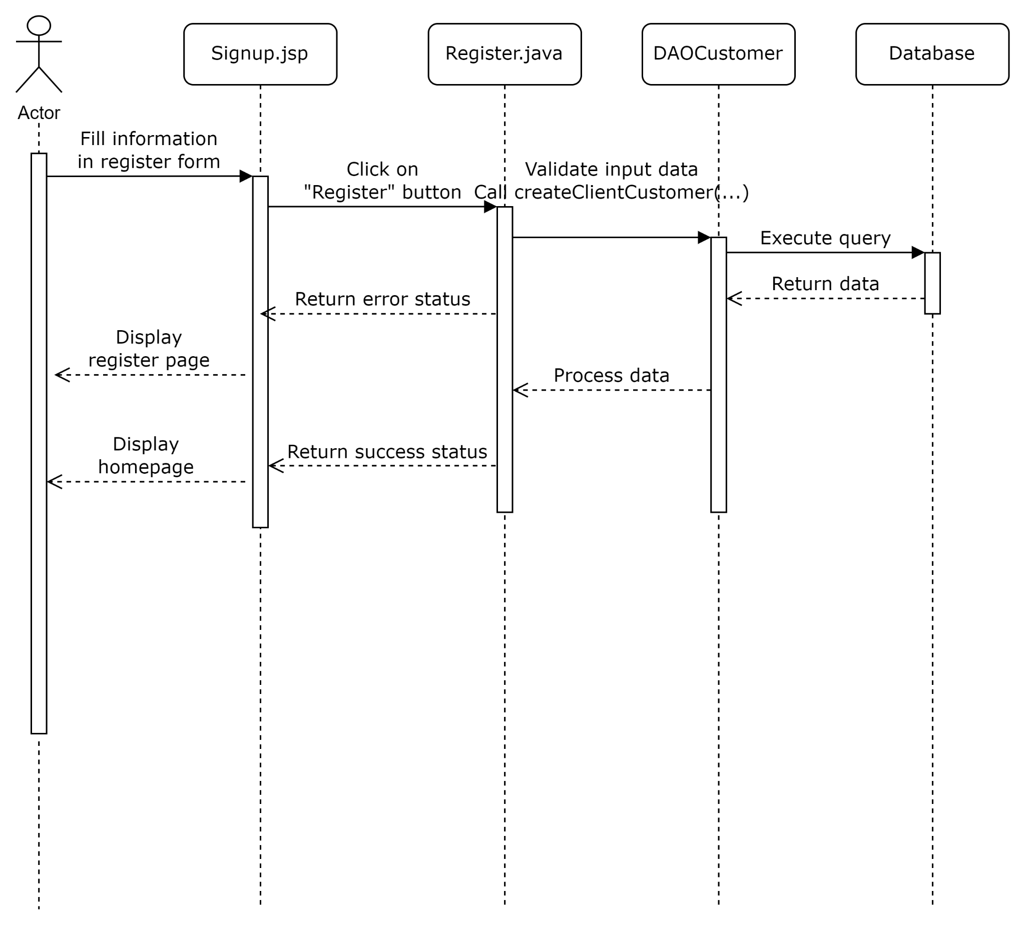

#### **Update Profile**

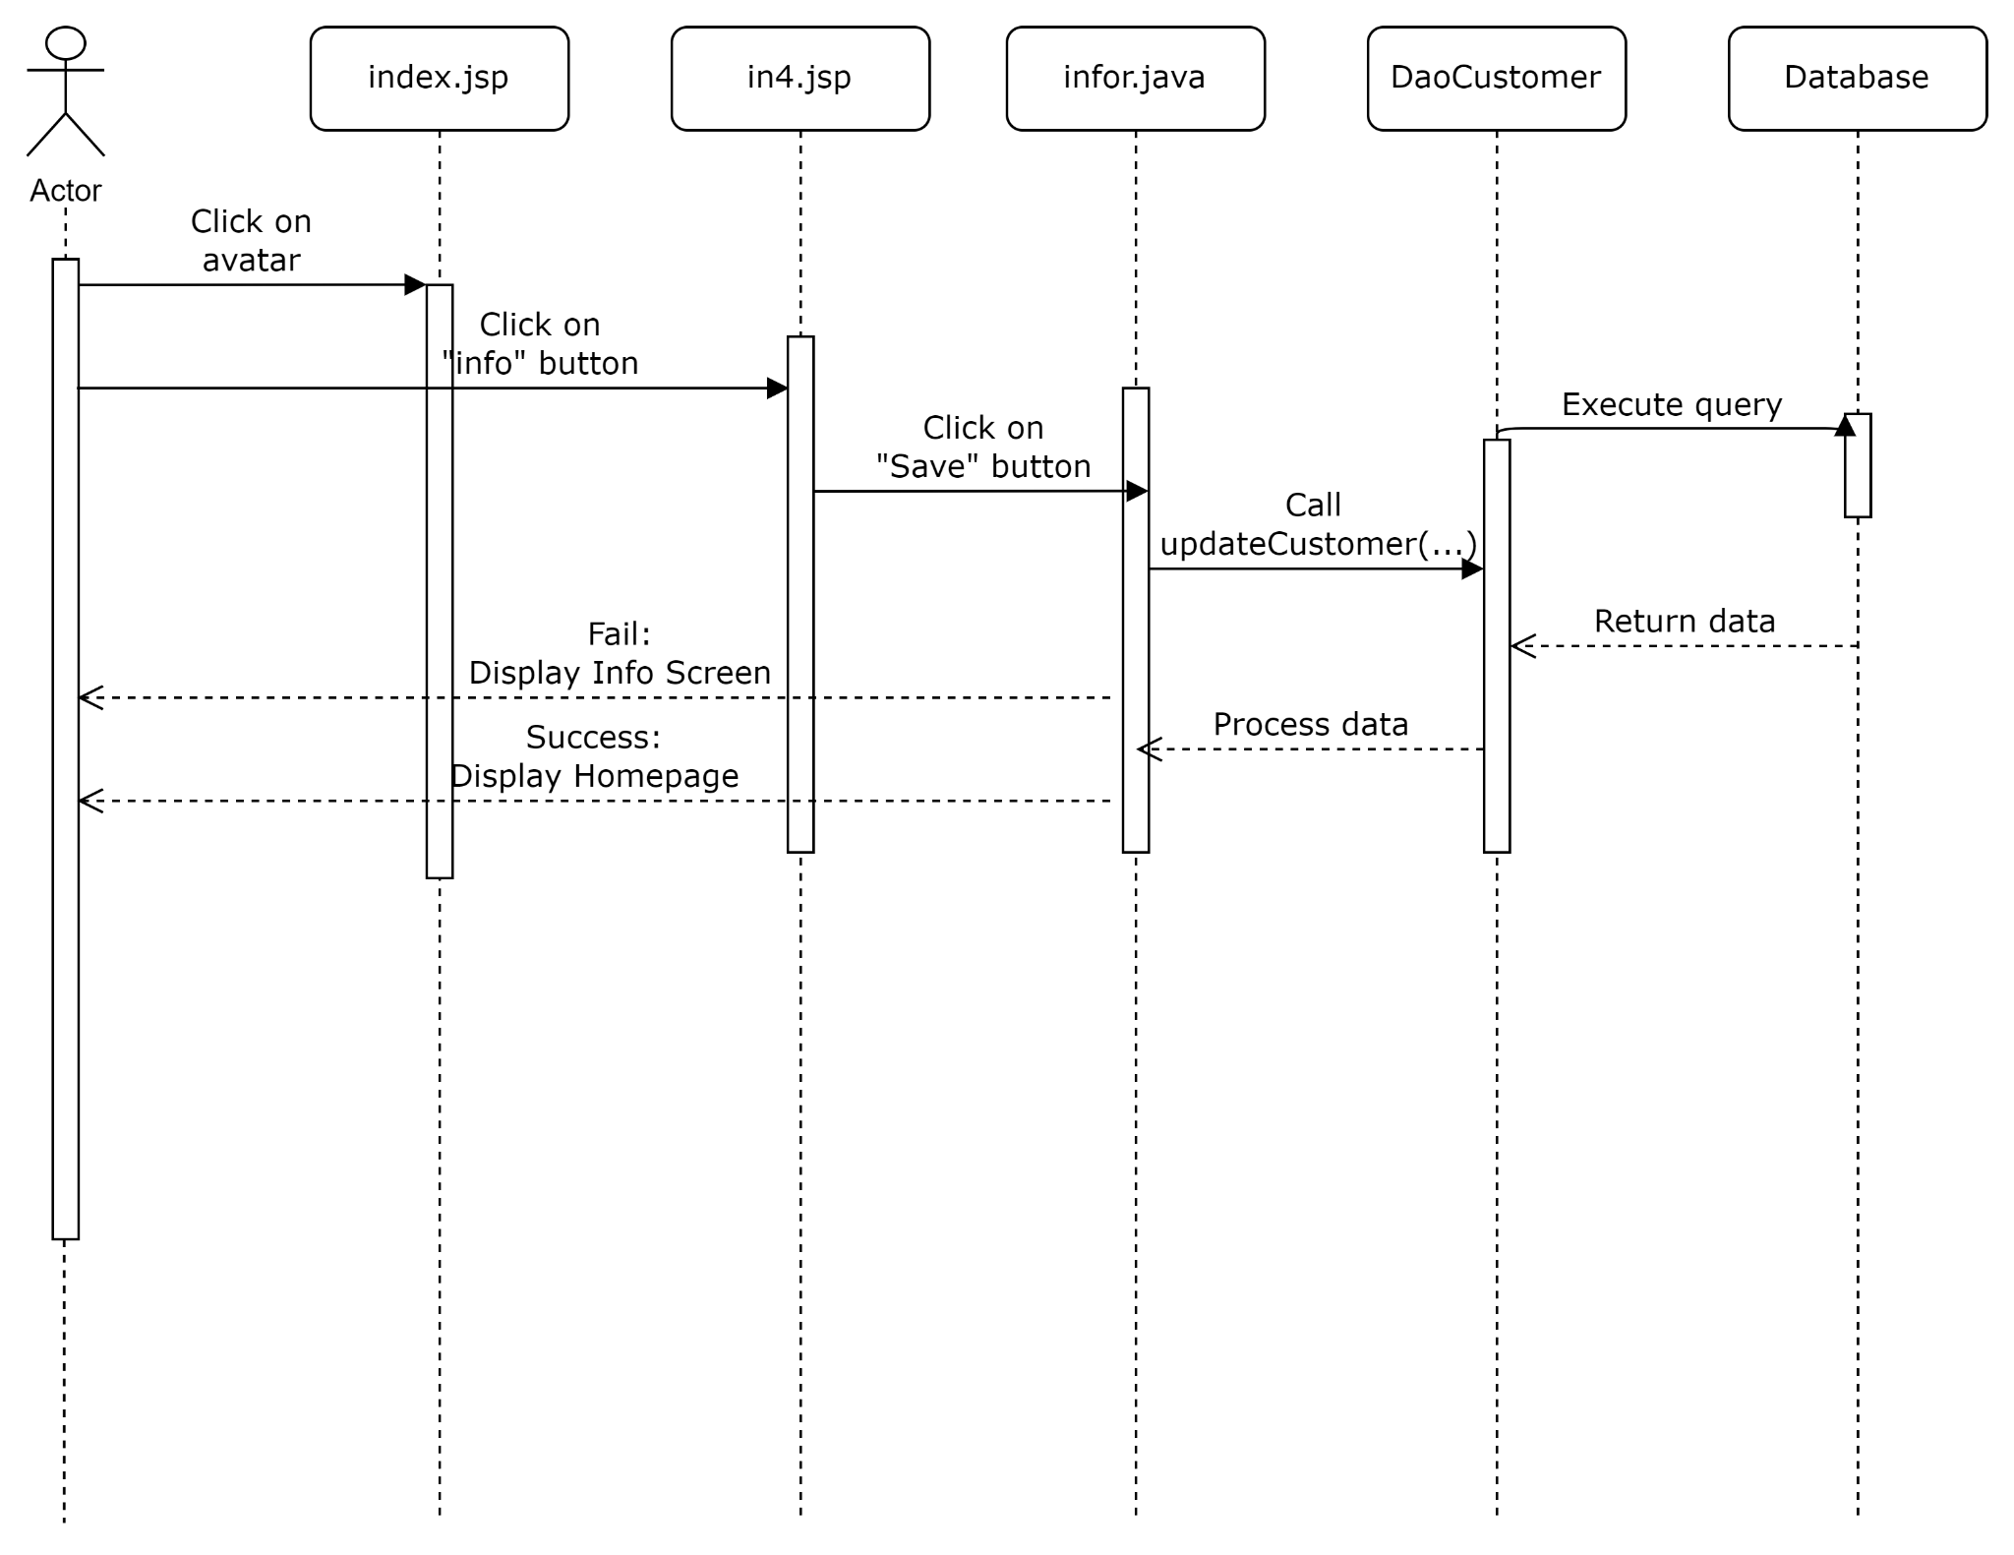

#### **View all customer**

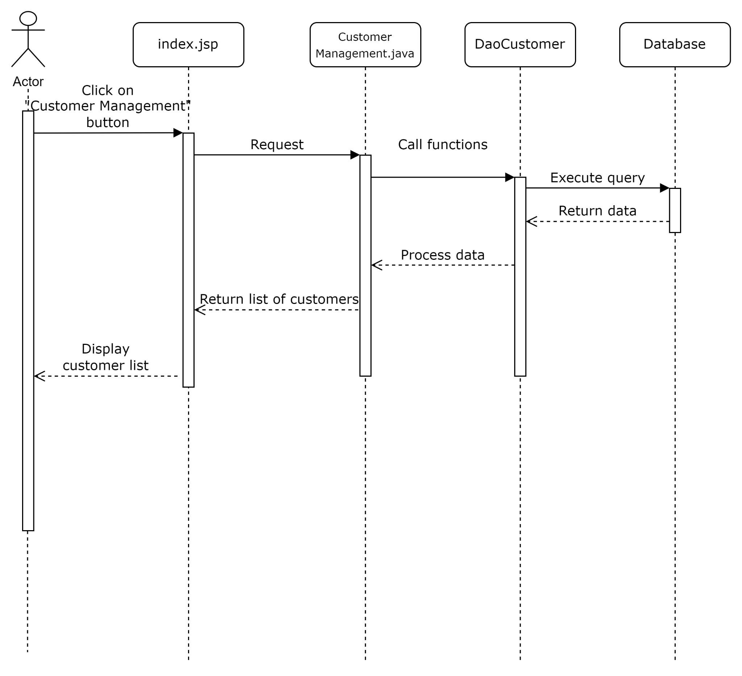

#### 

#### **Update customer**

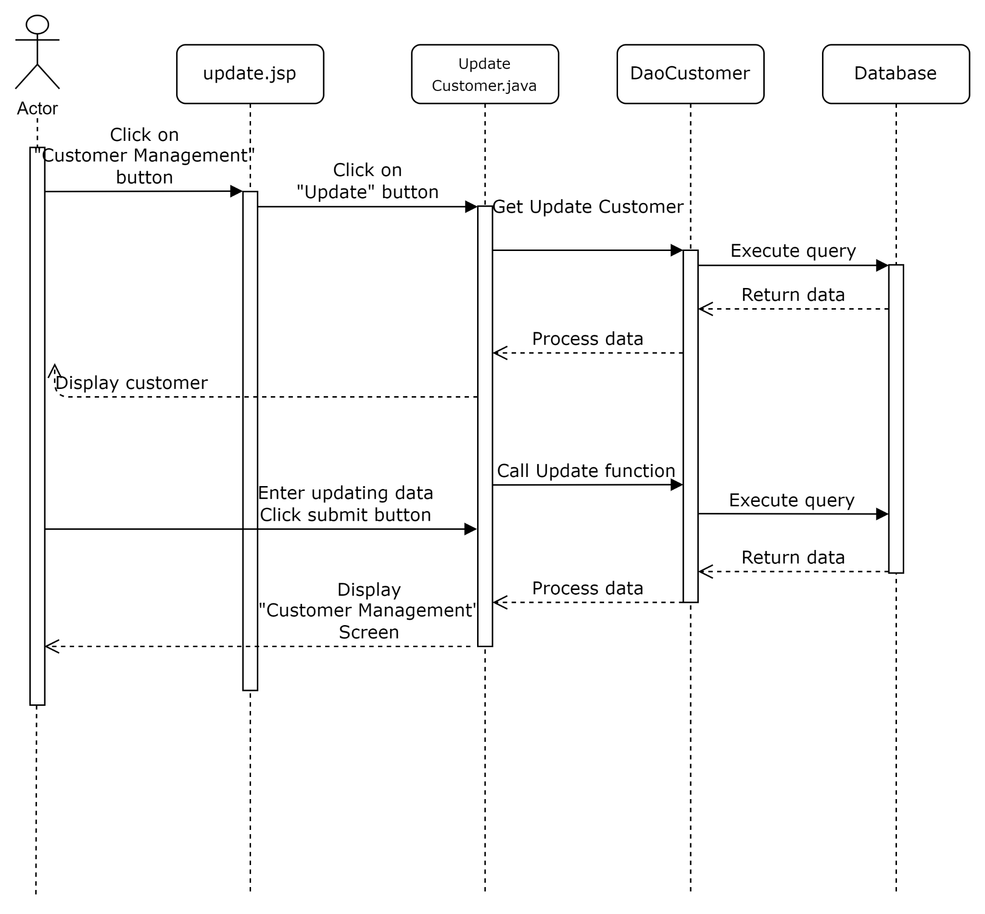

#### **Delete customer**

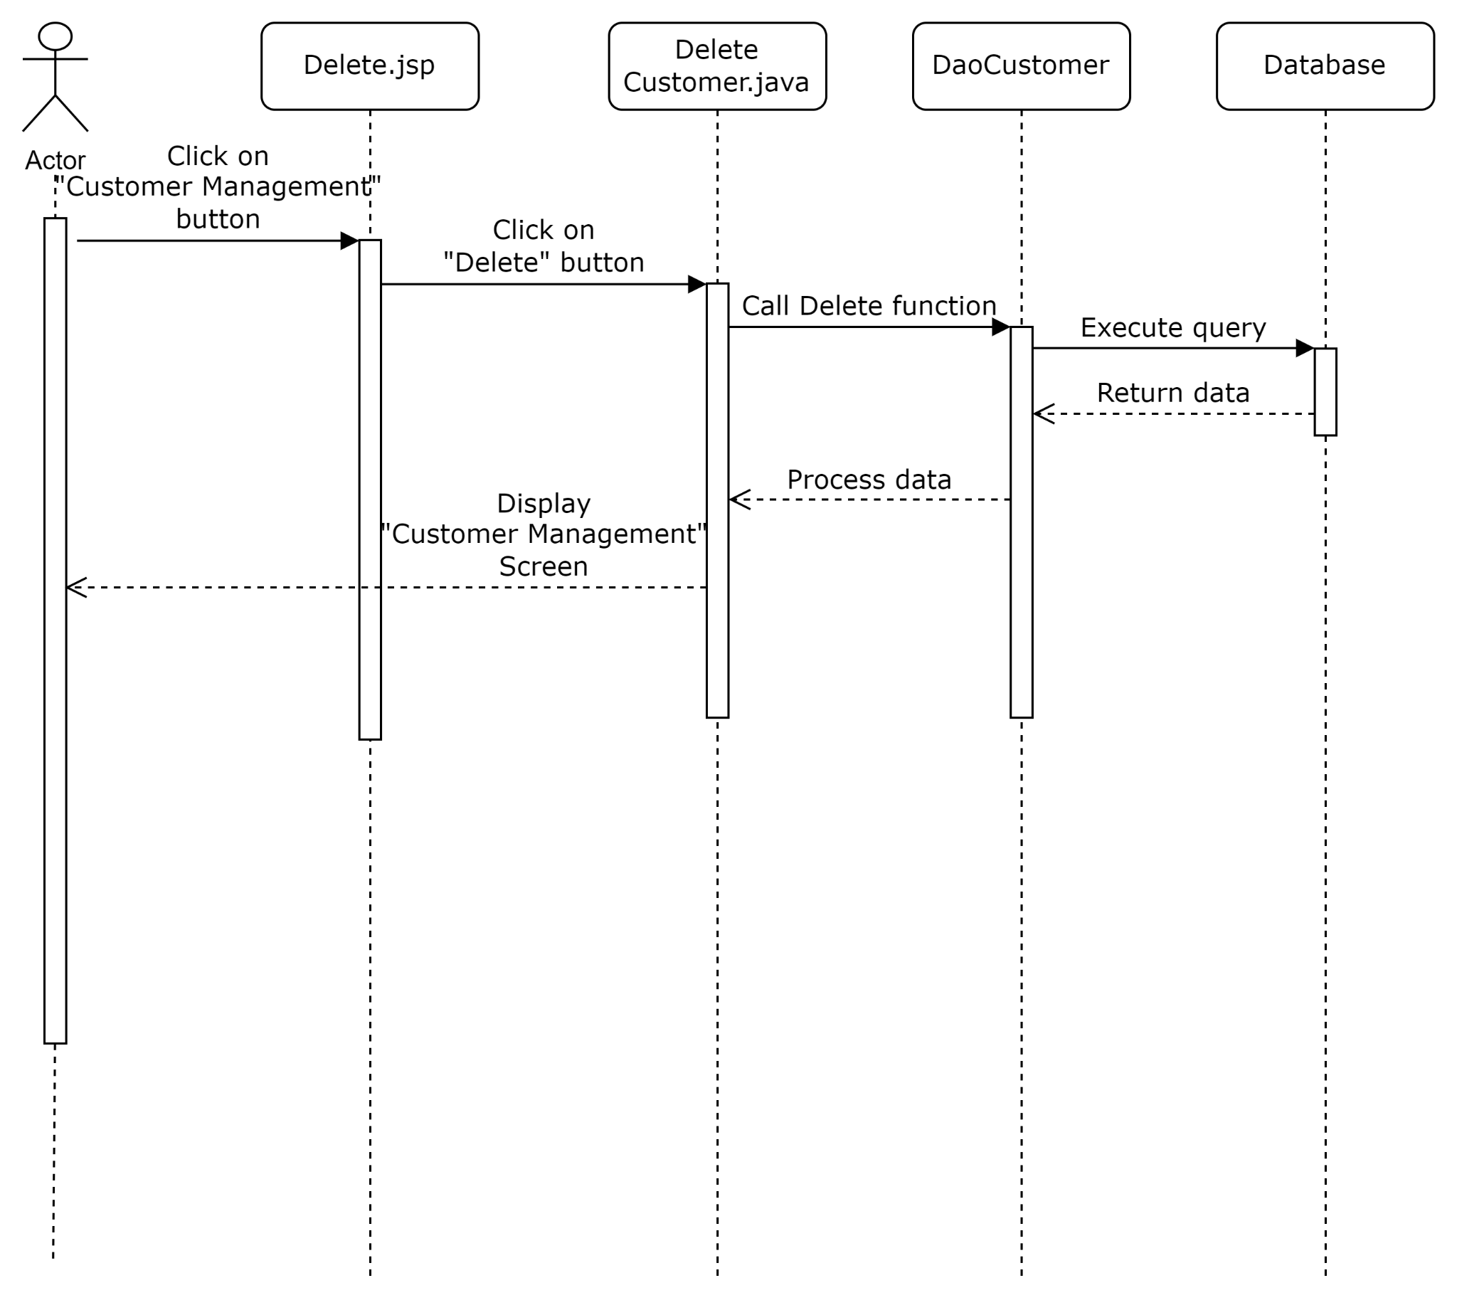

#### **Search customer**

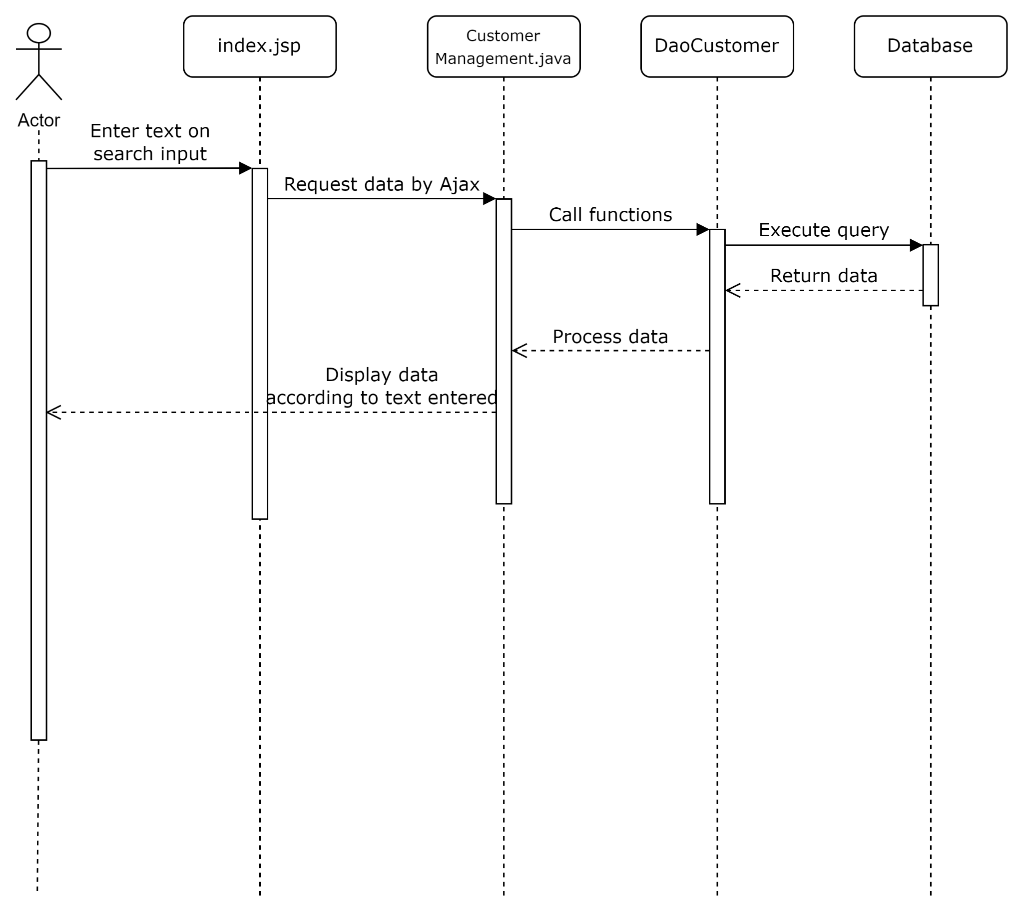

## 

## 2. Public Account

### a. Class Diagram

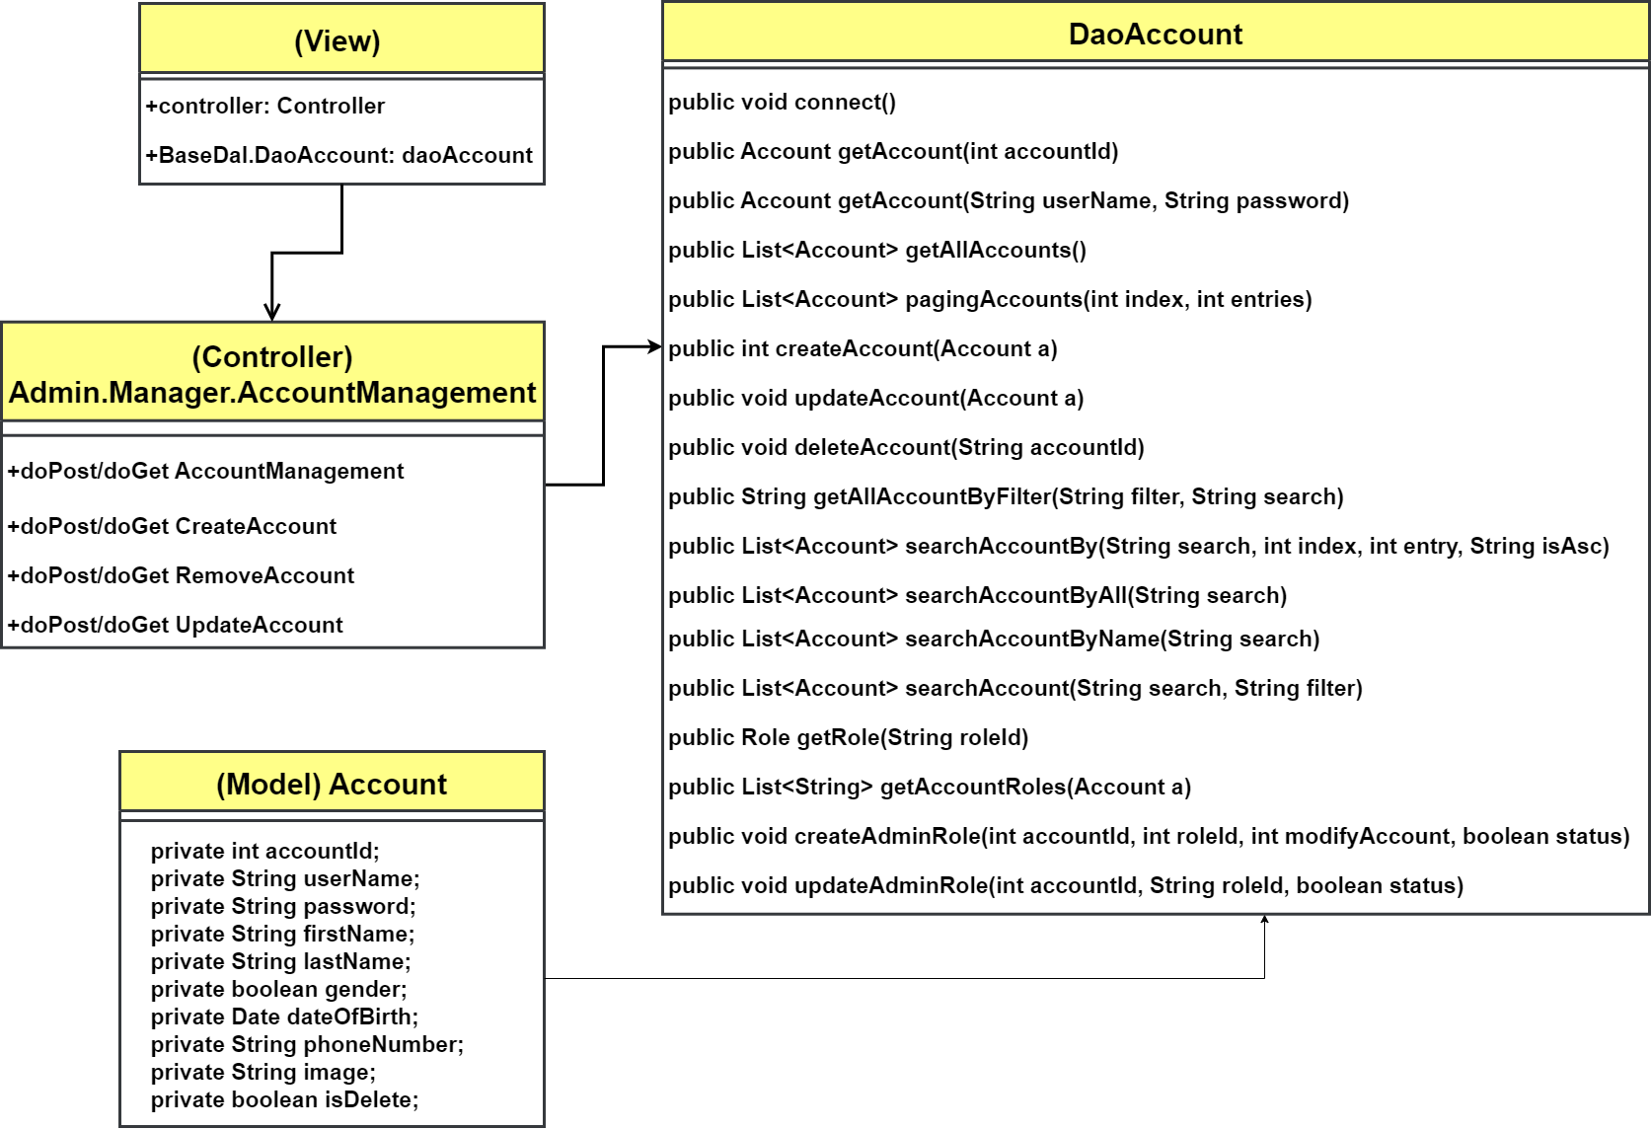

### b. Class Specifications

#### **DaoAccount.java**

| **No** | **Method** | **Description** |
| --- | --- | --- |
| 01 | public void connect() | Handle request create new connection to database |
| 02 | public Account getAccount(int accountId) | Handle request get Account by accountId |
| 03 | public List<Account> getAllAccounts() | Handle request get all Accounts |
| 04 | public Account getAccount(String userName, String password) | Handle request get Account by username and password |
| 05 | public int createAccount(Account a) | Handle request create new Account with passed data - Account a |
| 06 | public void updateAccount(Account a) | Handle request update existed Account with passed data - Account a |
| 07 | public void deleteAccount(String accountId) | Handle request delete Account by accountId |
| 08 | public List<Account> getAllAccountByFilter(String filter, String search) | Handle request get list of Accounts by filter and searched keyword |
| 09 | public List<Account> searchAccountByAll(String search) | Handle request get list of Accounts with searched keywords |
| 10 | public List<Account> searchAccountByName(String search) | Handle request get list of Accounts with searched name |
| 11 | public List<Account> searchAccount(String search, String filter) | Handle request get list of Accounts by filter and searched keyword |
| 12 | public Role getRole(String roleId) | Handle request get Role by roleId |
| 13 | public List<Role> getAllRoles() | Handle request get all Roles |
| 14 | public List<String> getAccountRoles(Account a) | Handle request get Roles that the account have access allowed |
| 15 | public void createAdminRole(int accountId, int roleId, int modifyAccount, boolean status) | Handle request add access role to an existing account |
| 16 | public void updateAdminRole(int accountId, String roleId, boolean status) | Handle request update access role to an existing account |

### c. Sequence Diagram(s)

#### **View All Admins**

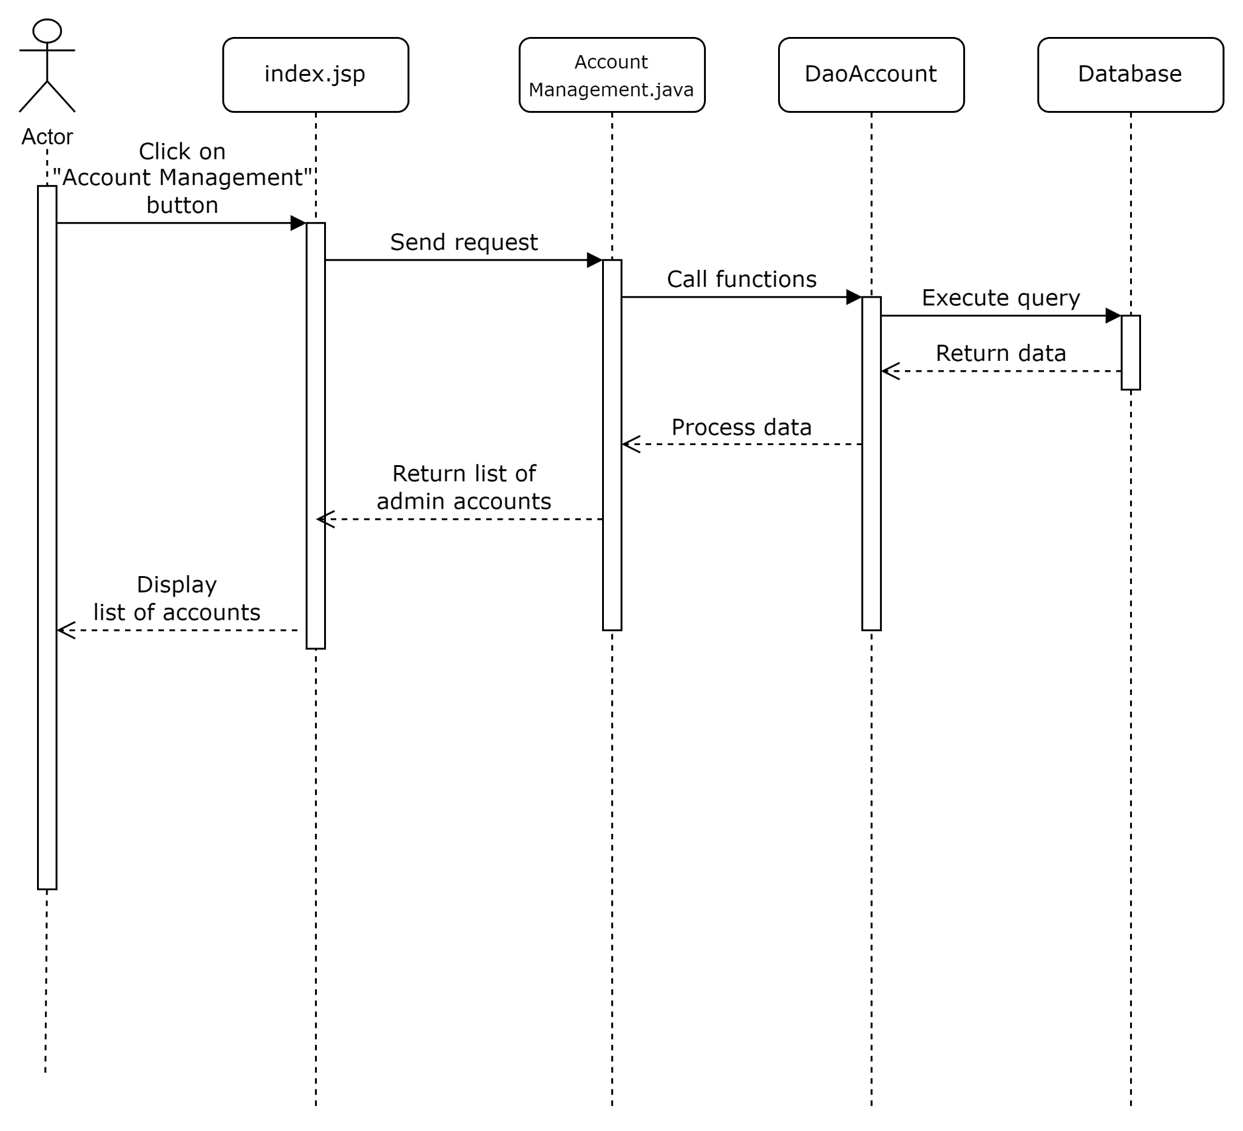

#### **Update Admin**

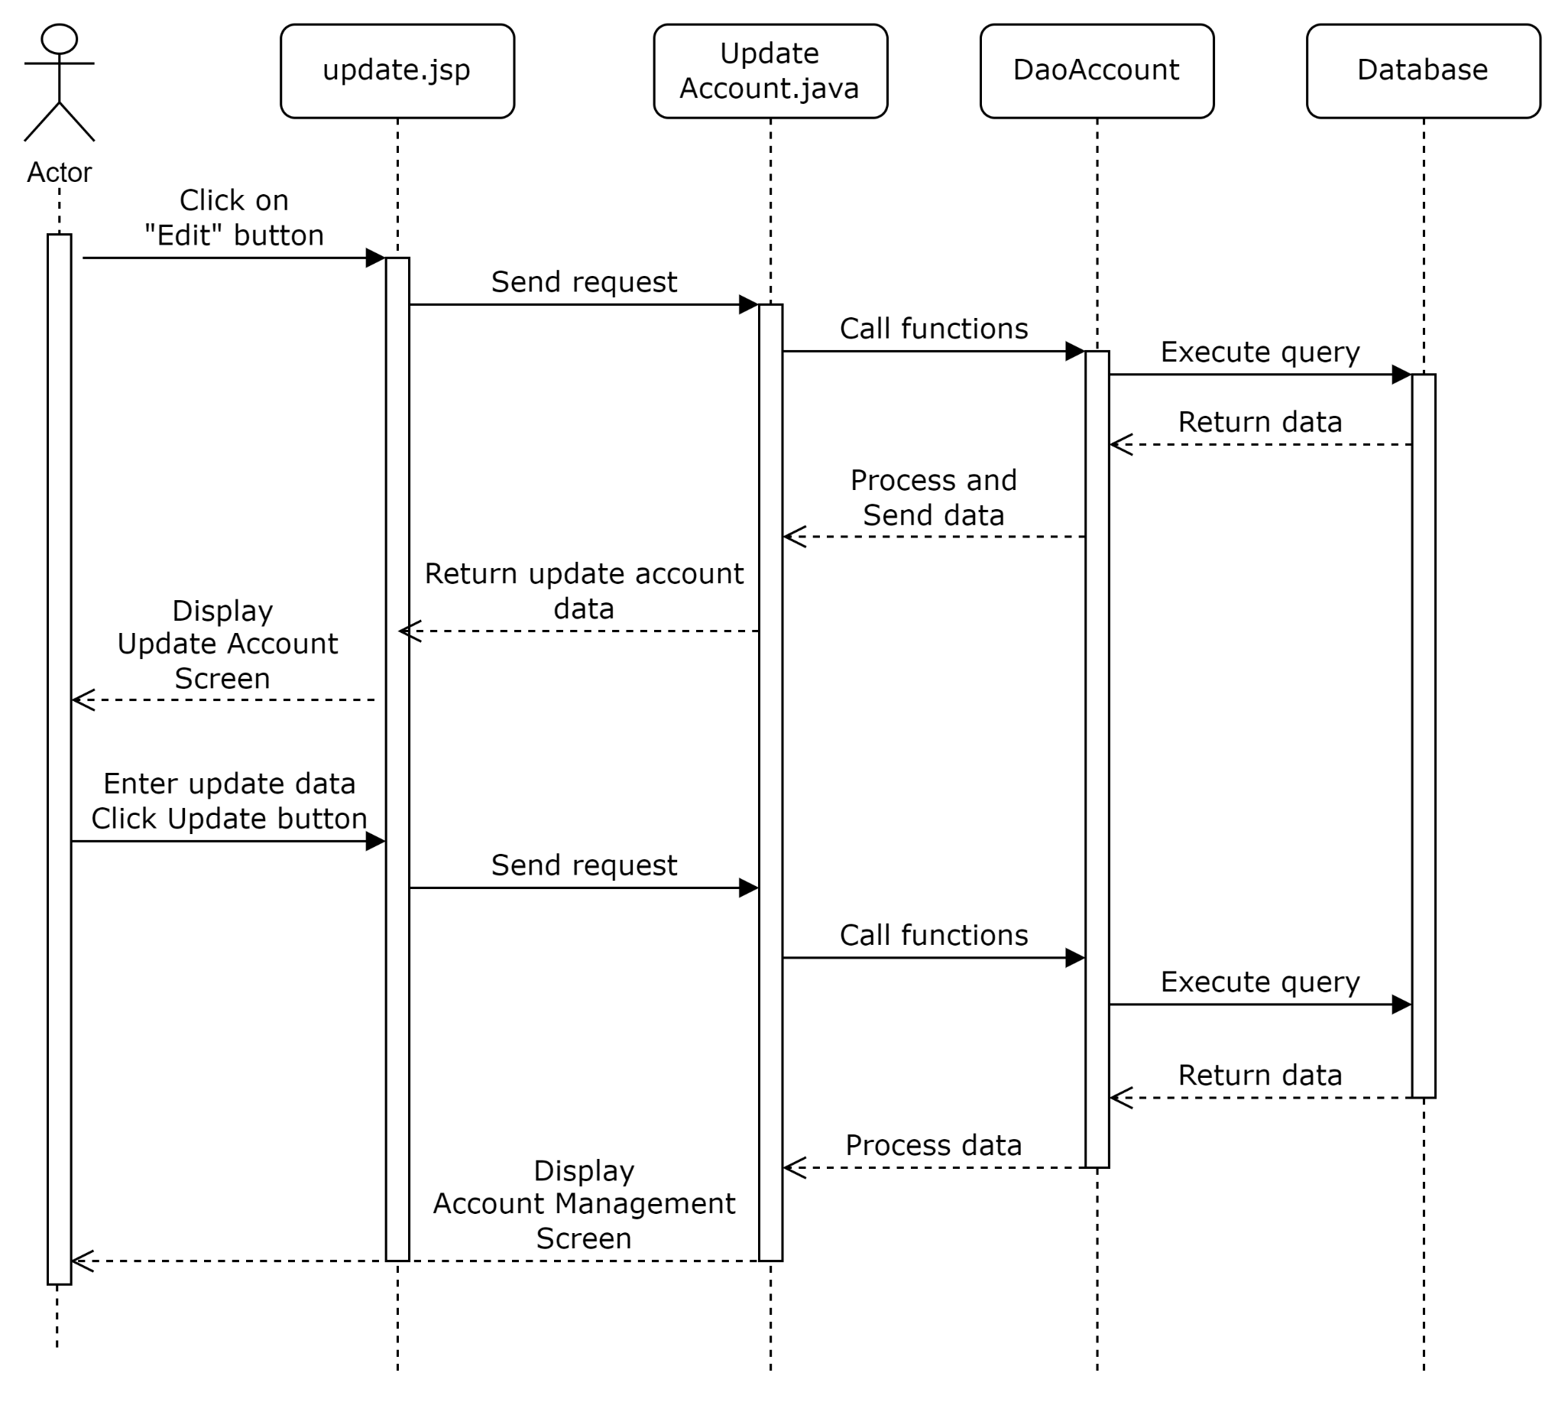

#### **Create Admin**

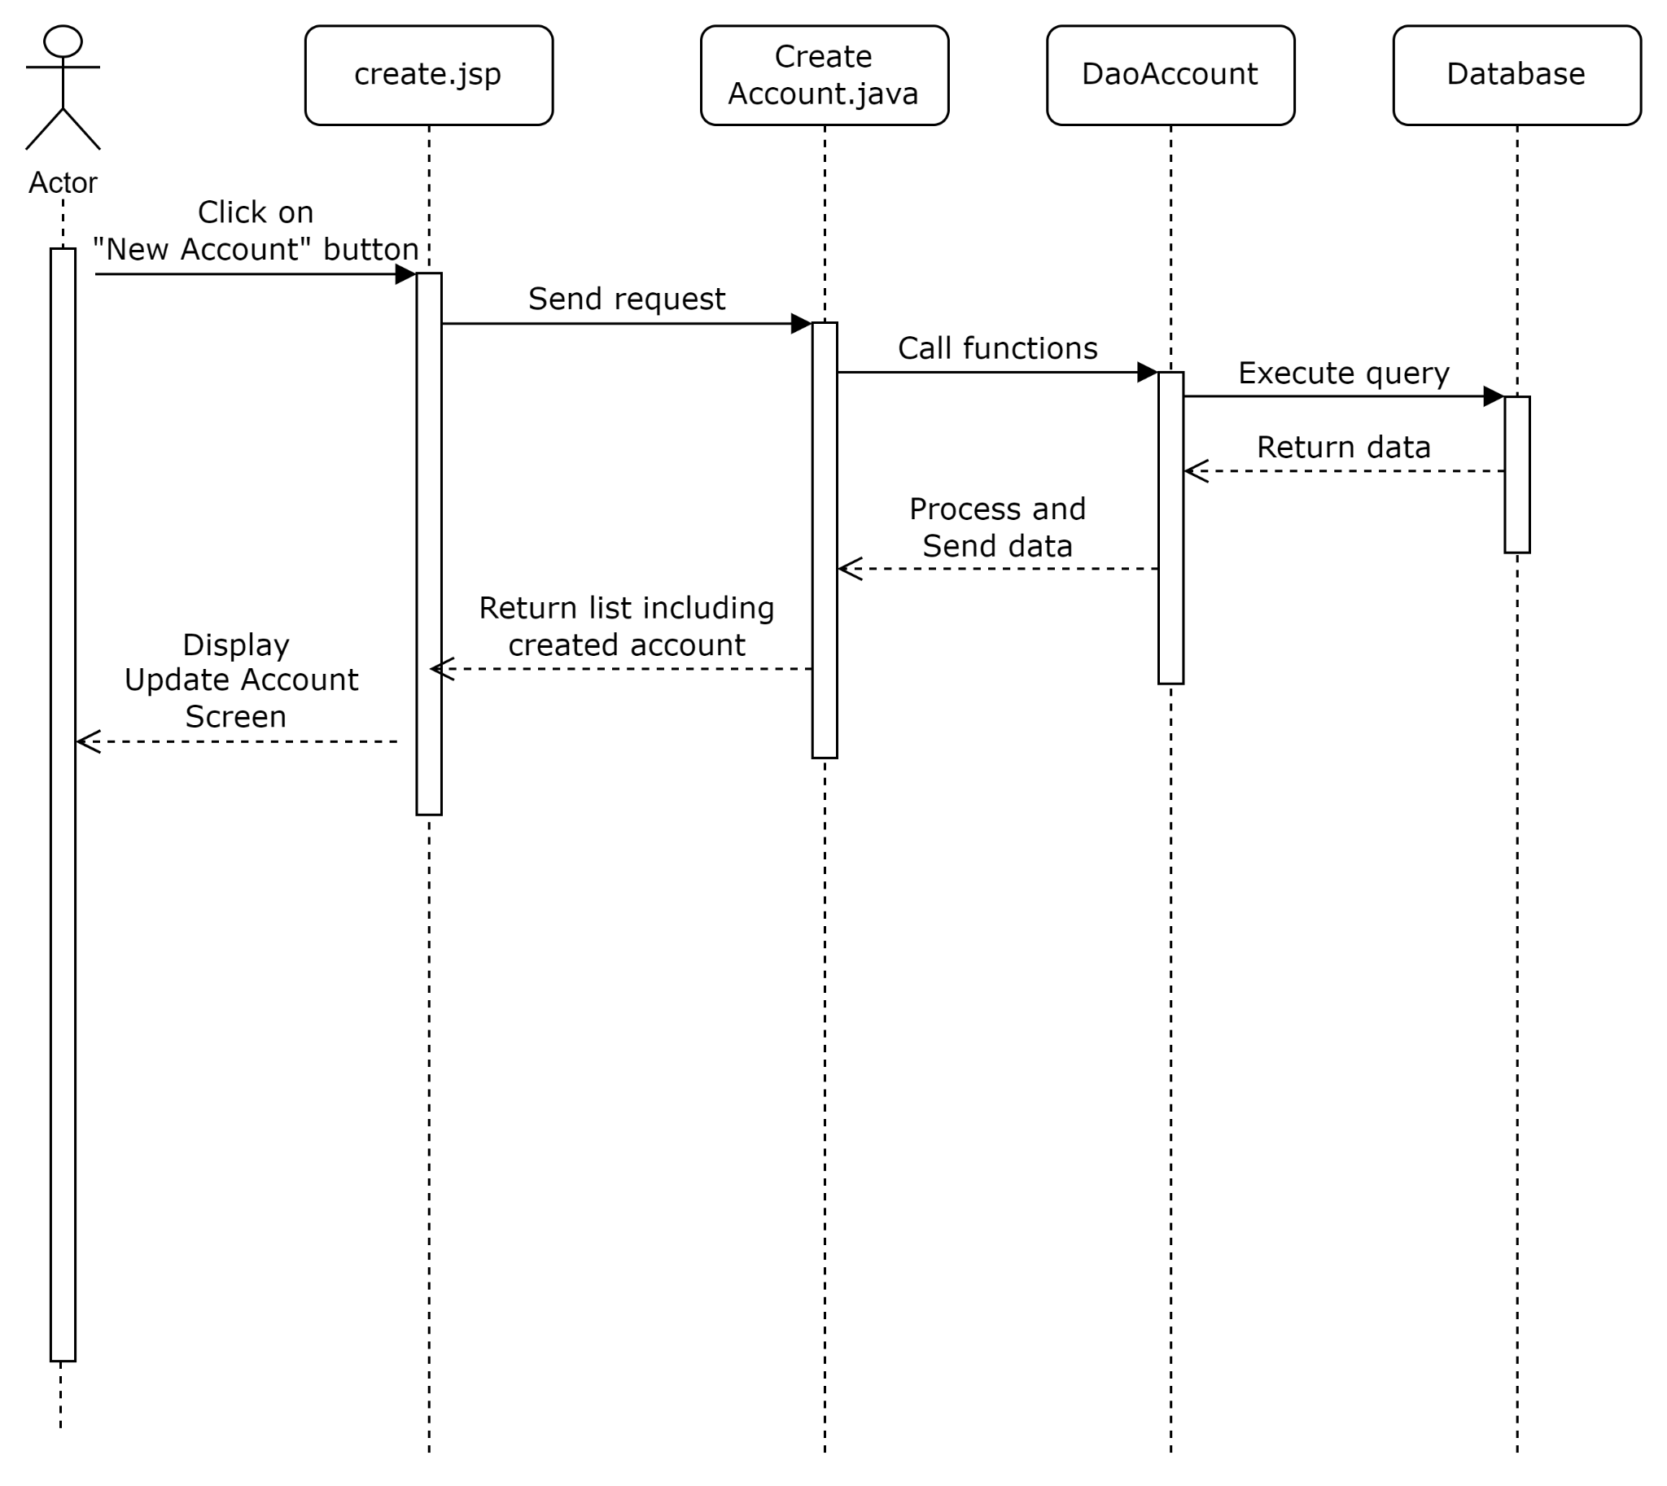

#### **Remove Admin**

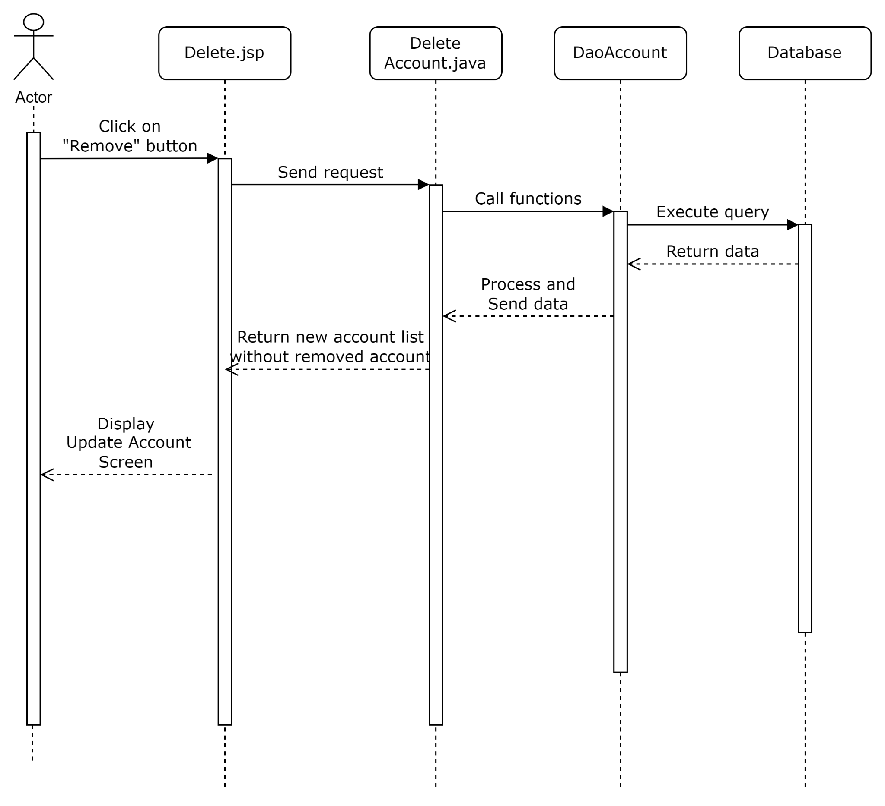

#### 

#### **Search Admins**

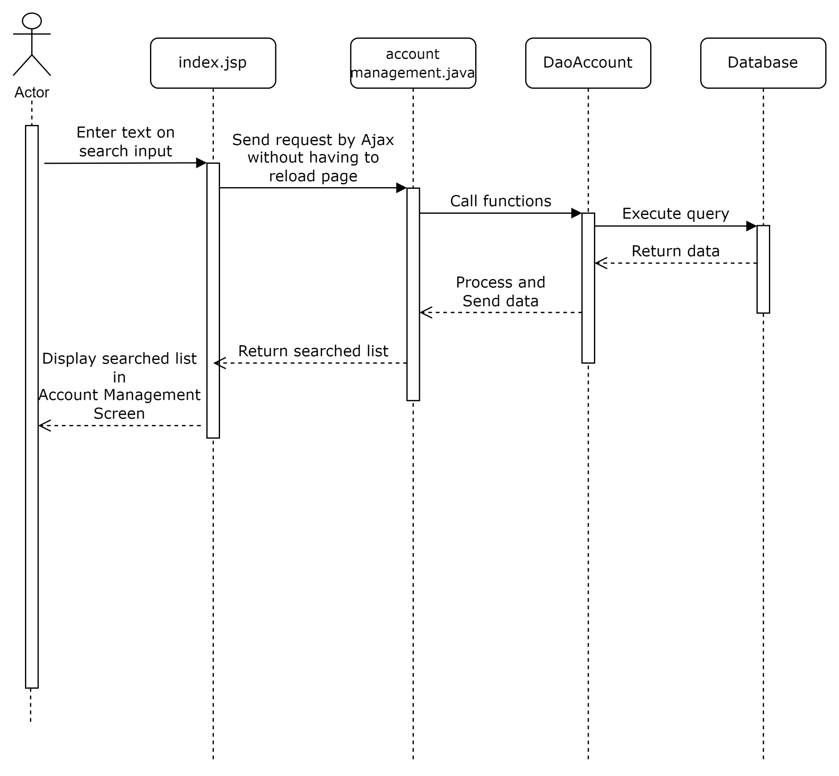

#### **Admin Login**

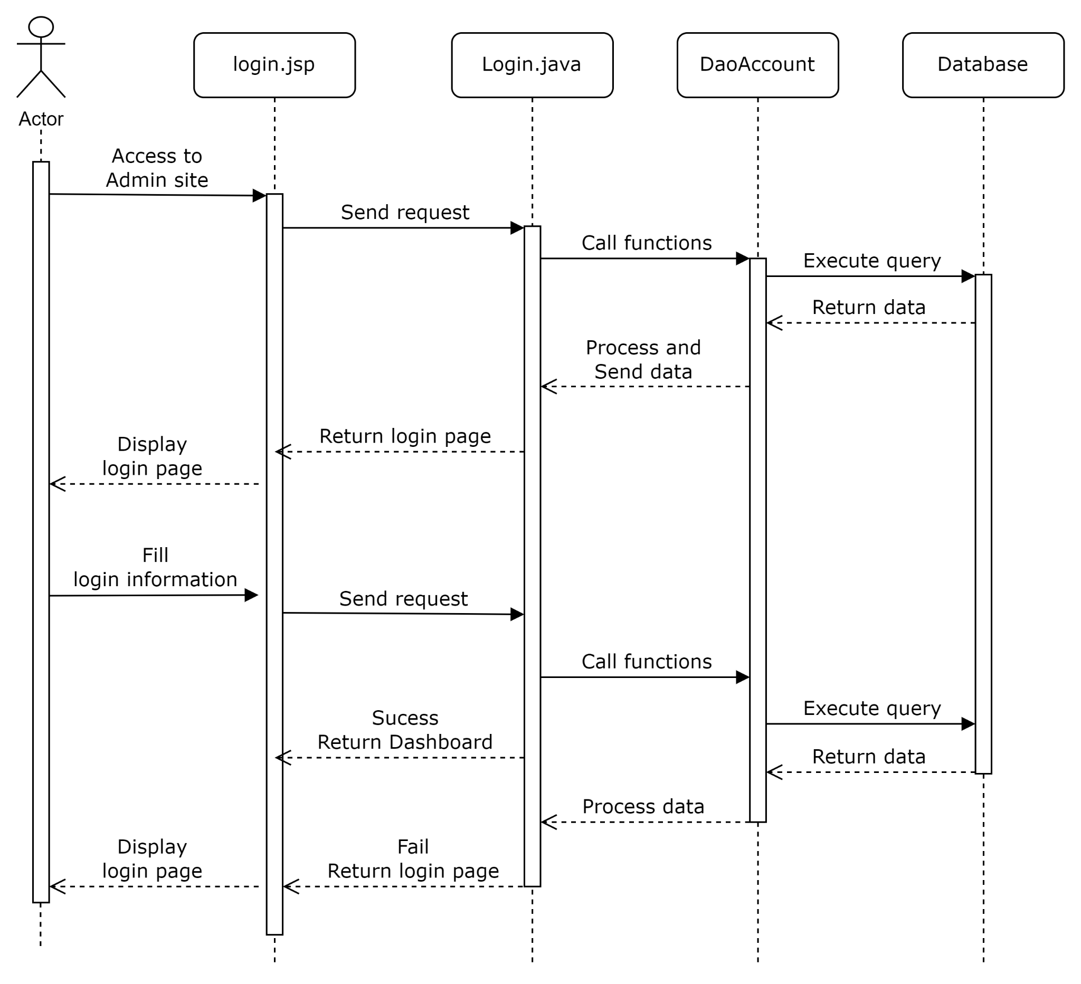

## 3. Public Order

### a. Class Diagram

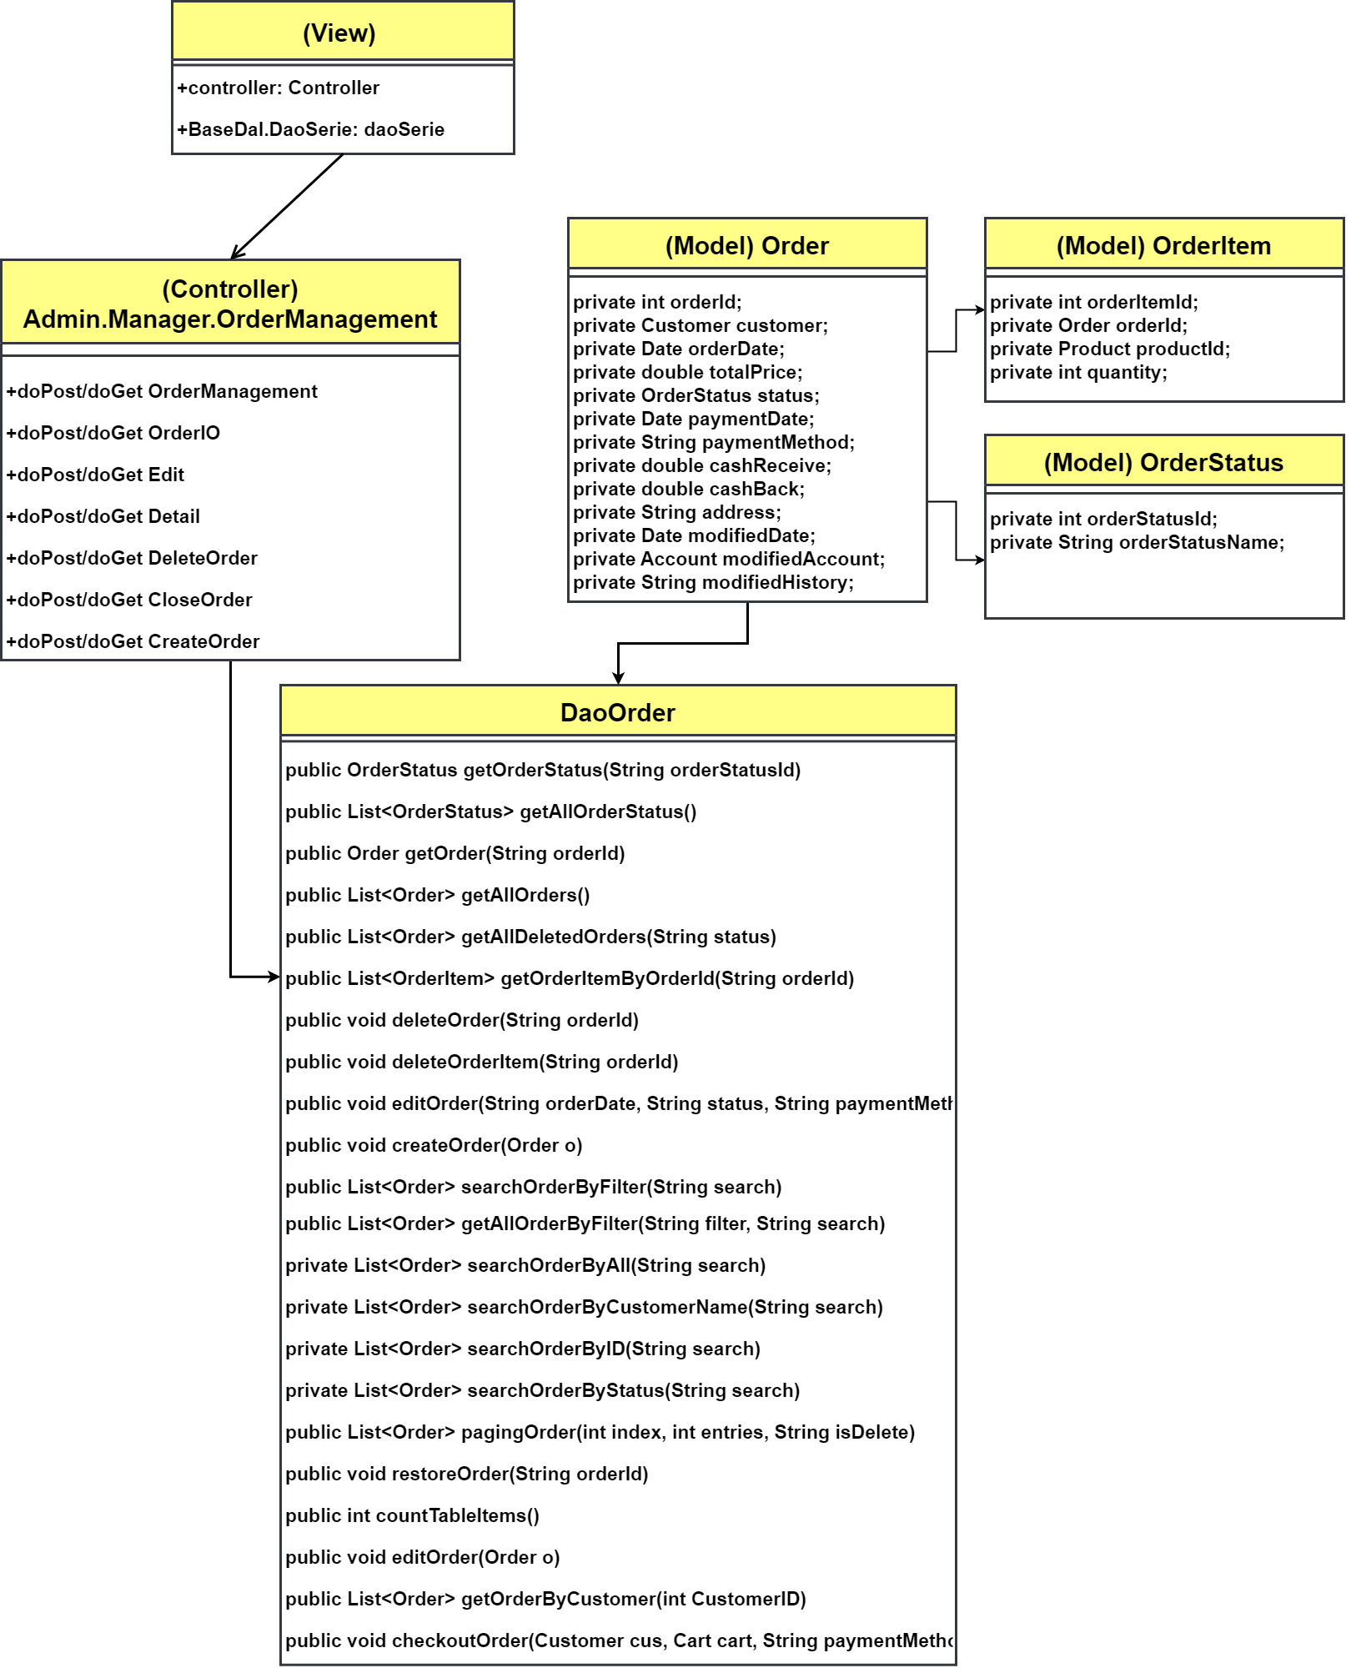

### b. Class Specifications

#### DAOOrder.java

| **No** | **Method** | **Description** |
| --- | --- | --- |
| 01 | public OrderStatus getOrderStatus(String orderStatusId) | Handle request get Order Status Name by Order Status Id |
| 02 | public List<OrderStatus> getAllOrderStatus() | Handle request get List Order Status |
| 03 | public Order getOrder(String orderId) | Handle request get Order by Order Id |
| 04 | public List<Order> getAllOrders() | Handle request get List Order |
| 05 | public List<Order> getAllDeletedOrders(String status) | Handle request get List Deleted Order |
| 06 | public List<OrderItem> getOrderItemByOrderId(String orderId) | Handle request get List Order Item in an order by Order Id |
| 07 | public void deleteOrder(String orderId) | Handle request update isDelete of an order to true in an Order by Order Id |
| 08 | public void deleteOrderItem(String orderId) | Handle request update isDelete of an Order Item to true in an Order by Order Id |
| 09 | public void editOrder(String orderDate, String status, String paymentMethod, String cashReceive, String cashBack, String address, Date modifiedDate, int acc, String modifiedHistory, String orderId) | Handle request update Order information |
|  | public void createOrder(Order o) | Handle request add an Order |
|  | public List<Order> searchOrderByFilter(String search) |  |
|  | public List<Order> getAllOrderByFilter(String filter, String search) | Handle request List Order that match Filter and Search and isDelete is false |
|  | private List<Order> searchOrderByAll(String search) | Handle request get List Order that match the key word and isDelete is false |
|  | public List<Order> searchOrder(String search, String filter) | Handle request get List Order that match the key word and isDelete is false |
|  | private List<Order> searchOrderByCustomerName(String search) | Handle request get List Order that match customer Name and isDelete is false |
|  | private List<Order> searchOrderByID(String search) | Handle request get List Order that match Order Id and isDelete is false |
|  | private List<Order> searchOrderByStatus(String search) | Handle request get List Order that match Order Status name and isDelete is false |
|  | public List<Order> pagingOrder(int index, int entries, String isDelete) | Handle request get List order that have been paging |
|  | public void restoreOrder(String orderId) | Handle request update isDelete of an Order to false by Order Id |
|  | public int countTableItems() | Handle request count the number of Orders in database |
|  | public void editOrder(Order o) | Handle request update OrderStatusId, ModifiedDate, AdminModified, ModifiedHistory in an Order when something is change |
|  | public List<Order> getOrderByCustomer(int CustomerID) | Handle request get List Order that the Customer has placed by Customer Id |
|  | public void checkoutOrder(Customer cus, Cart cart, String paymentMethod) | Handle request |

### c. Sequence Diagram(s)

#### Add to cart

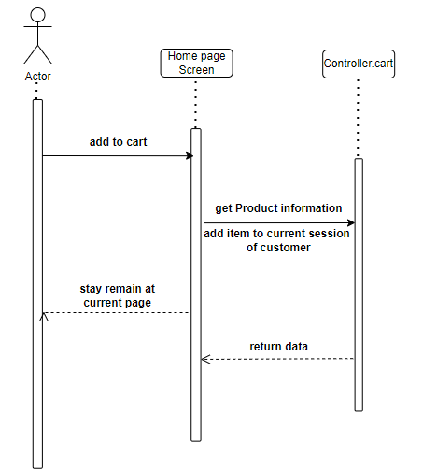

#### CheckOut VnPay

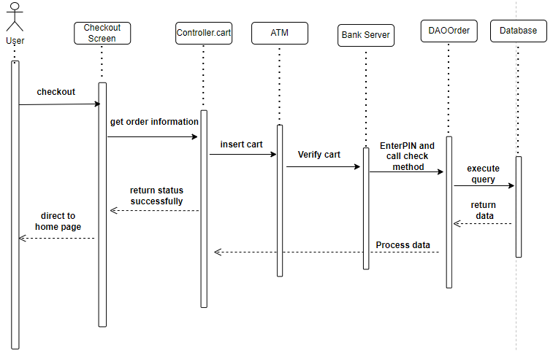

#### CheckOut Direct

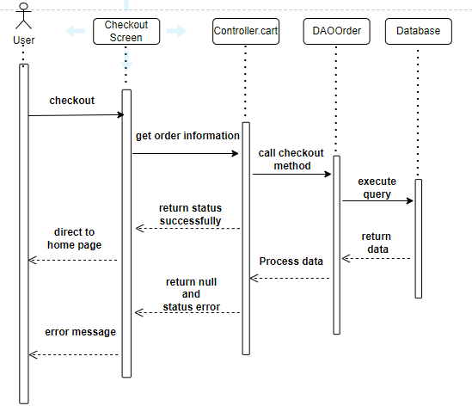

#### Update Order Status

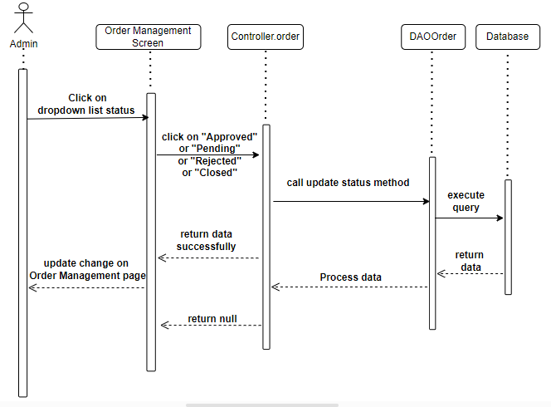

#### View Order Detail

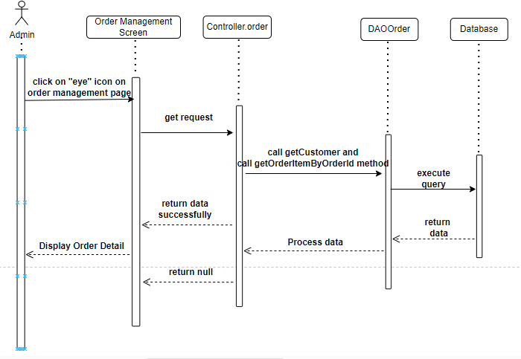

#### Search Order

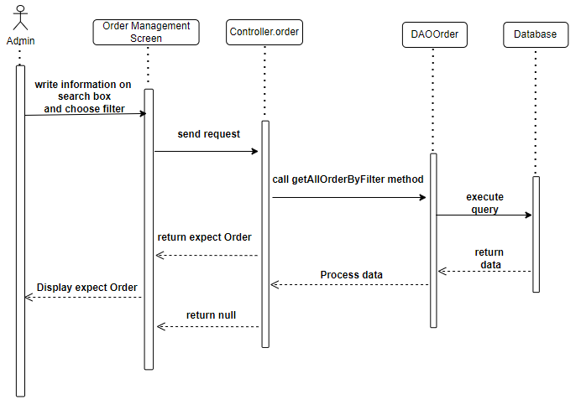

#### View all order

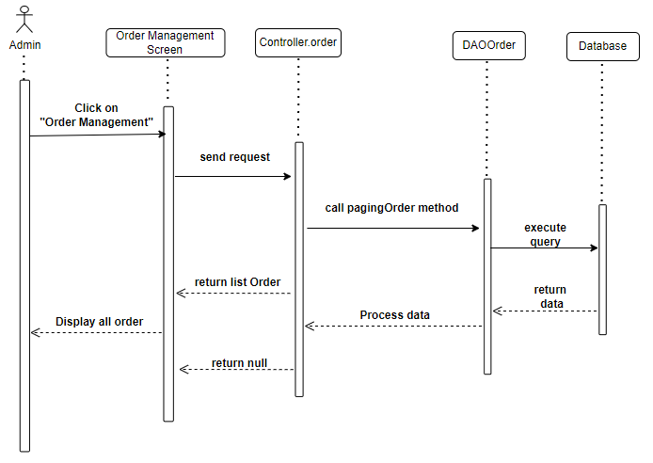

#### Delete Order

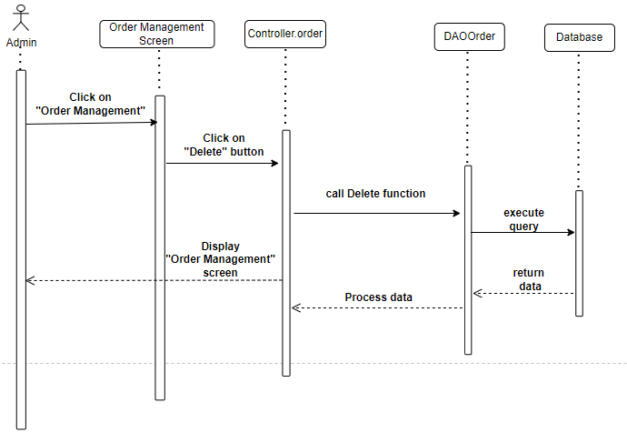

## 4. Public Series

### a. Class Diagram

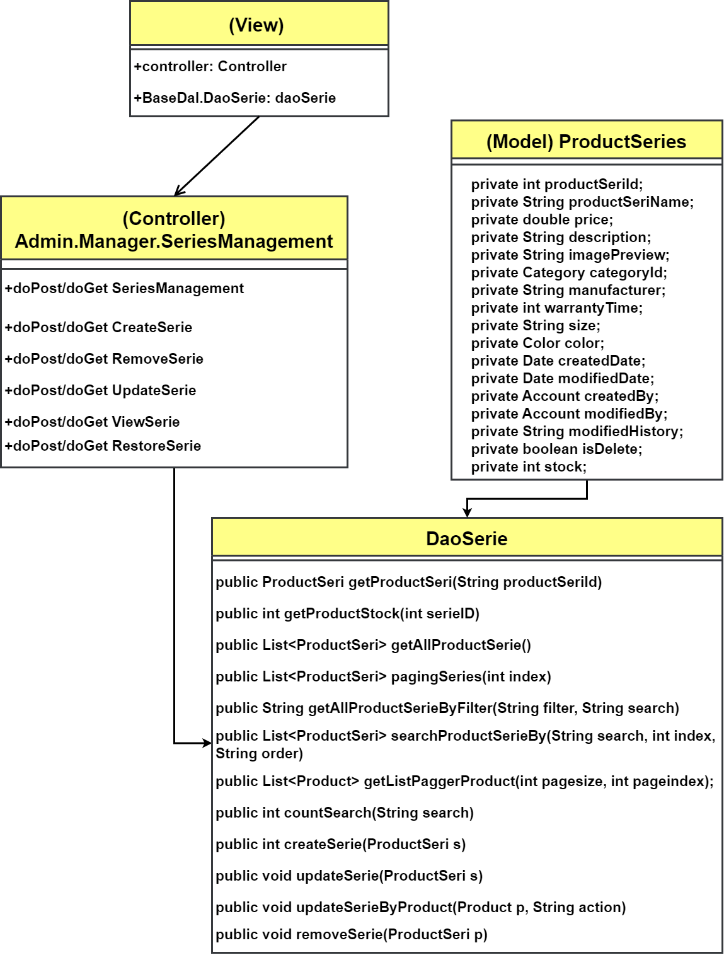

### b. Class Specifications

#### Series Class

| **No** | **Method** | **Description** |
| --- | --- | --- |
| 01 | public ProductSeri getProductSeri(String productSeriId) | Handle request get single Series information |
| 02 | public int getProductStock(int serieID) | Handle request set stock of a Series |
| 03 | public List<ProductSeri> getAllProductSerie() | Handle request get List of available Series |
| 04 | public List<ProductSeri> pagingSeries(int index) | Handle request get List of available Series in page of index |
| 05 | public String getAllProductSerieByFilter(String filter, String search) | Handle request get Series by Filters |
| 06 | public List<ProductSeri> searchProductSerieBy(String search, int index, String order) | Handle request get Series by Filters, page and arrange by Order |
| 07 | public List<Product> getListPaggerProduct(int pagesize, int pageindex); | Handle request get list pagger product |
| 08 | public int countSearch(String search) | Handle request count total available Series |
| 09 | public int createSerie(ProductSeri s) | Handle request create Series |
| 10 | public void updateSerie(ProductSeri s) | Handle request update Series |
| 11 | public void updateSerieByProduct(Product p, String action) | Handel request update Modify history of Series from actions of Products |
| 12 | public void removeSerie(ProductSeri p) | Handle request remove Series |
| 13 |  |  |

### c. Sequence Diagram(s)

#### **View Series List**

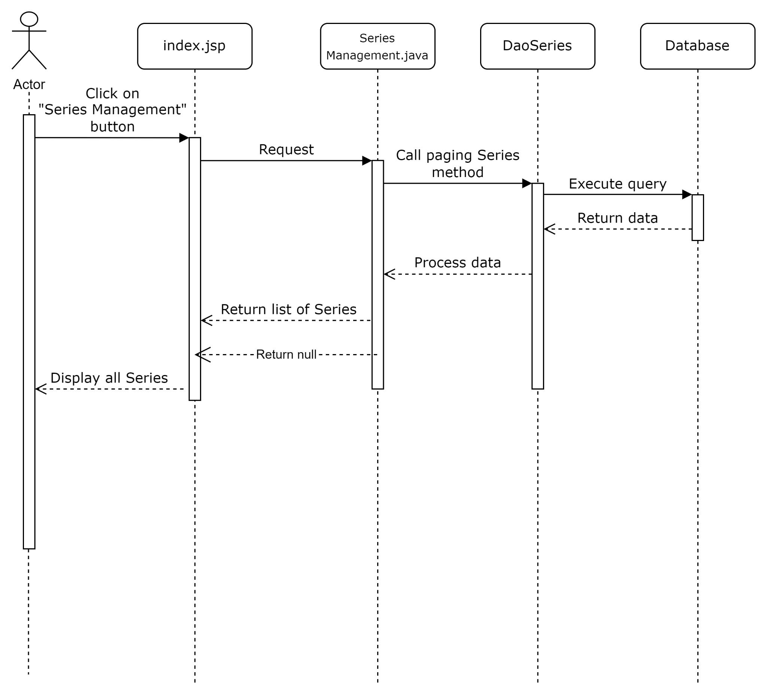

#### **View Serie detail**

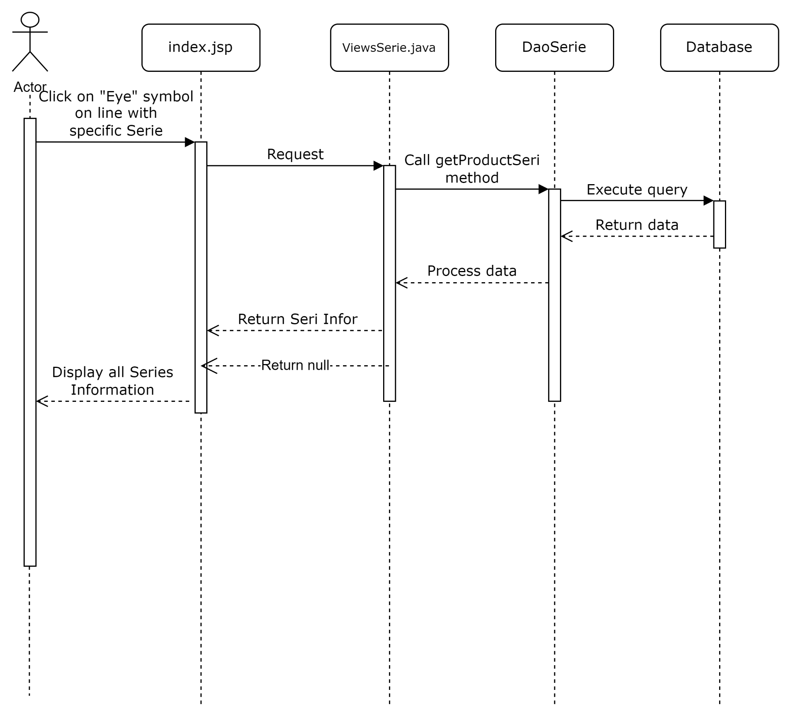

#### **Search Series**

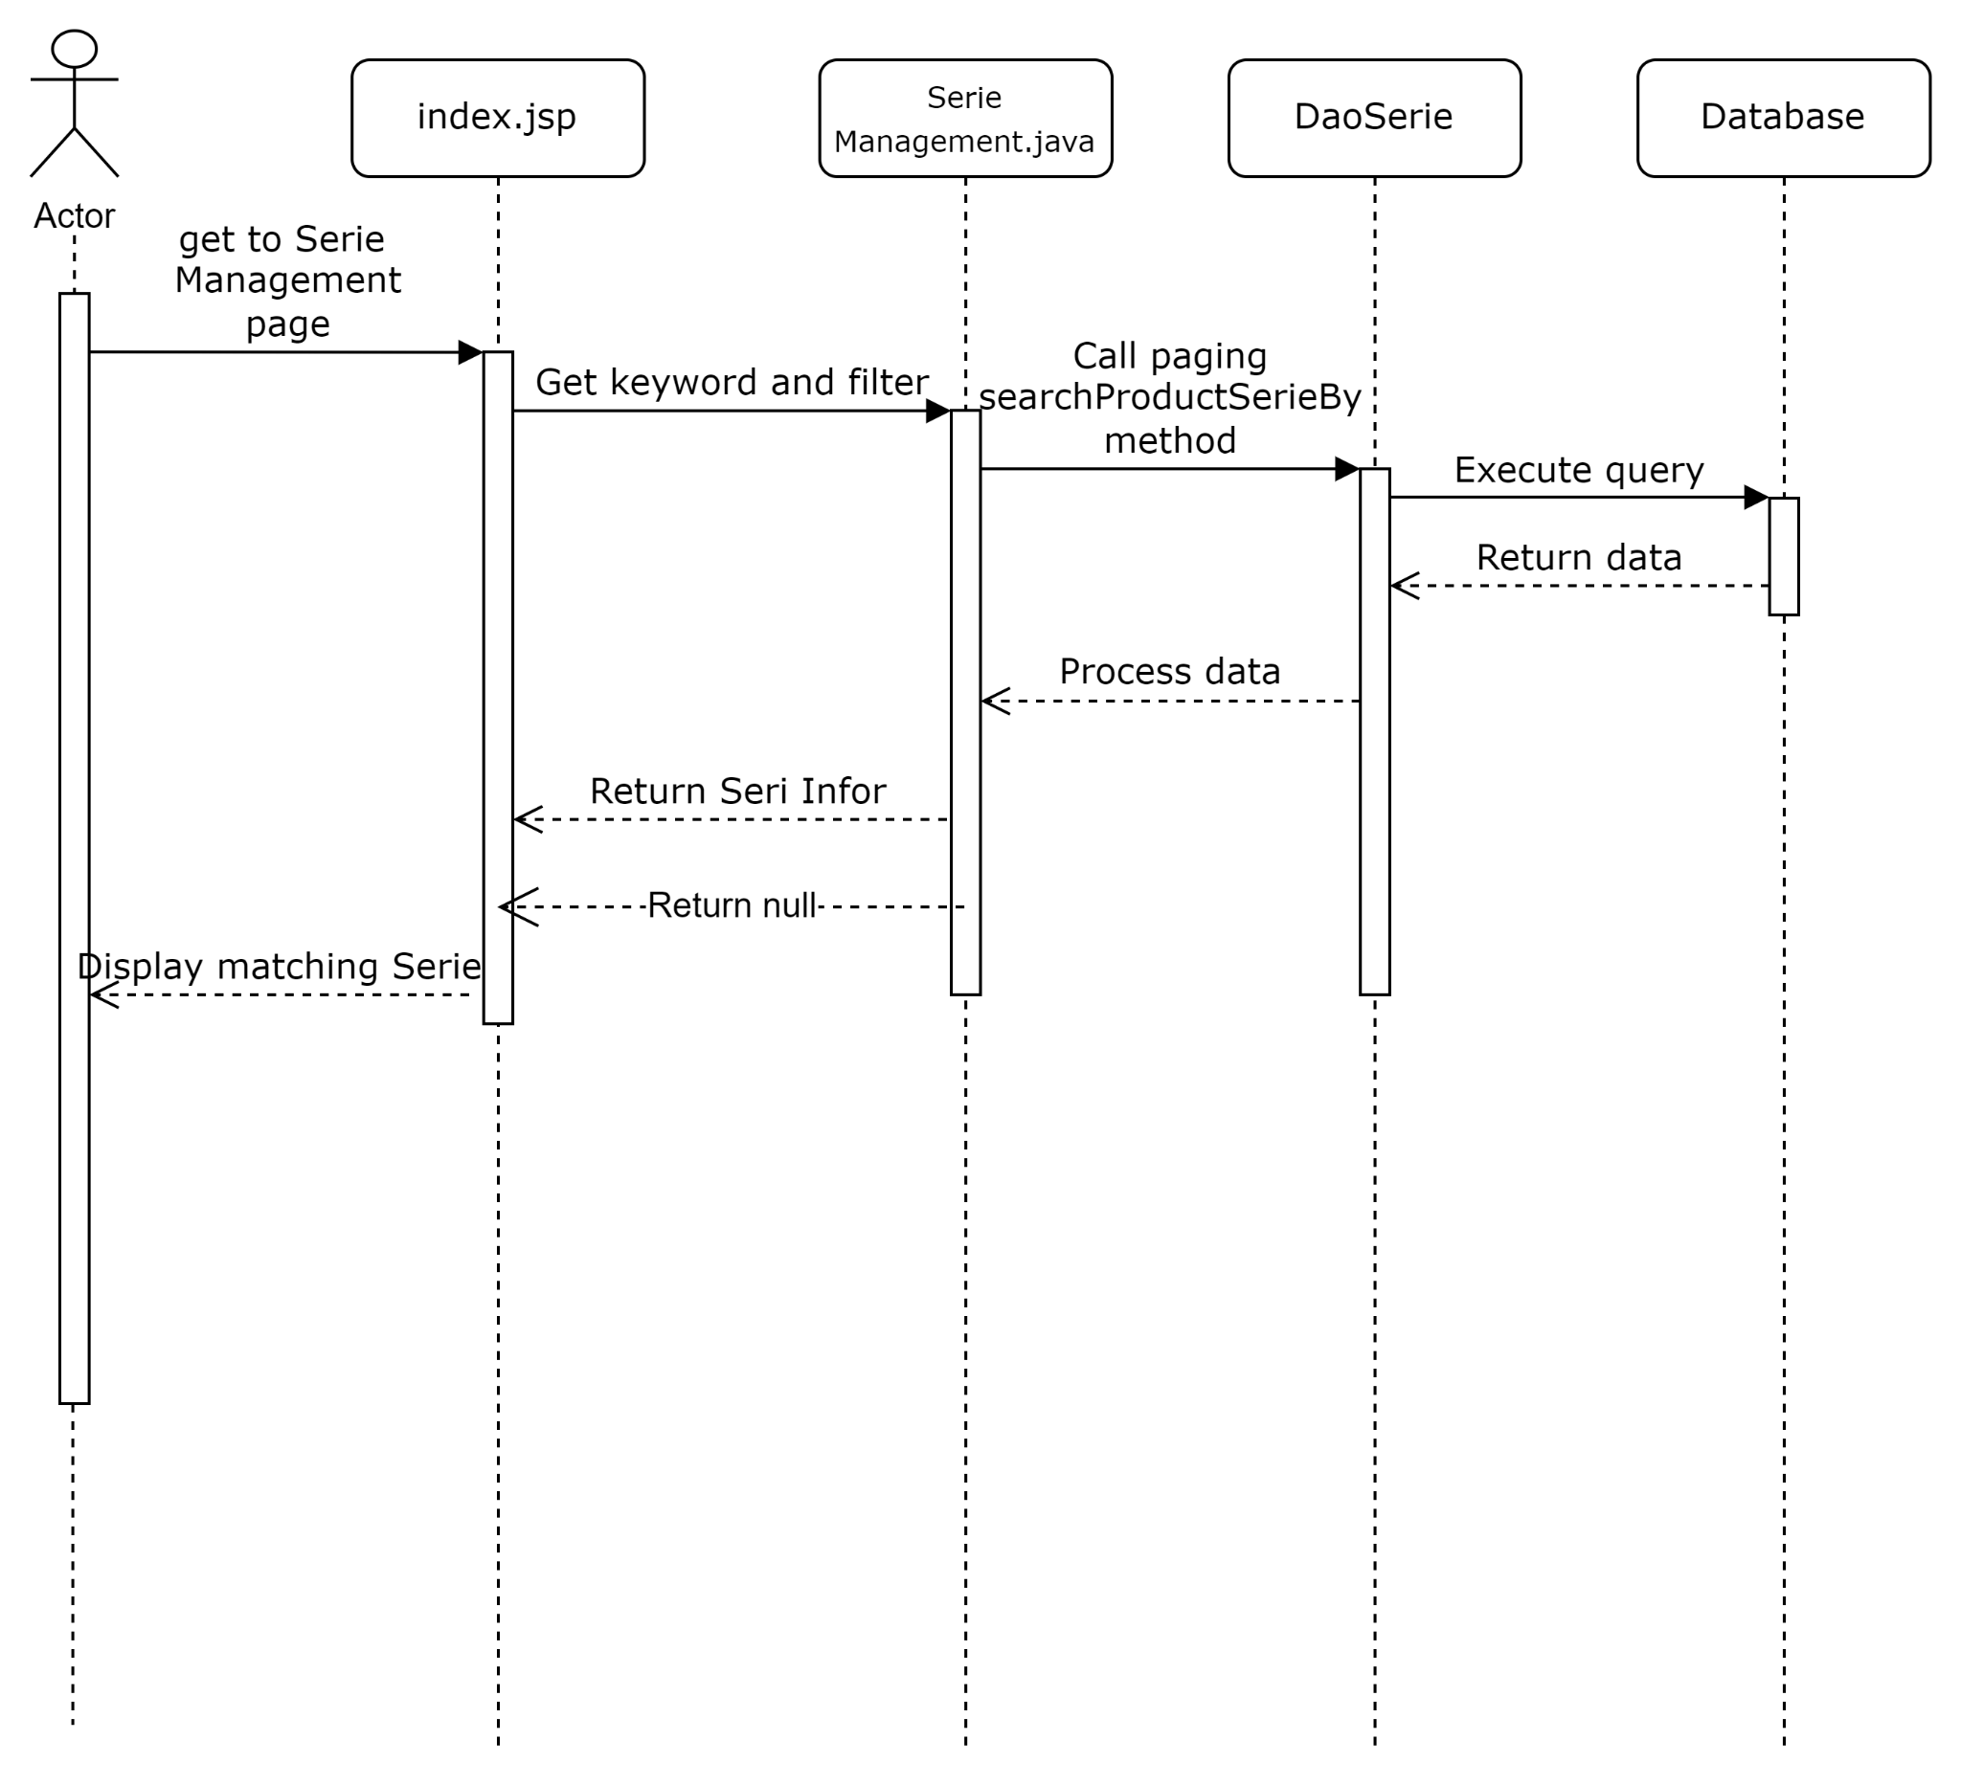

#### **Add Serie**

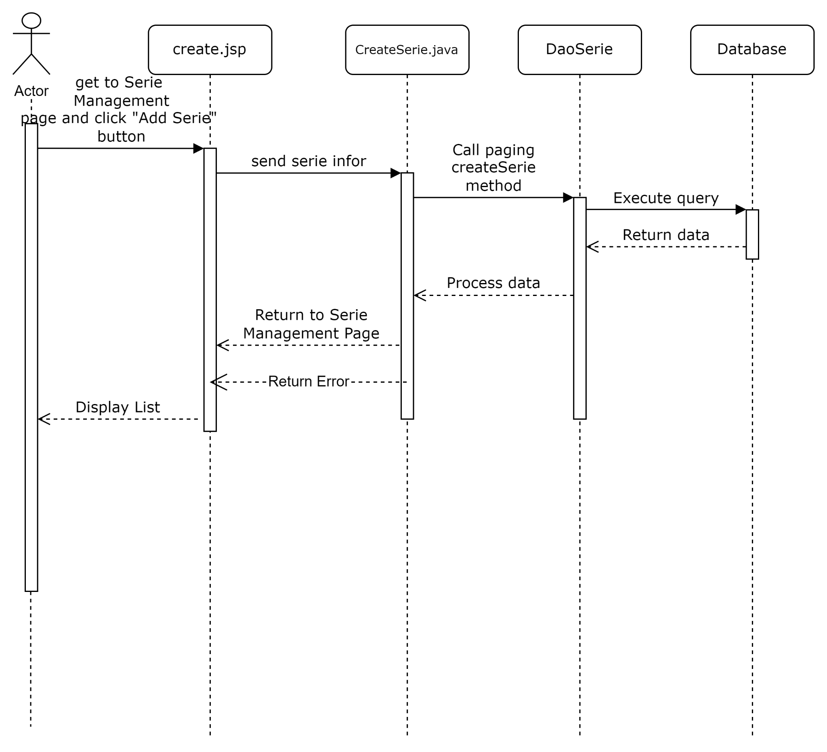

#### **Edit product**

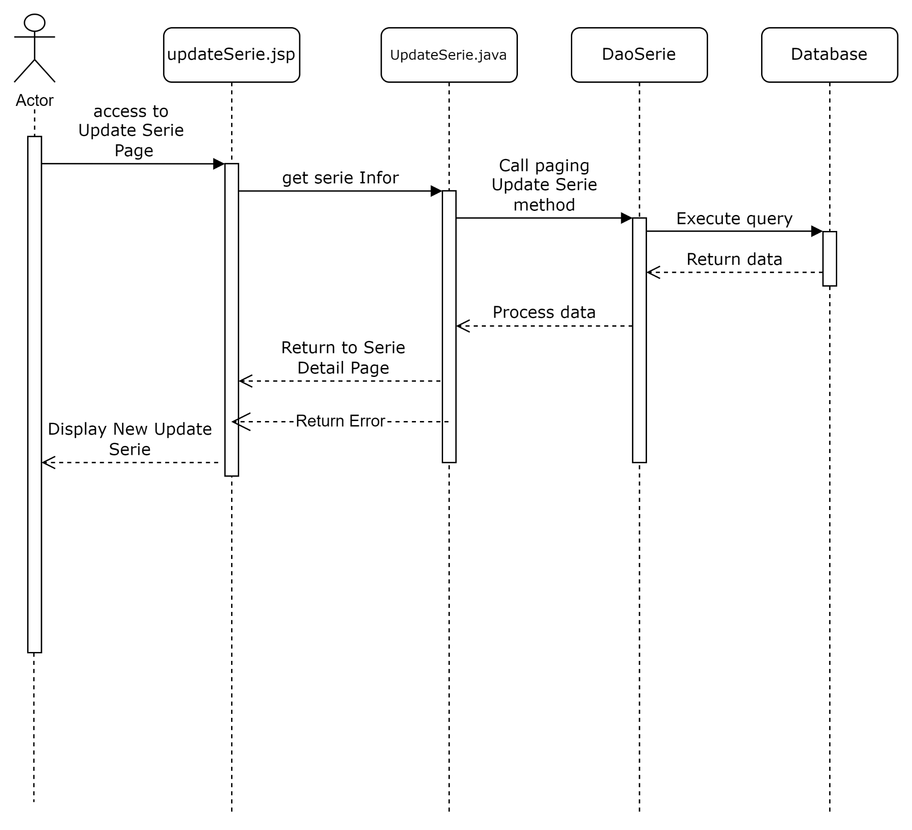

## **5. Public Products**

### a. Class Diagram

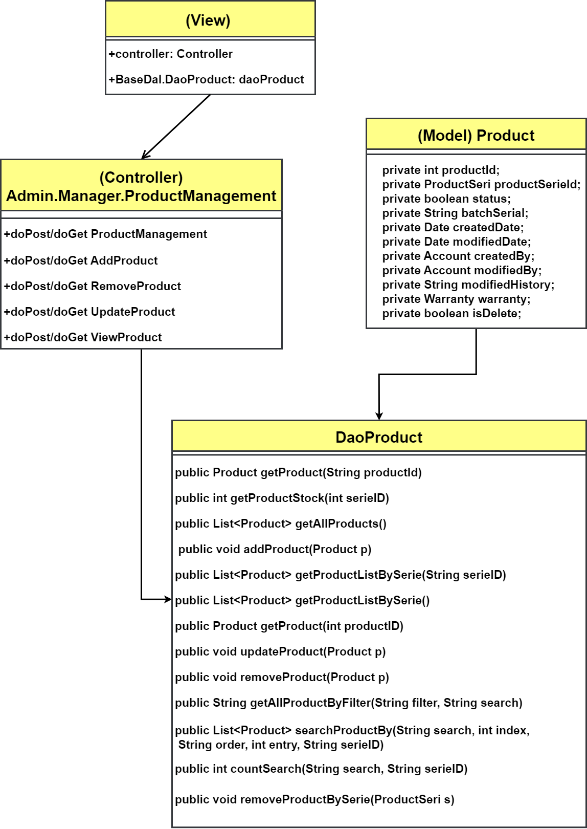

### b. Class Specifications

#### Product Class

| **No** | **Method** | **Description** |
| --- | --- | --- |
| 01 | public ProductSeri getProductSeri(String productSeriId) | Handle request get single Series information |
| 02 | public int getProductStock(int serieID) | Handle request set stock of a Series |
| 03 | public List<ProductSeri> getAllProductSerie() | Handle request get List of available Series |
| 04 | public List<ProductSeri> pagingSeries(int index) | Handle request get List of available Series in page of index |
| 05 | public String getAllProductSerieByFilter(String filter, String search) | Handle request get Series by Filters |
| 06 | public List<ProductSeri> searchProductSerieBy(String search, int index, String order) | Handle request get Series by Filters, page and arrange by Order |
| 07 | public List<Product> getListPaggerProduct(int pagesize, int pageindex); | Handle request get list pagger product |
| 08 | public int countSearch(String search) | Handle request count total available Series |
| 09 |  |  |
| 10 |  |  |

### c. Sequence Diagram(s)

**View Product List**

#### View product detail

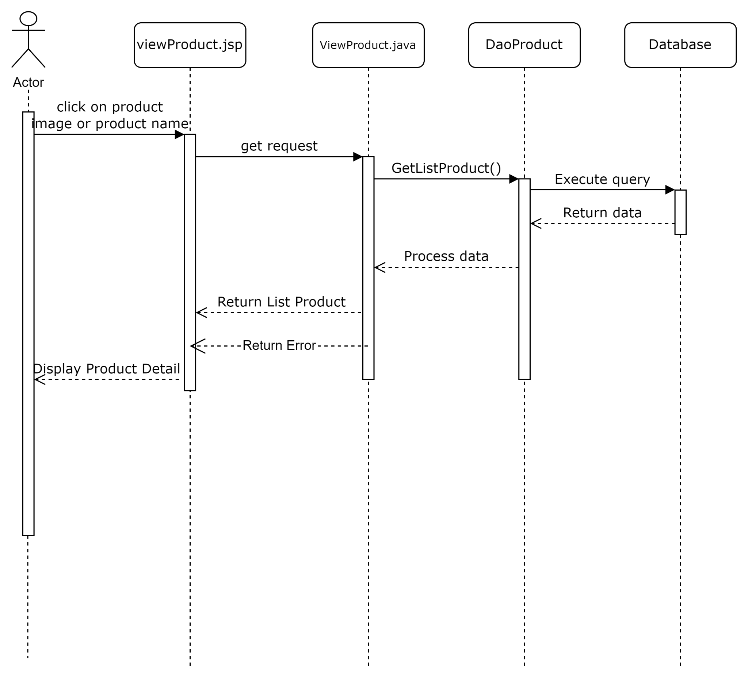

#### Search product

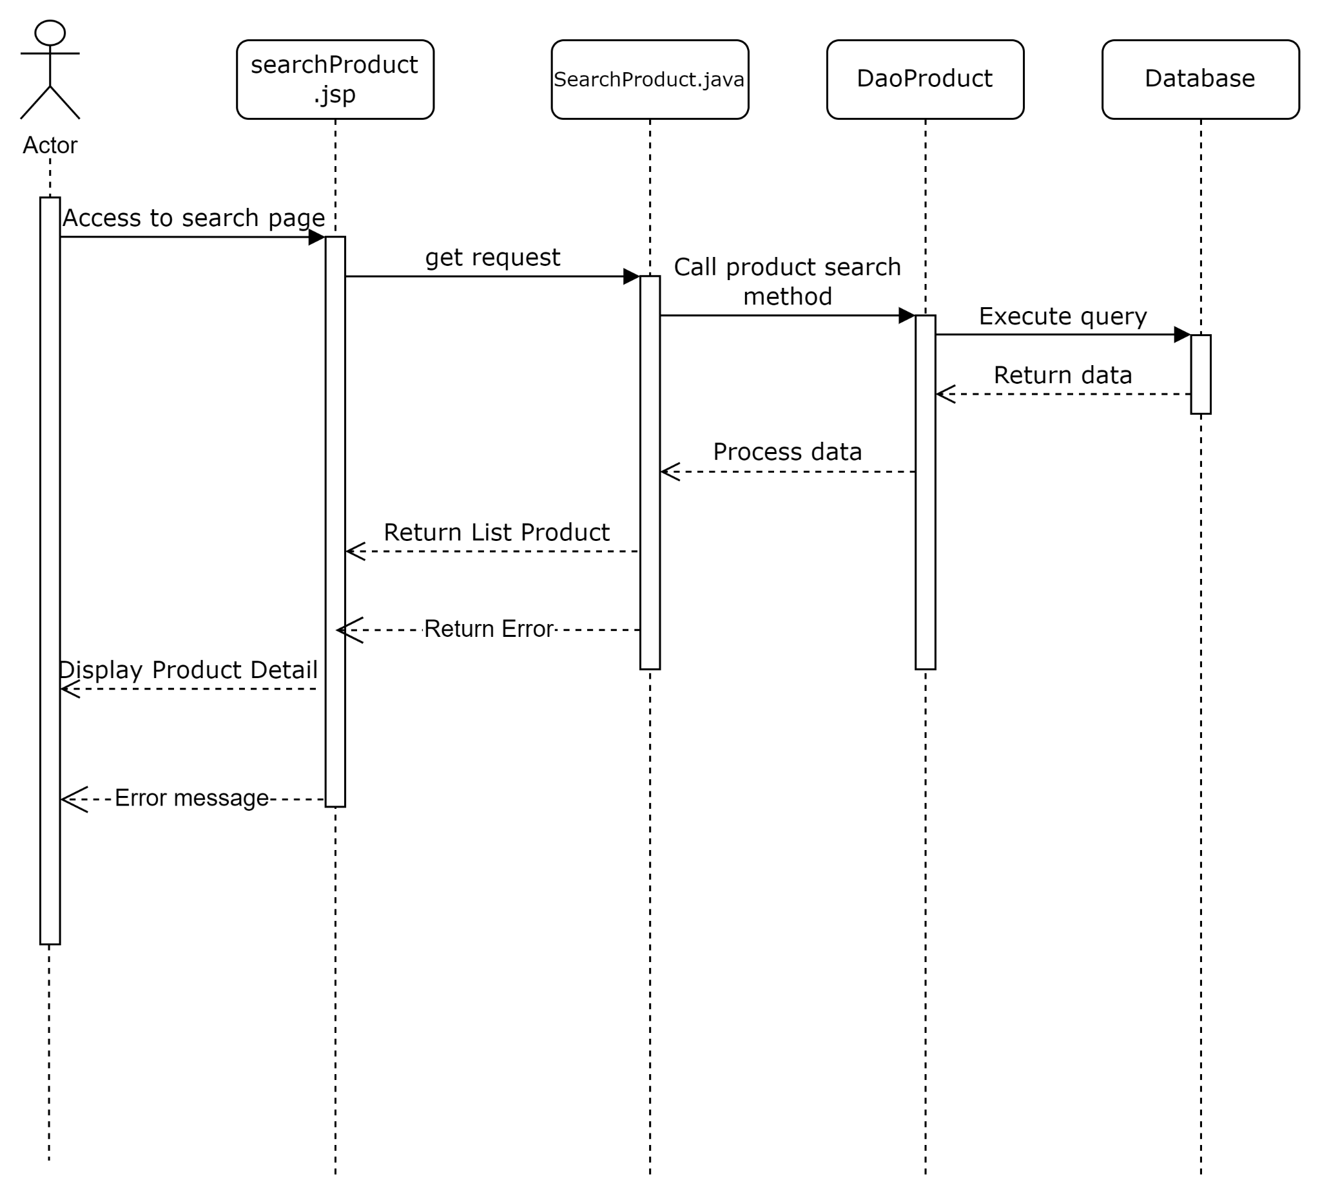

#### View all product

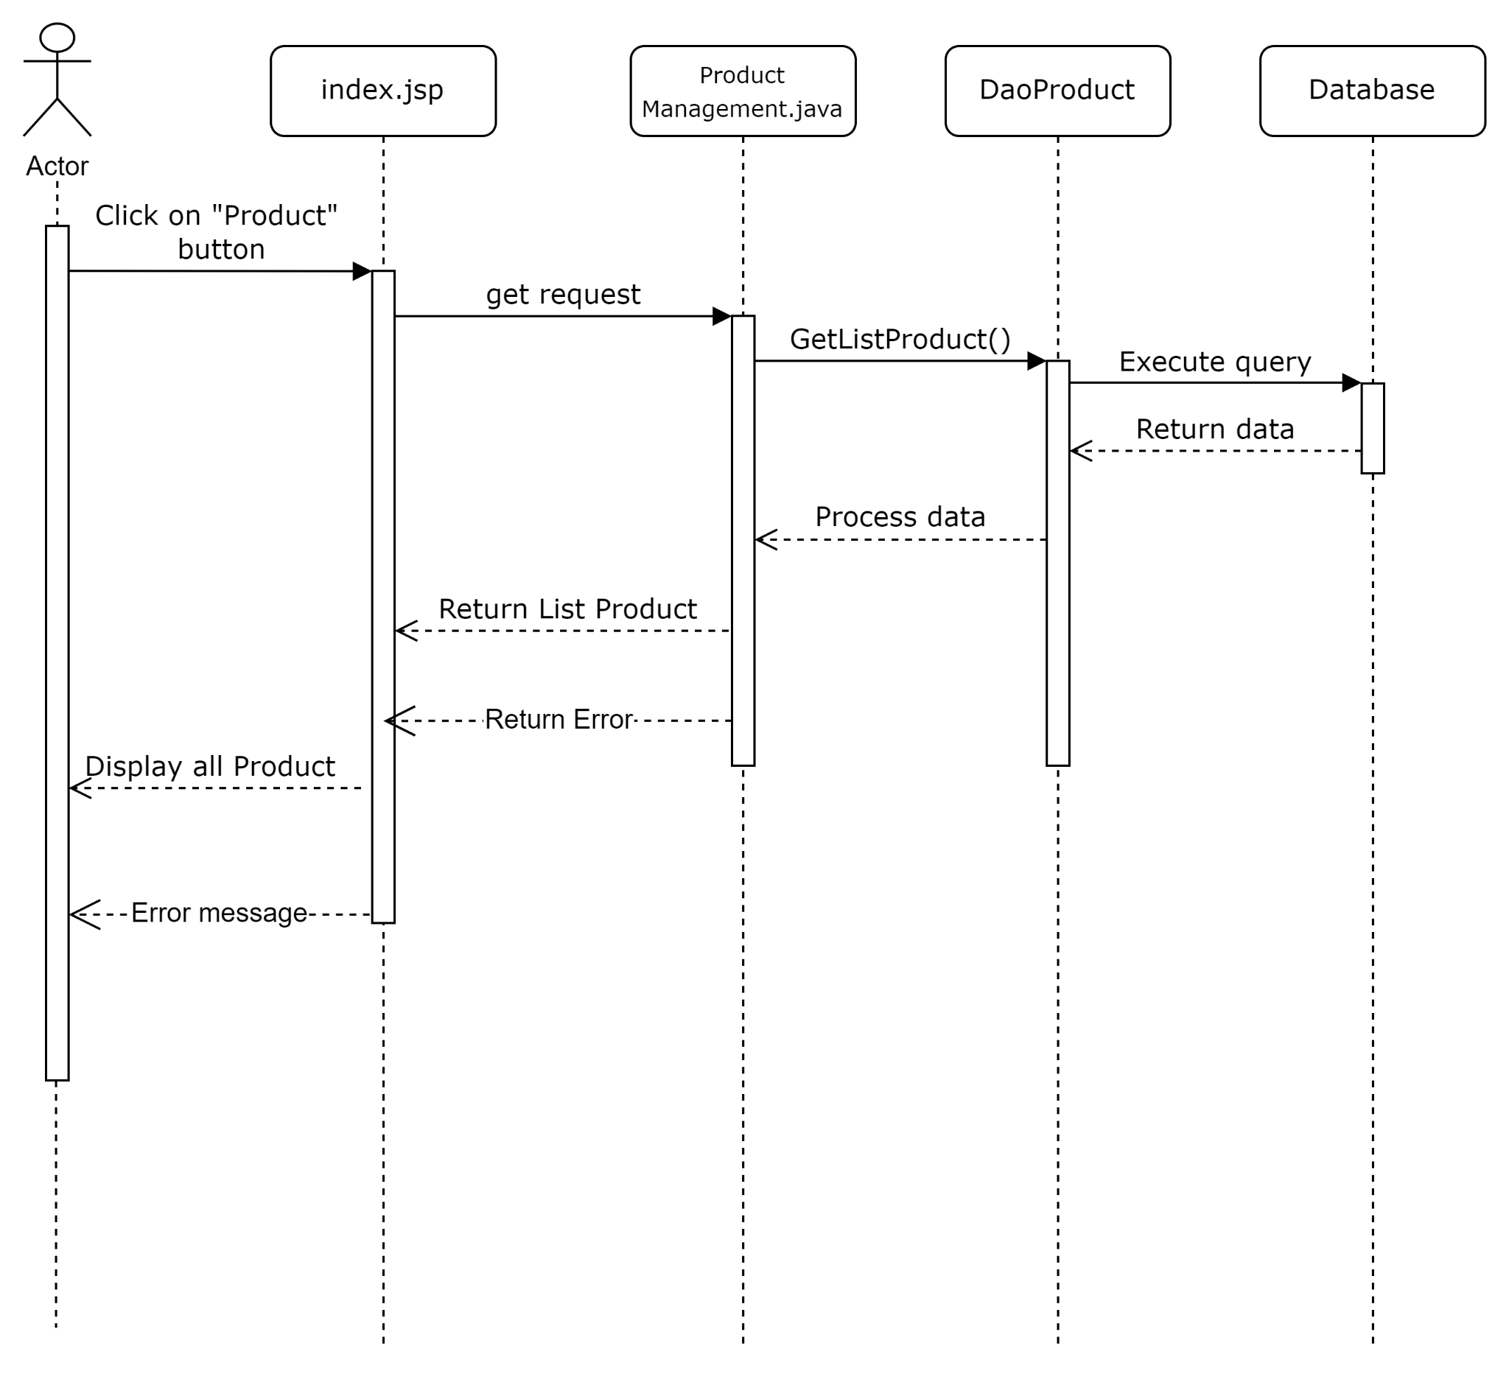

#### Add Product

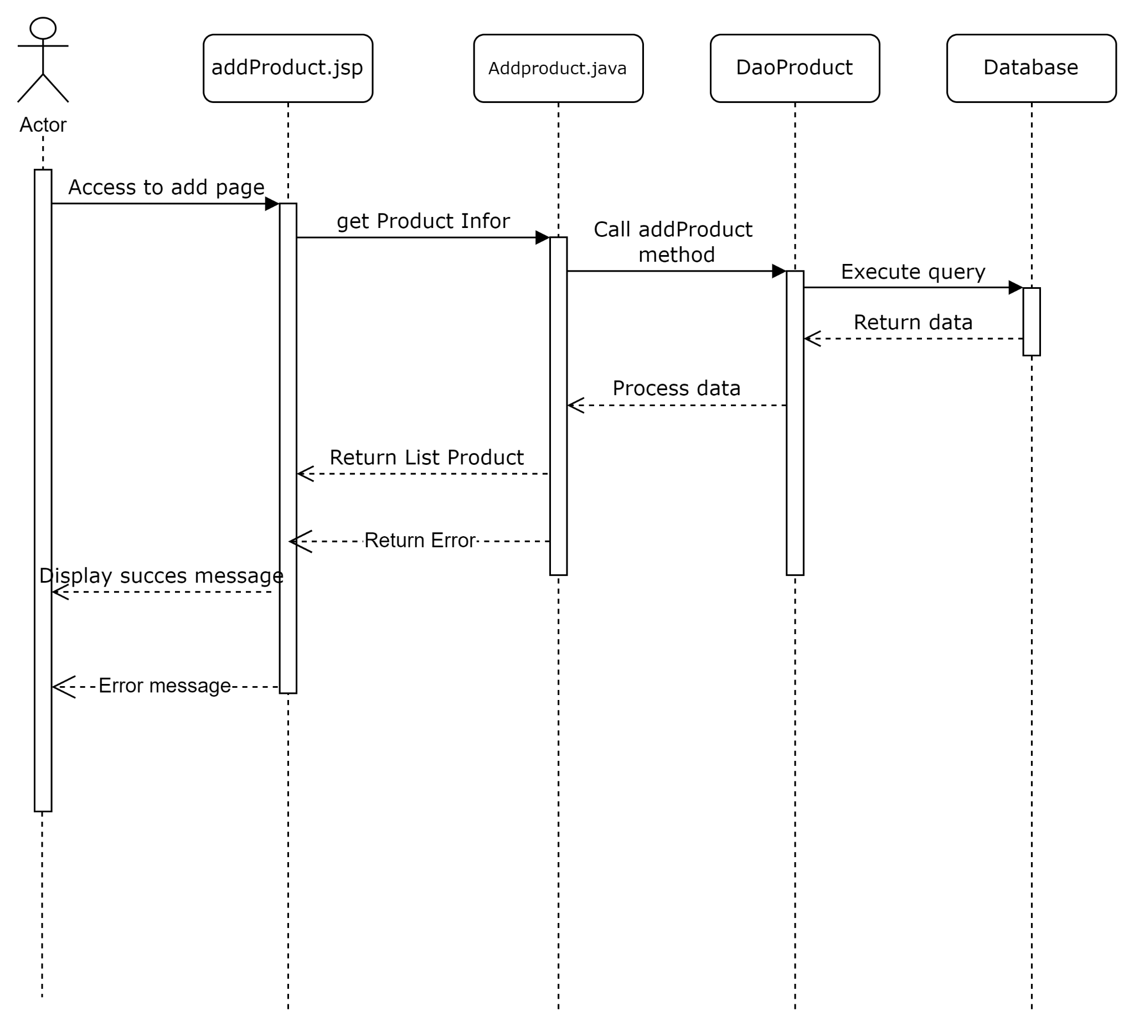

#### Edit product

## 6. Public News

### a. Class Diagram

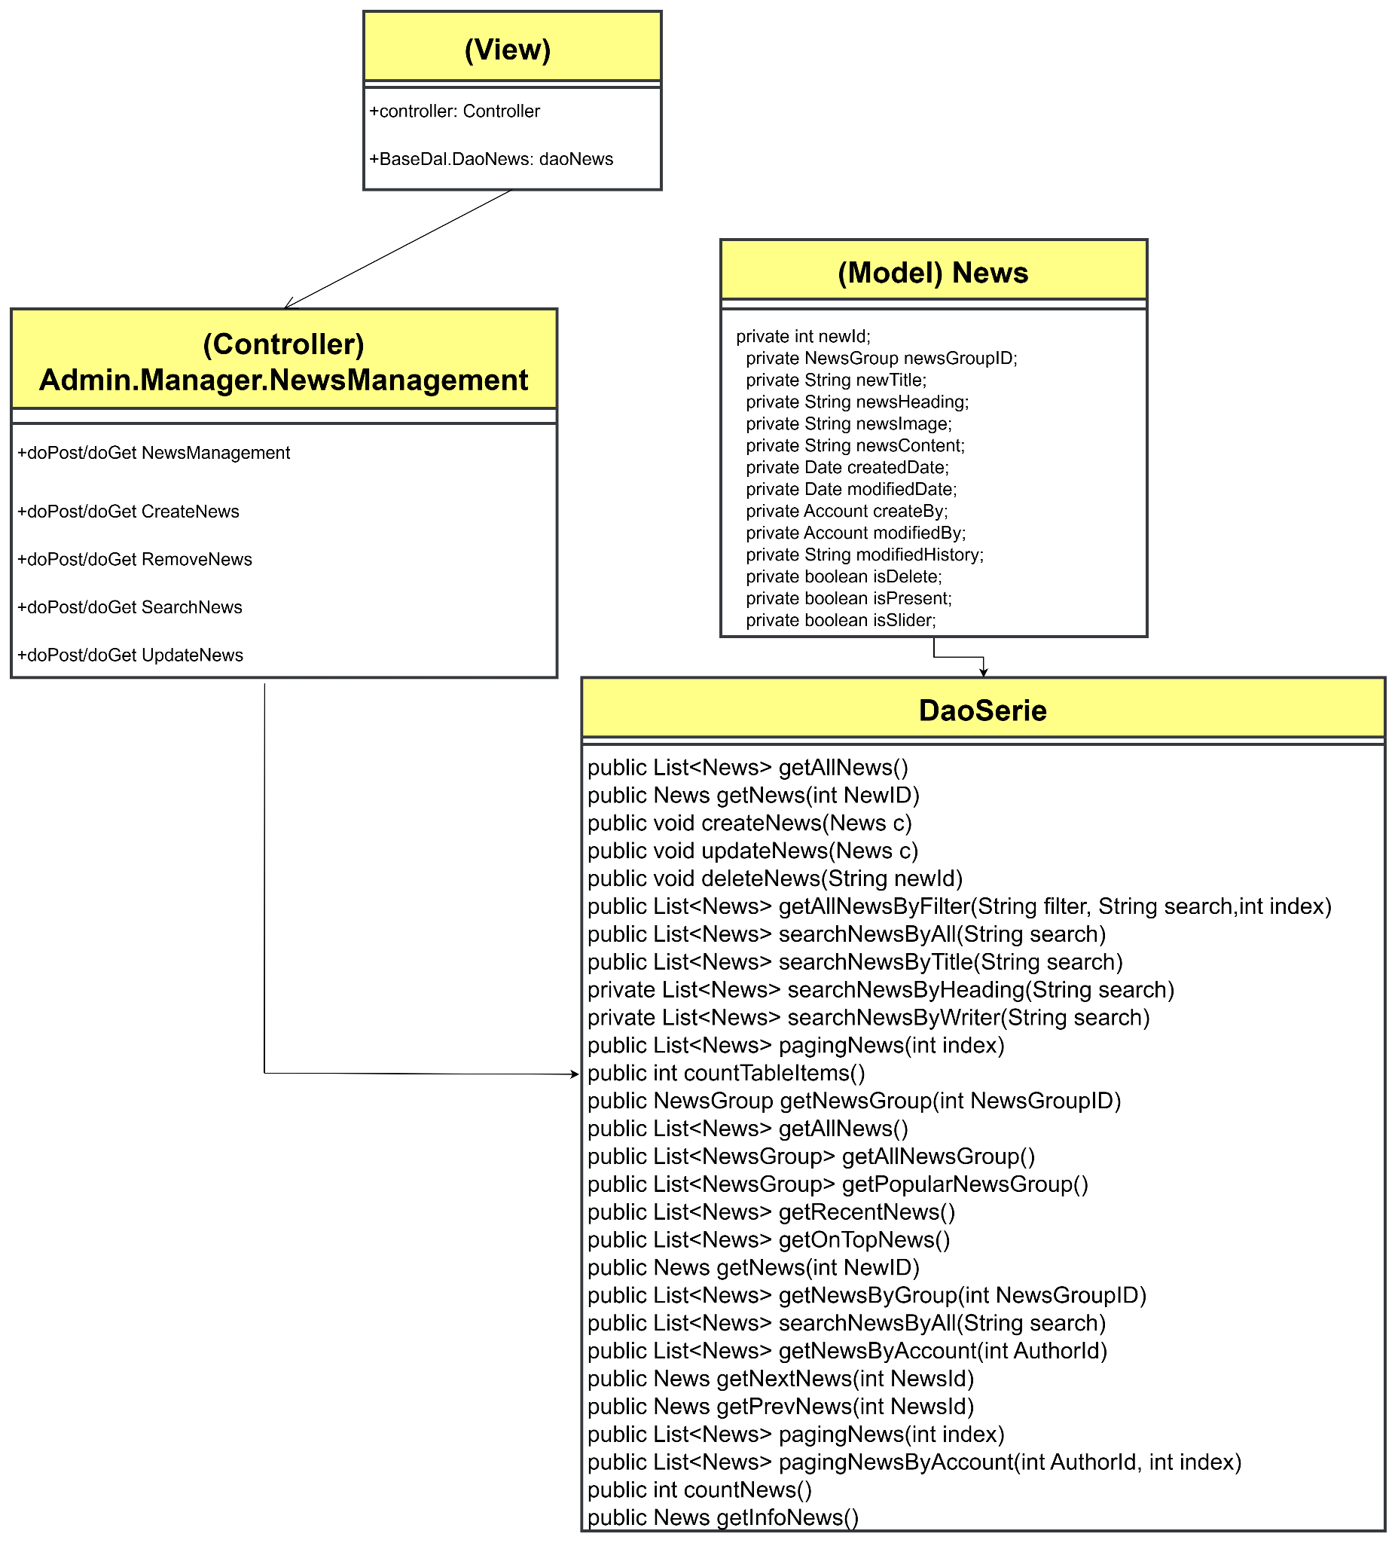

### b. Class Specifications

#### NewsDAO

| **No** | **Method** | **Description** |
| --- | --- | --- |
| 01 | public List<News> getAllNews() | Handle request get all news |
| 02 | public News getNews(int NewID) | Handle request news by id |
| 03 | public void createNews(News c) | Handle request created news |
| 04 | public void updateNews(News c) | Handle request update news |
| 05 | public void deleteNews(String newId) | Handle request delete news by newsID |
| 06 | public List<News> getAllNewsByFilter(String filter, String search,int index) | Handle request search News by filter |
| 07 | public List<News> searchNewsByAll(String search) | Handle request search by all |
| 08 | public List<News> searchNewsByTitle(String search) | Handle request search by title |
| 09 | private List<News> searchNewsByHeading(String search) | Handle request search by heading |
| 10 | private List<News> searchNewsByWriter(String search) | Handle request search by writter |
| 11 | public List<News> pagingNews(int index) | Handle request paging news |
| 12 | public int countTableItems() | Handle request paging news |

#### New DAO Client

| **No** | **Method** | **Description** |
| --- | --- | --- |
| 01 | public NewsGroup getNewsGroup(int NewsGroupID) | Handle request get News Group by id |
| 02 | public List<News> getAllNews() | Handle request get all news |
| 03 | public List<NewsGroup> getAllNewsGroup() | Handle request get all newsgroup |
| 04 | public List<NewsGroup> getPopularNewsGroup() | Handle request get top 4 popular newsgroup |
| 05 | public List<News> getRecentNews() | Handle request get top 3 new News |
| 06 | public List<News> getOnTopNews() | Handle request get on top 4 news random |
| 07 | public News getNews(int NewID) | Handle request get news by id |
| 08 | public List<News> getNewsByGroup(int NewsGroupID) | Handle request get news by newsgroup |
| 09 | public List<News> searchNewsByAll(String search) | Handle request search news by all |
| 10 | public List<News> getNewsByAccount(int AuthorId) | Handle request get news by account |
| 11 | public News getNextNews(int NewsId) | Handle request get next news |
| 12 | public News getPrevNews(int NewsId) | Handle request get pre news |
| 13 | public List<News> pagingNews(int index) | Handle request paging news home |
| 14 | public List<News> pagingNewsByAccount(int AuthorId, int index) | Handle request paging news at author |
| 15 | public int countNews() | Handle request paging news |
| 16 | public News getInfoNews() | Handle request get information of company for footer |

### c. Sequence Diagram(s)

#### View list news

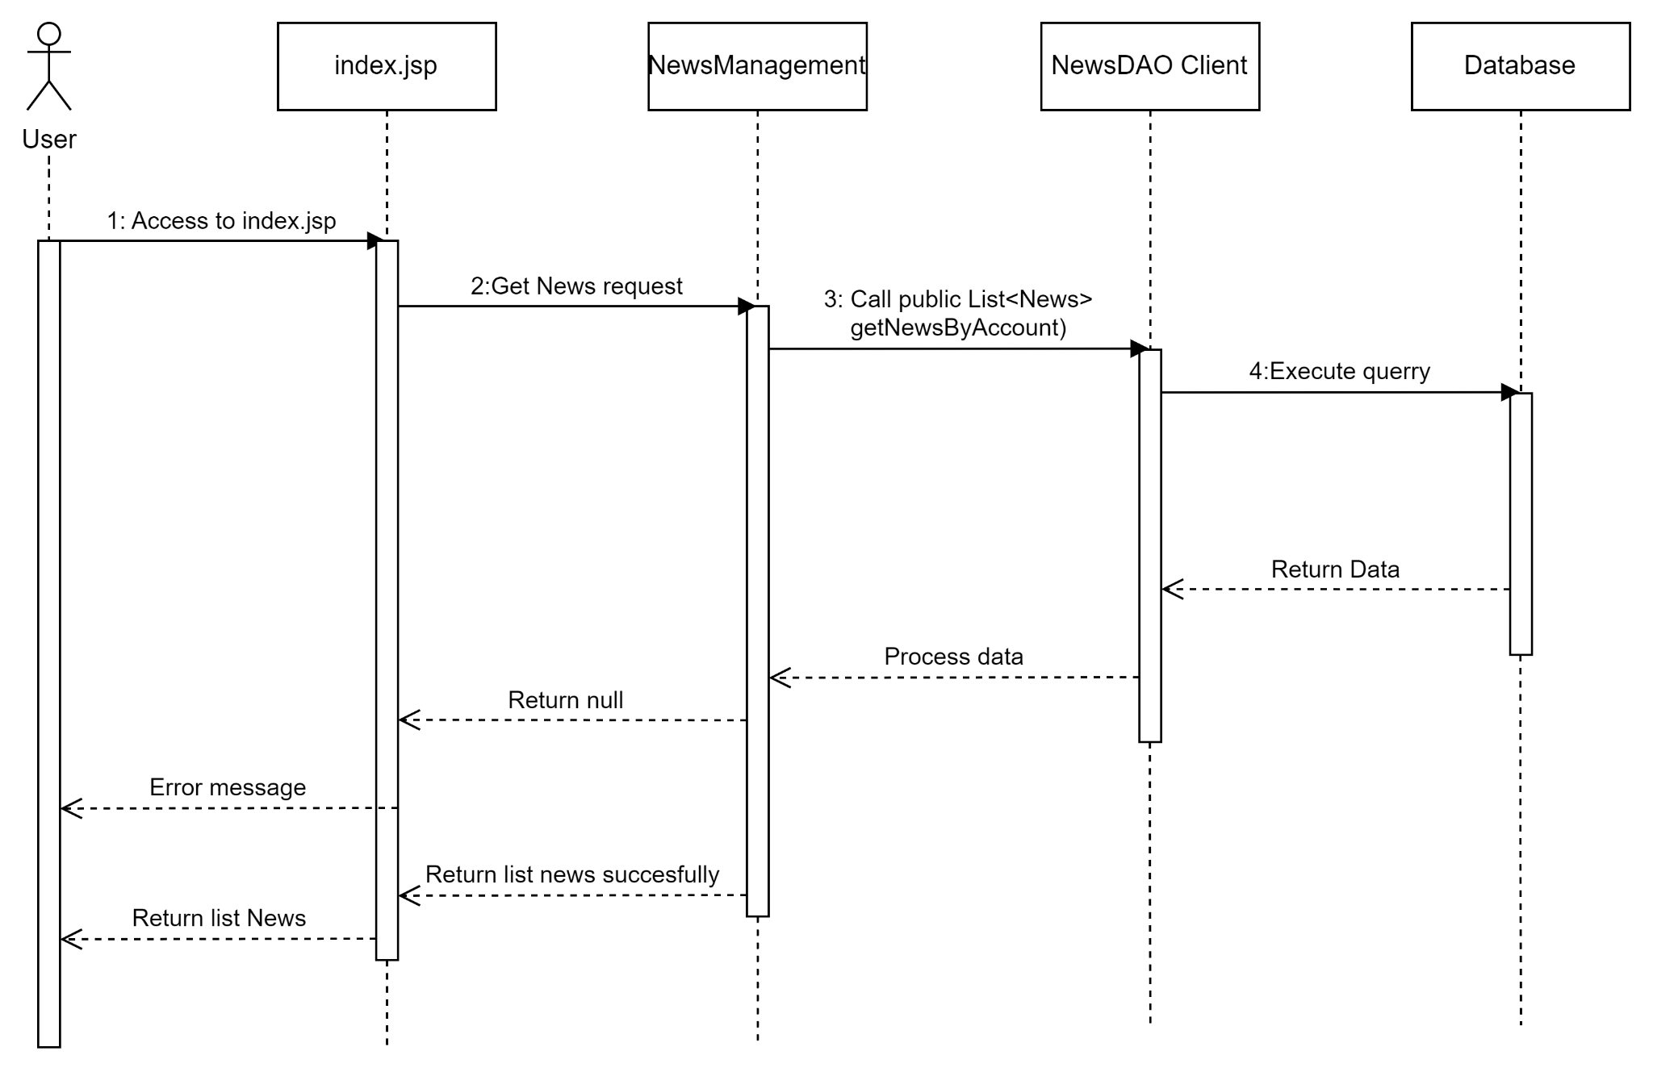

#### Add news

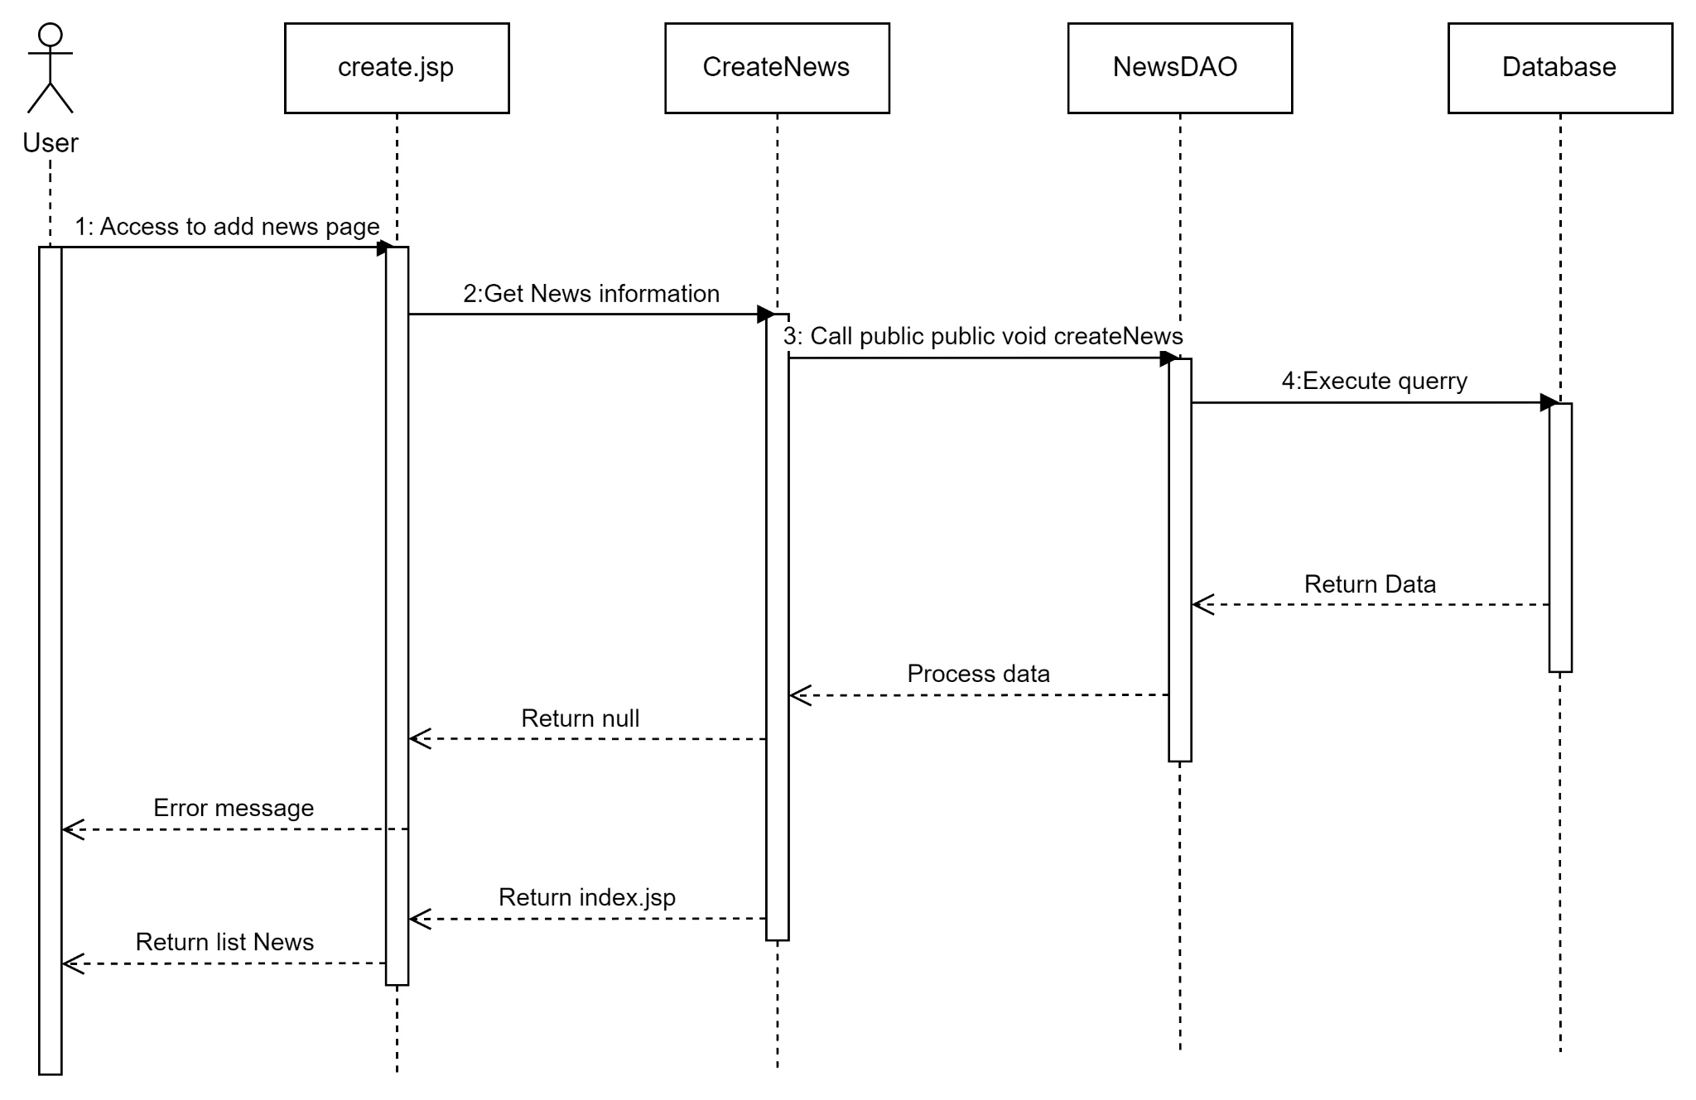

#### Update news

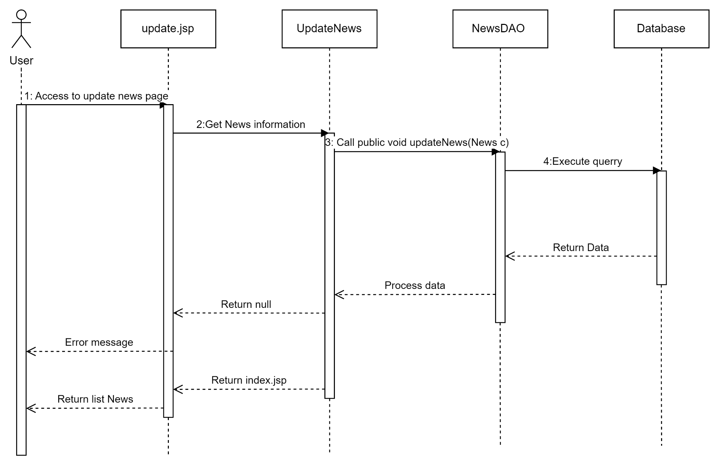

#### Delete news status

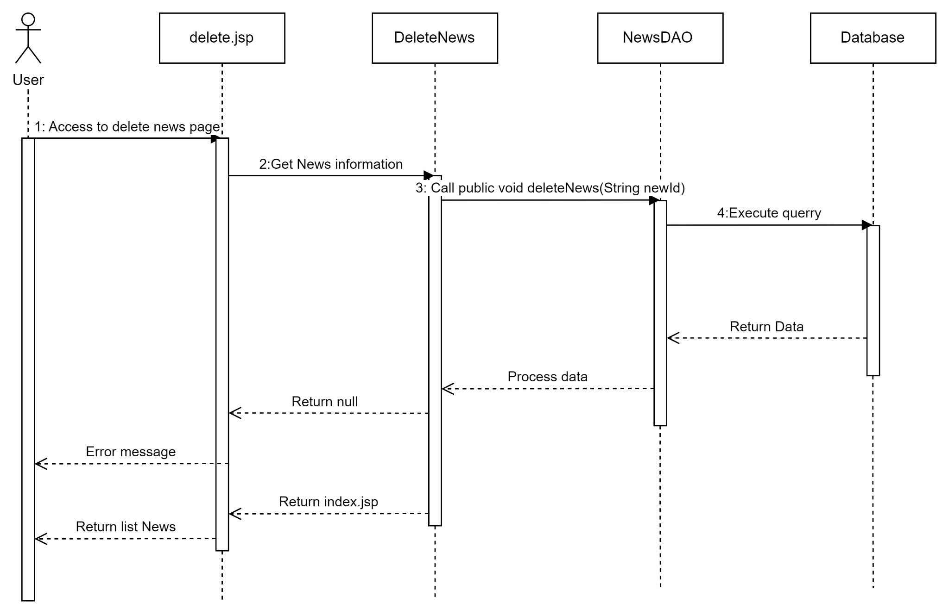

#### Search news

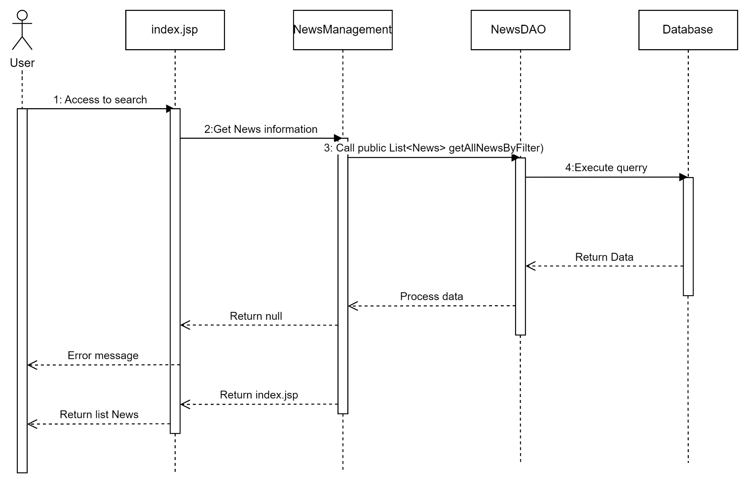

#### Show news home

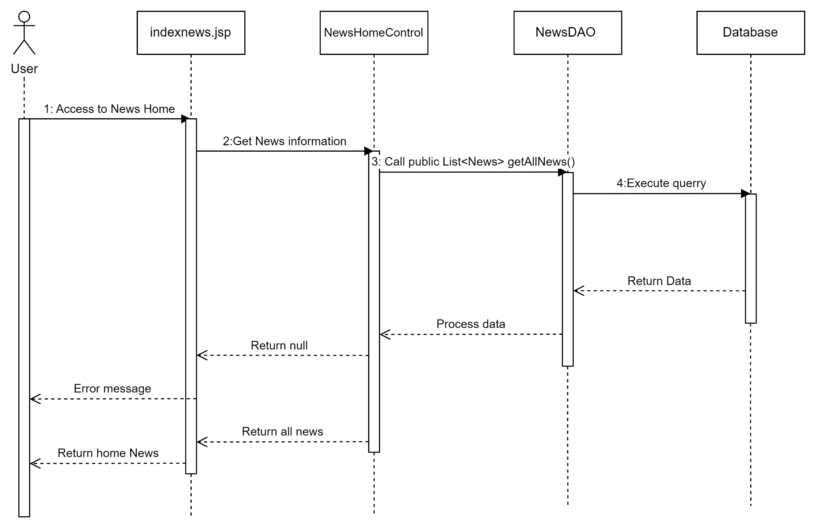

#### 

## 7. Public Category

### a. Class Diagram

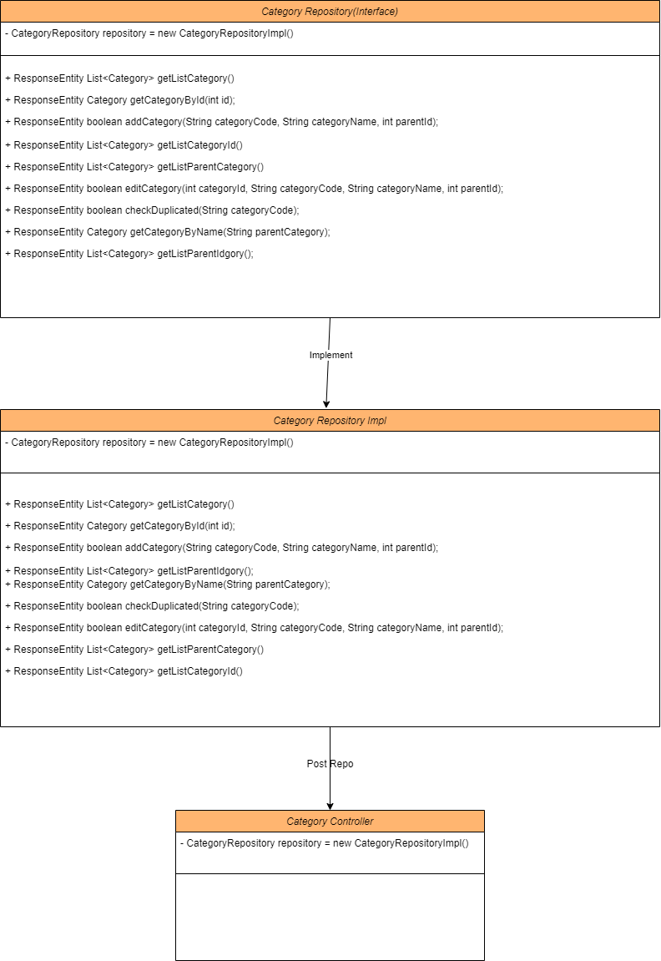

### b. Class Specifications

#### XYZ Class

| **No** | **Method** | **Description** |
| --- | --- | --- |
| 01 | public List<Category> getListCategory() | Handle request get list category |
| 02 | public Category getCategoryById(int id) | Handle request get category by ID |
| 03 | public boolean addCategory(String categoryCode, String categoryName, int parentId) | Handle request add category |
| 04 | public List<Category> getListCategoryId() | Handle request get list categoryID |
| 05 | public List<Category> getListParentCategory() | Handle request get list parent category |
| 06 | public boolean editCategory(int categoryId, String categoryCode, String categoryName, int parentId) | Handle request edit category |
| 07 | public boolean checkDuplicated(String categoryCode) | Handle request check duplicated category |
| 08 | public Category getCategoryByName(String parentCategory) | Handle request get category by name |
| 09 | public List<Category> getListParentIdgory() | Handle request list parentID |

### c. Sequence Diagram(s)

#### View list category

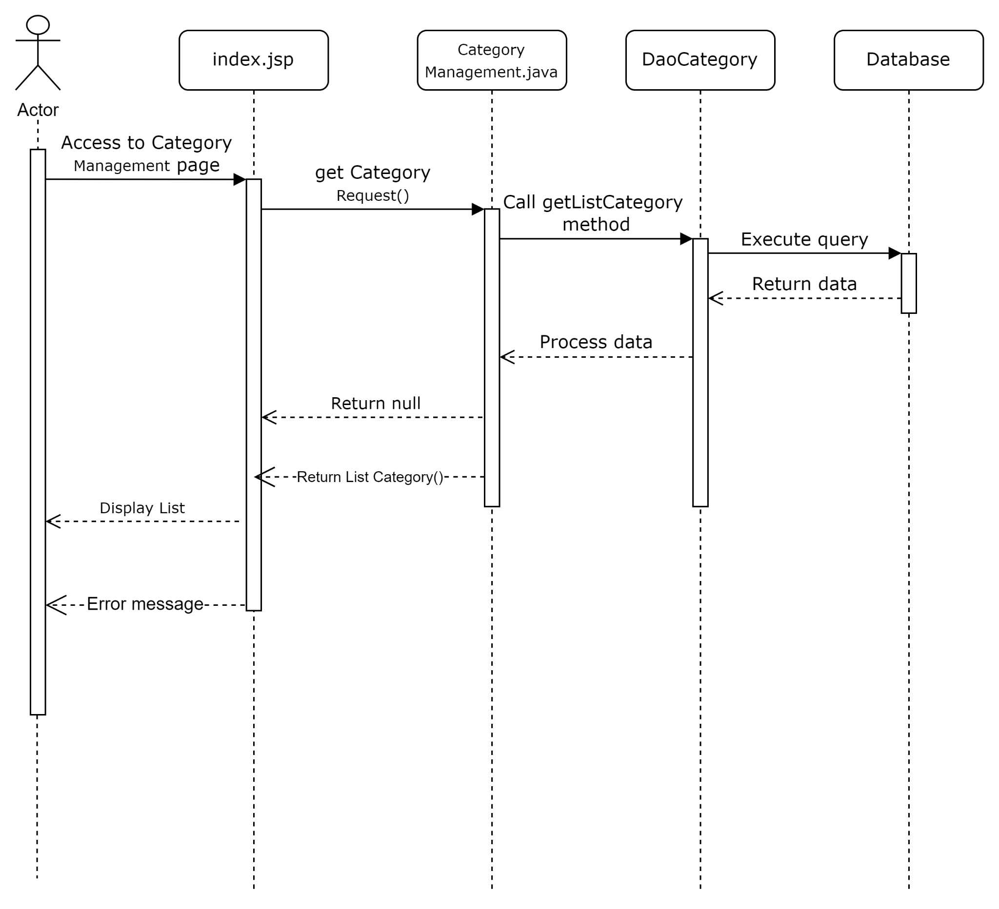

#### Add category

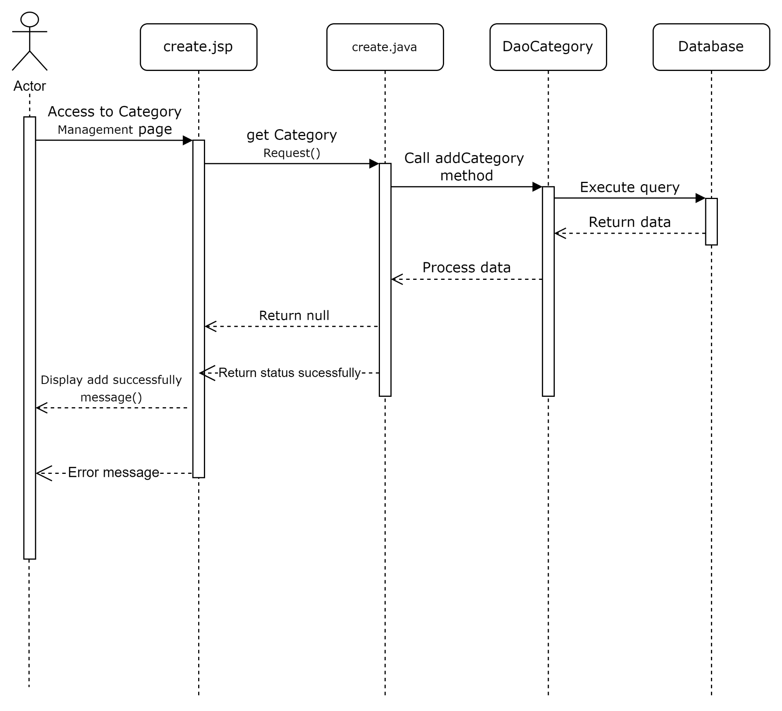

#### Edit category

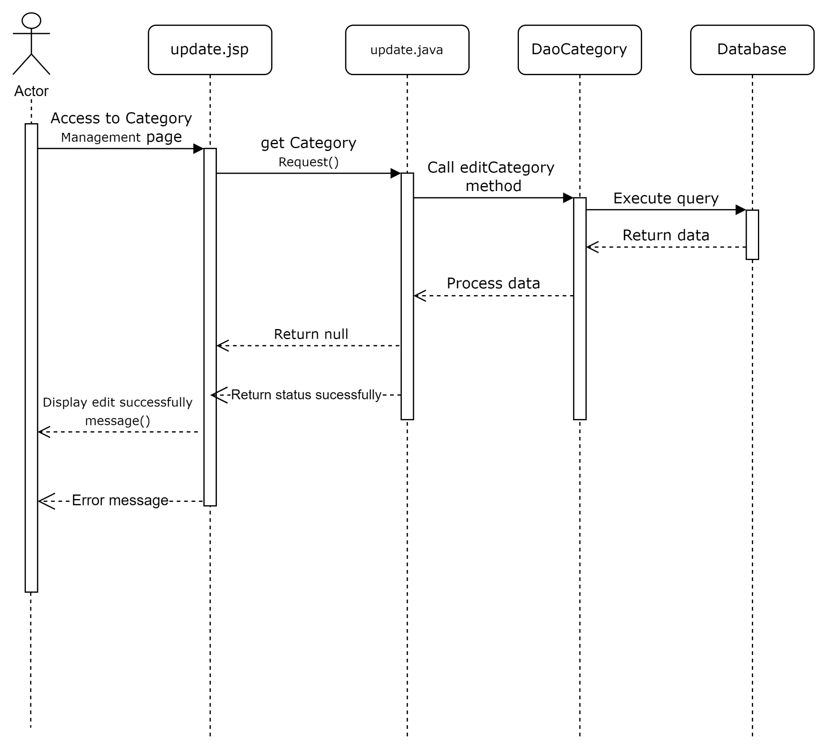

## 8.Public Warranty

### a. Class Diagram

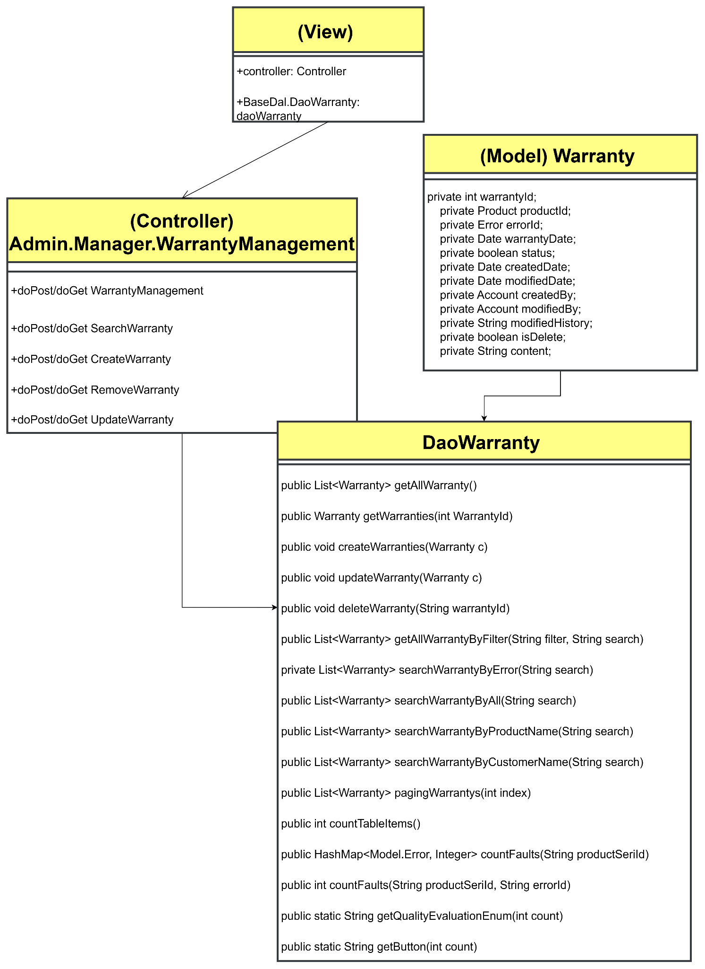

### b. Class Specifications

#### **Warranties DAO admin**

| **No** | **Method** | **Description** |
| --- | --- | --- |
| 01 | public List<Warranty> getAllWarranty() | Handle request get all Warranties |
| 02 | public Warranty getWarranties(int WarrantyId) | Handle request get Warranties by id |
| 03 | public void createWarranties(Warranty c) | Handle request created Warranties |
| 04 | public void updateWarranty(Warranty c) | Handle request update Warranties |
| 05 | public void deleteWarranty(String warrantyId) | Handle request delete Warranties by ID |
| 06 | public List<Warranty> getAllWarrantyByFilter(String filter, String search) | Handle request search Warranties by filter |
| 07 | private List<Warranty> searchWarrantyByError(String search) | Handle request search by Error |
| 08 | public List<Warranty> searchWarrantyByAll(String search) | Handle request search all |
| 09 | public List<Warranty> searchWarrantyByProductName(String search) | Handle request search by name |
| 10 | public List<Warranty> searchWarrantyByCustomerName(String search) | Handle request search by customer name |
| 11 | public List<Warranty> pagingWarrantys(int index) | Handle request paging Warranties |
| 12 | public int countTableItems() | Handle request paging Warranties |
| 13 | public HashMap<Model.Error, Integer> countFaults(String productSeriId) | Handle request warranty quality evaluation |
| 14 | public int countFaults(String productSeriId, String errorId) | Handle request warranty quality evaluation |
| 15 | public static String getQualityEvaluationEnum(int count) | Handle request warranty quality evaluation |
| 16 | public static String getButton(int count) | Handle request warranty quality evaluation |

### c. Sequence Diagram(s)

#### **View list Warranty**

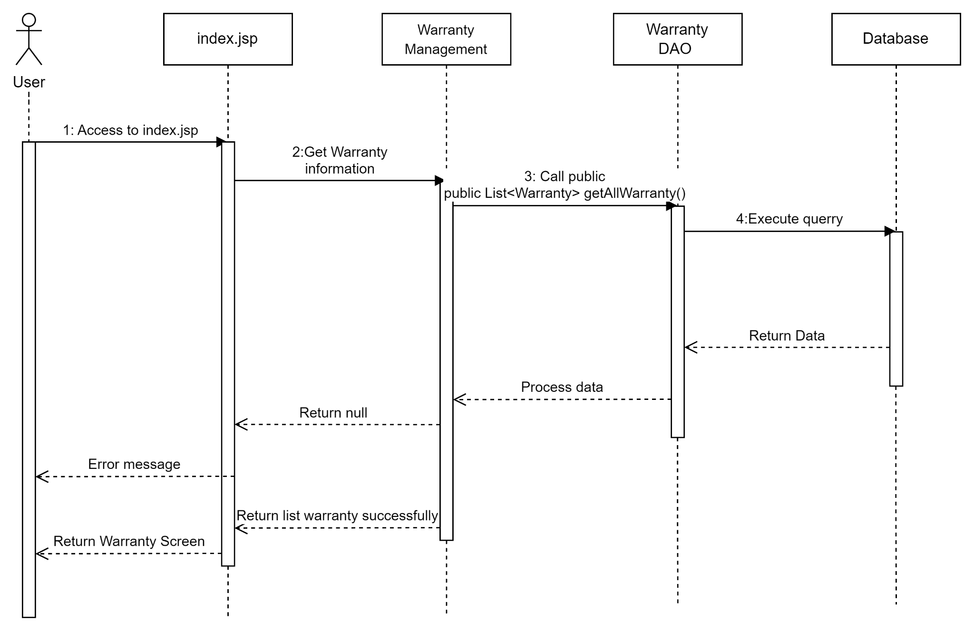

#### **Add Warranty**

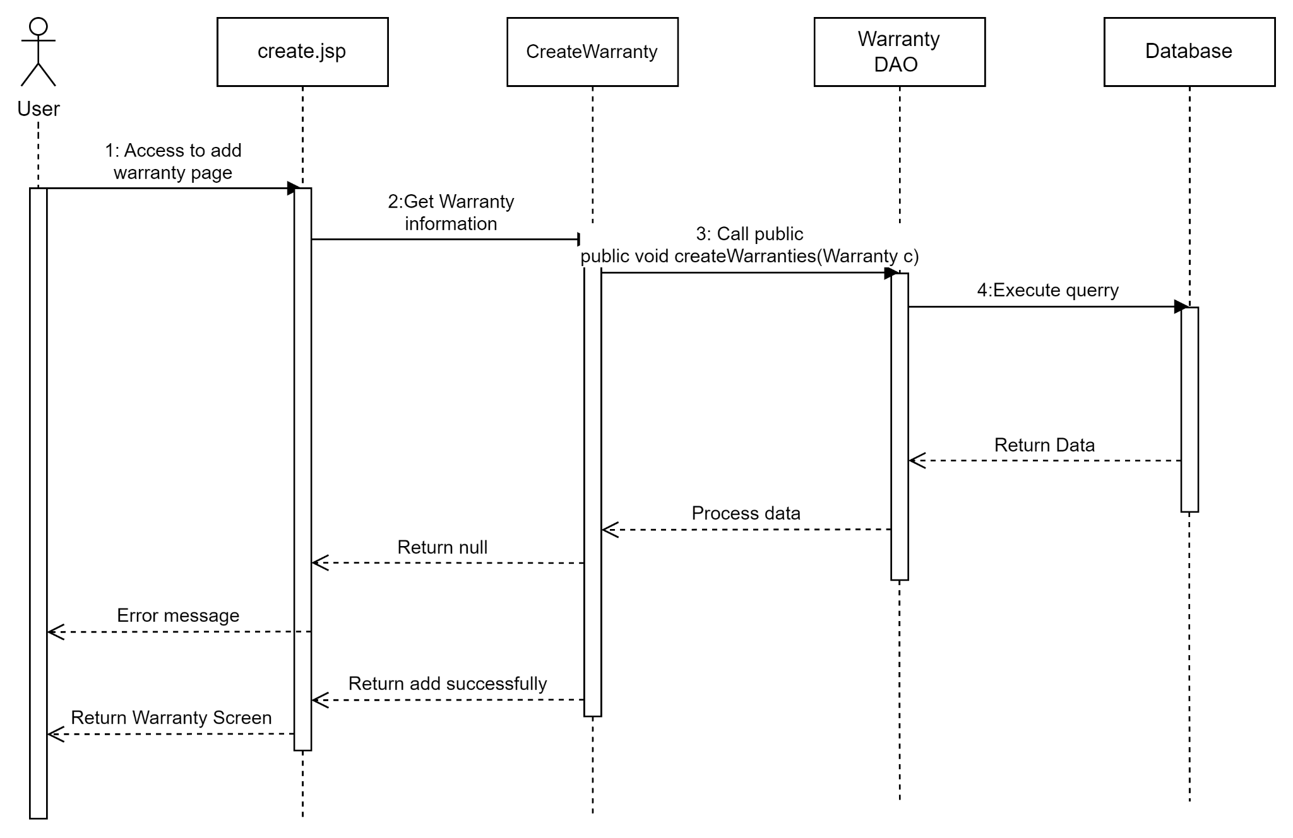

#### **Update Warranty**

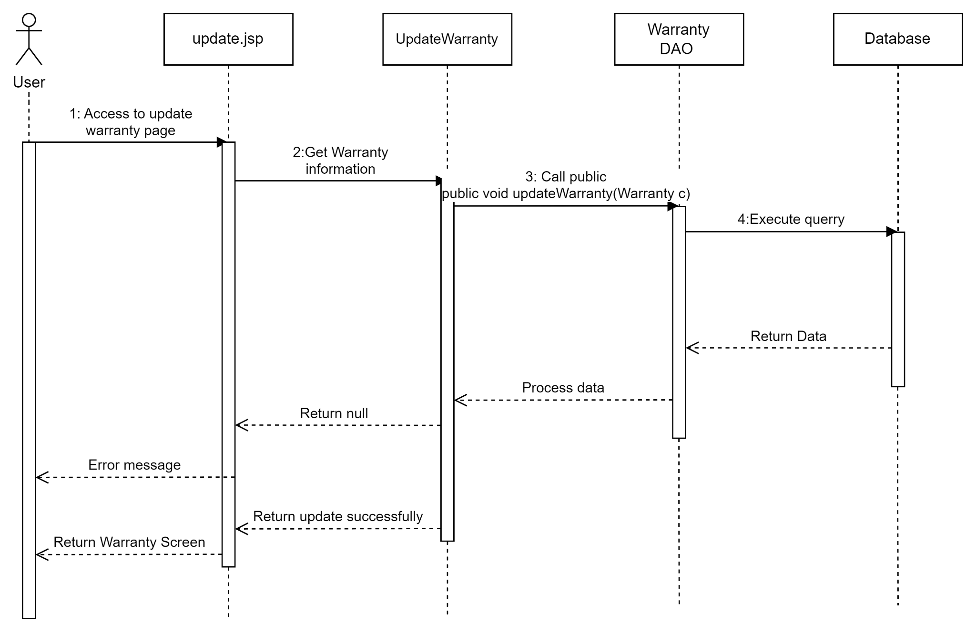

#### **Delete Warranty**

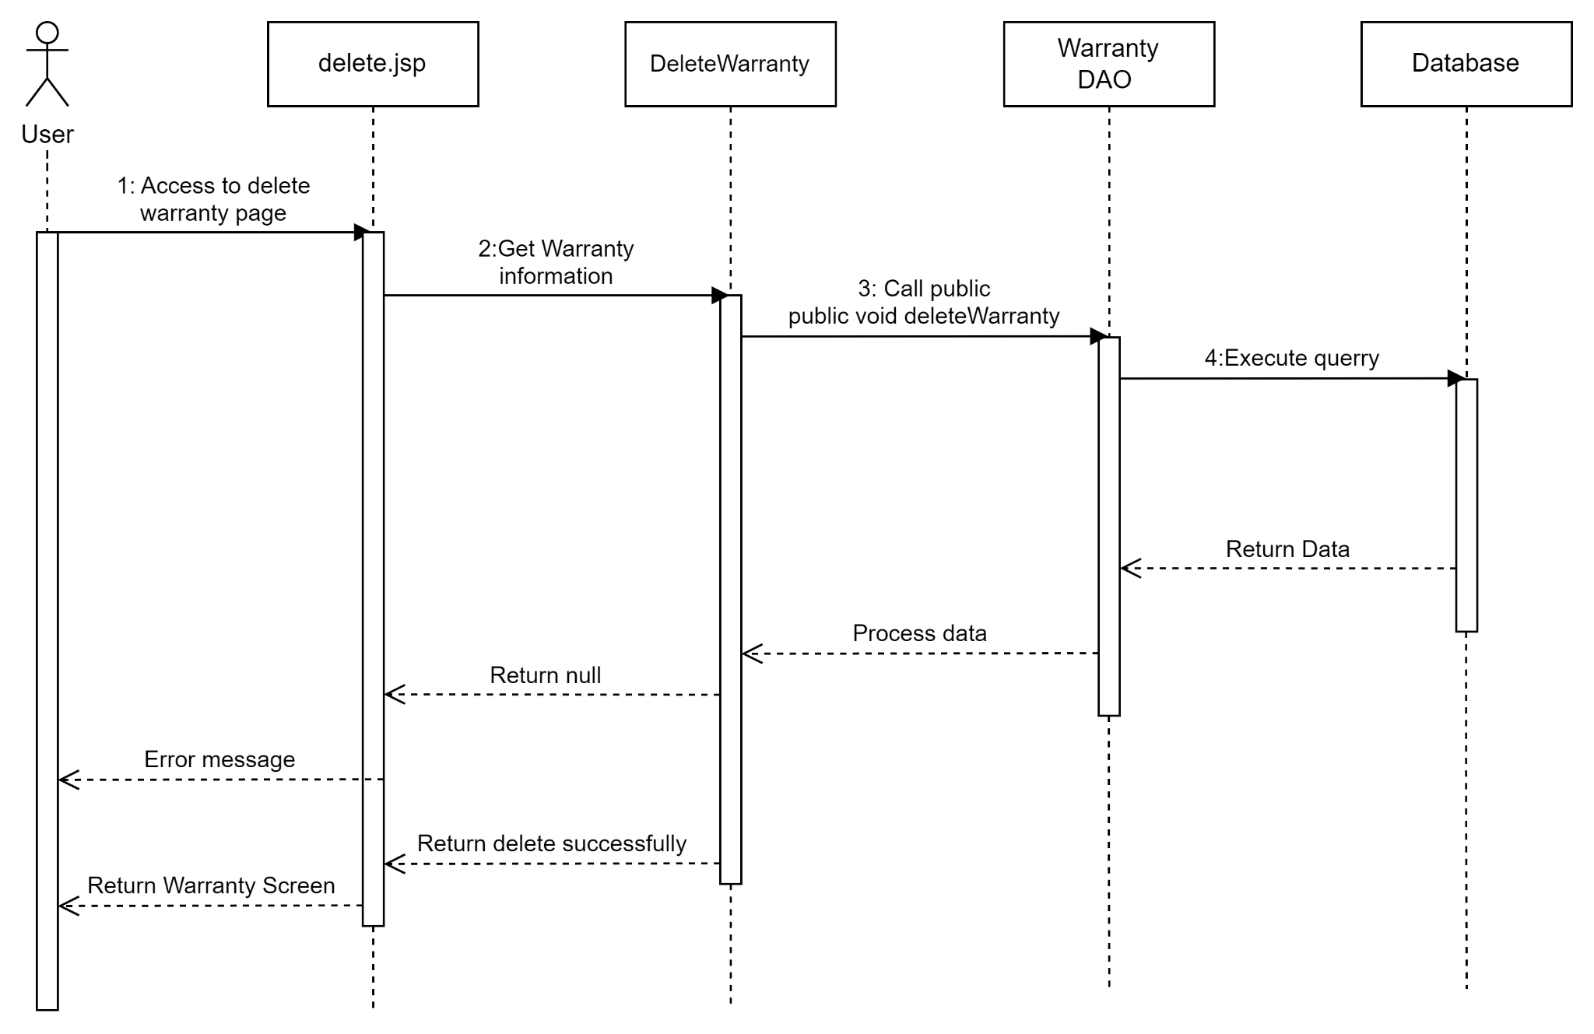

#### **Search Warranty**

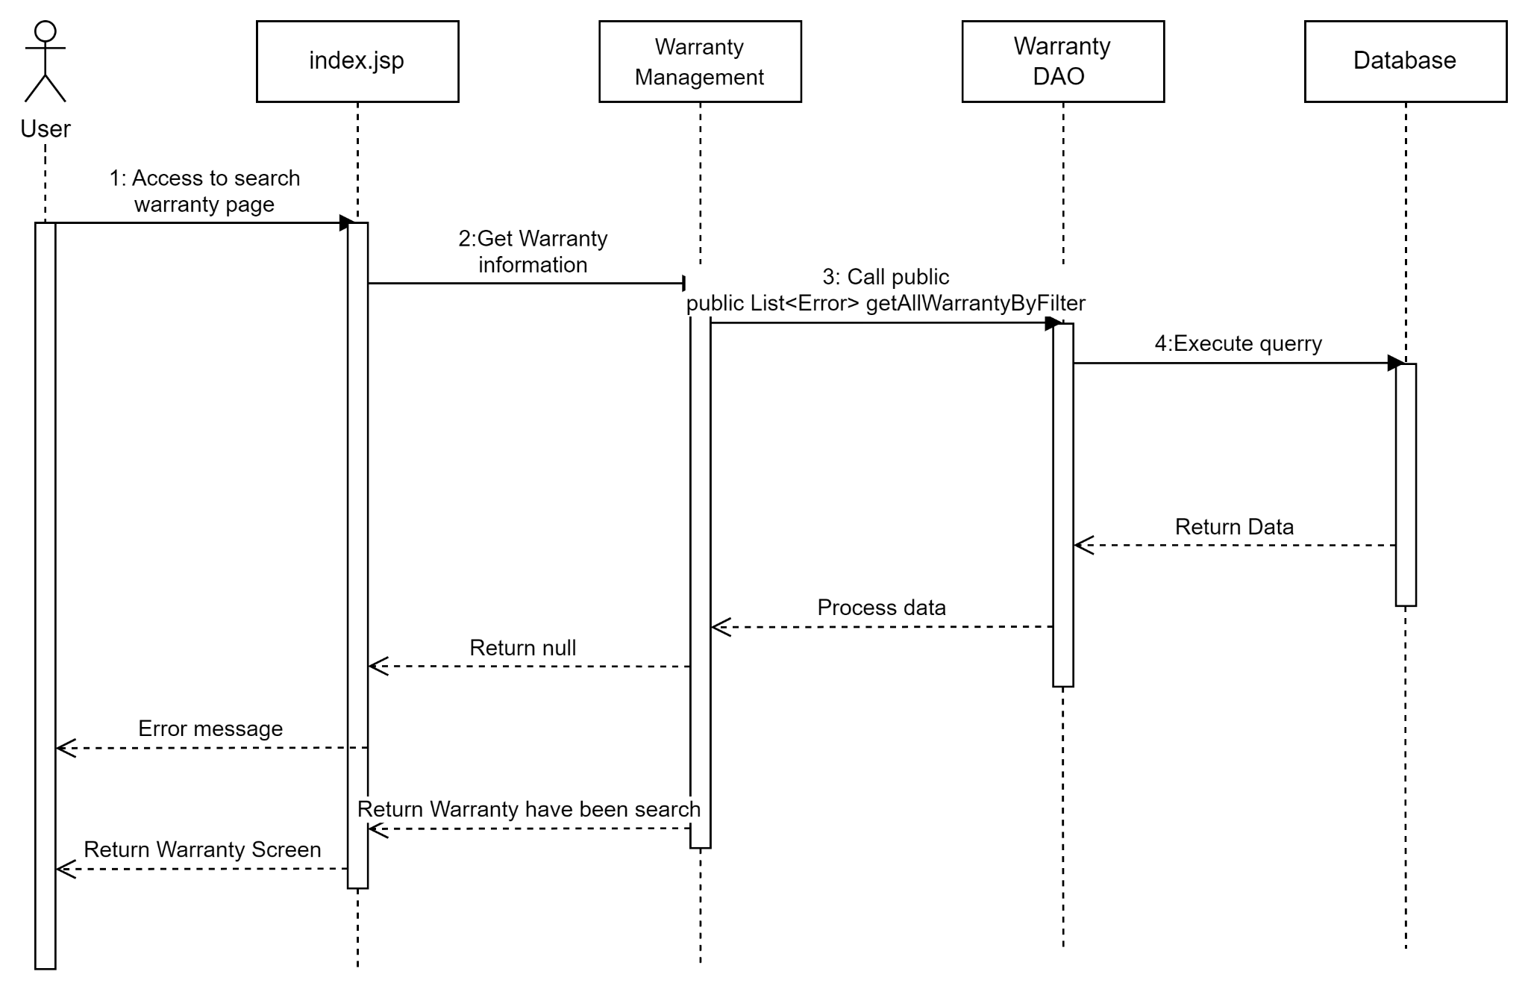

## 9.Public News Group

### a.Class Diagram

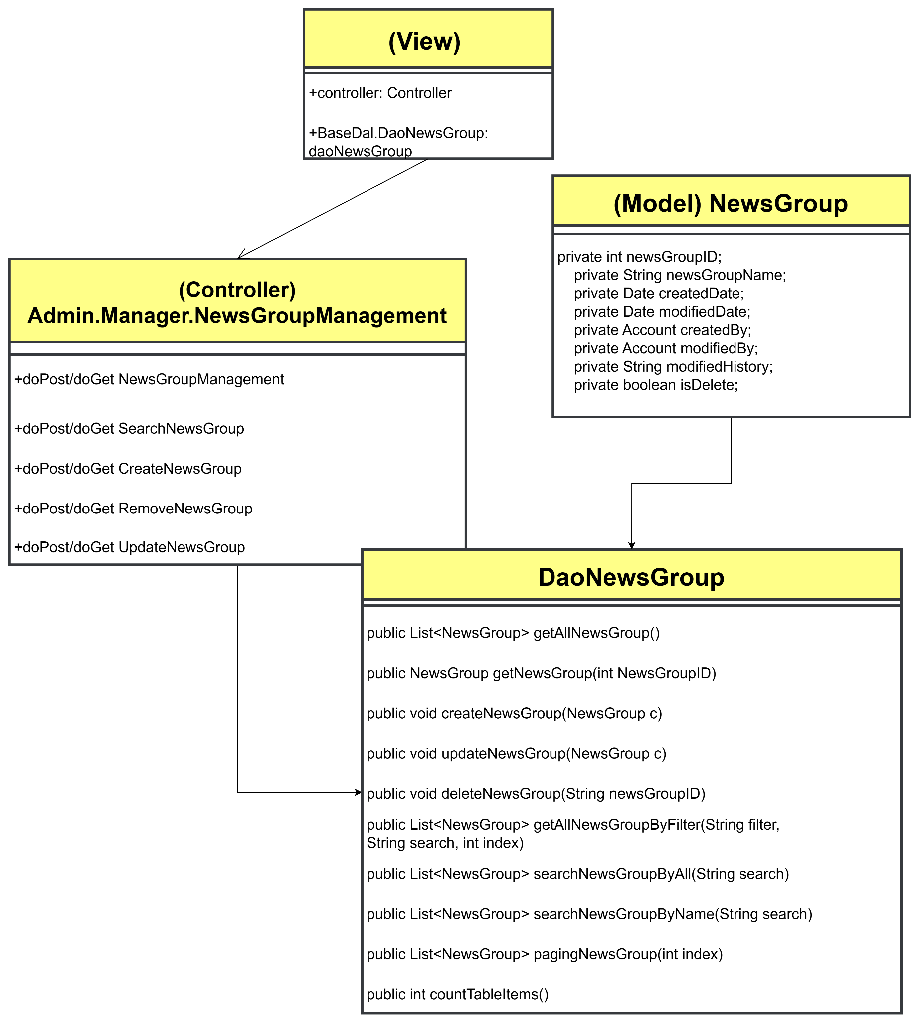

### b. Class Specifications

#### **NewsGroup DAO admin**

| **No** | **Method** | **Description** |
| --- | --- | --- |
| 01 | public List<NewsGroup> getAllNewsGroup() | Handle request get all news group |
| 02 | public NewsGroup getNewsGroup(int NewsGroupID) | Handle request news group by id |
| 03 | public void createNewsGroup(NewsGroup c) | Handle request created news group |
| 04 | public void updateNewsGroup(NewsGroup c) | Handle request update news group |
| 05 | public void deleteNewsGroup(String newsGroupID) | Handle request delete news group by ID |
| 06 | public List<NewsGroup> getAllNewsGroupByFilter(String filter, String search, int index) | Handle request search News Group by filter |
| 07 | public List<NewsGroup> searchNewsGroupByAll(String search) | Handle request search by all |
| 08 | public List<NewsGroup> searchNewsGroupByName(String search) | Handle request search by name |
| 09 | public List<NewsGroup> pagingNewsGroup(int index) | Handle request paging news group |
| 10 | public int countTableItems() | Handle request paging news group |

### c. Sequence Diagram(s)

#### **View list News Group**

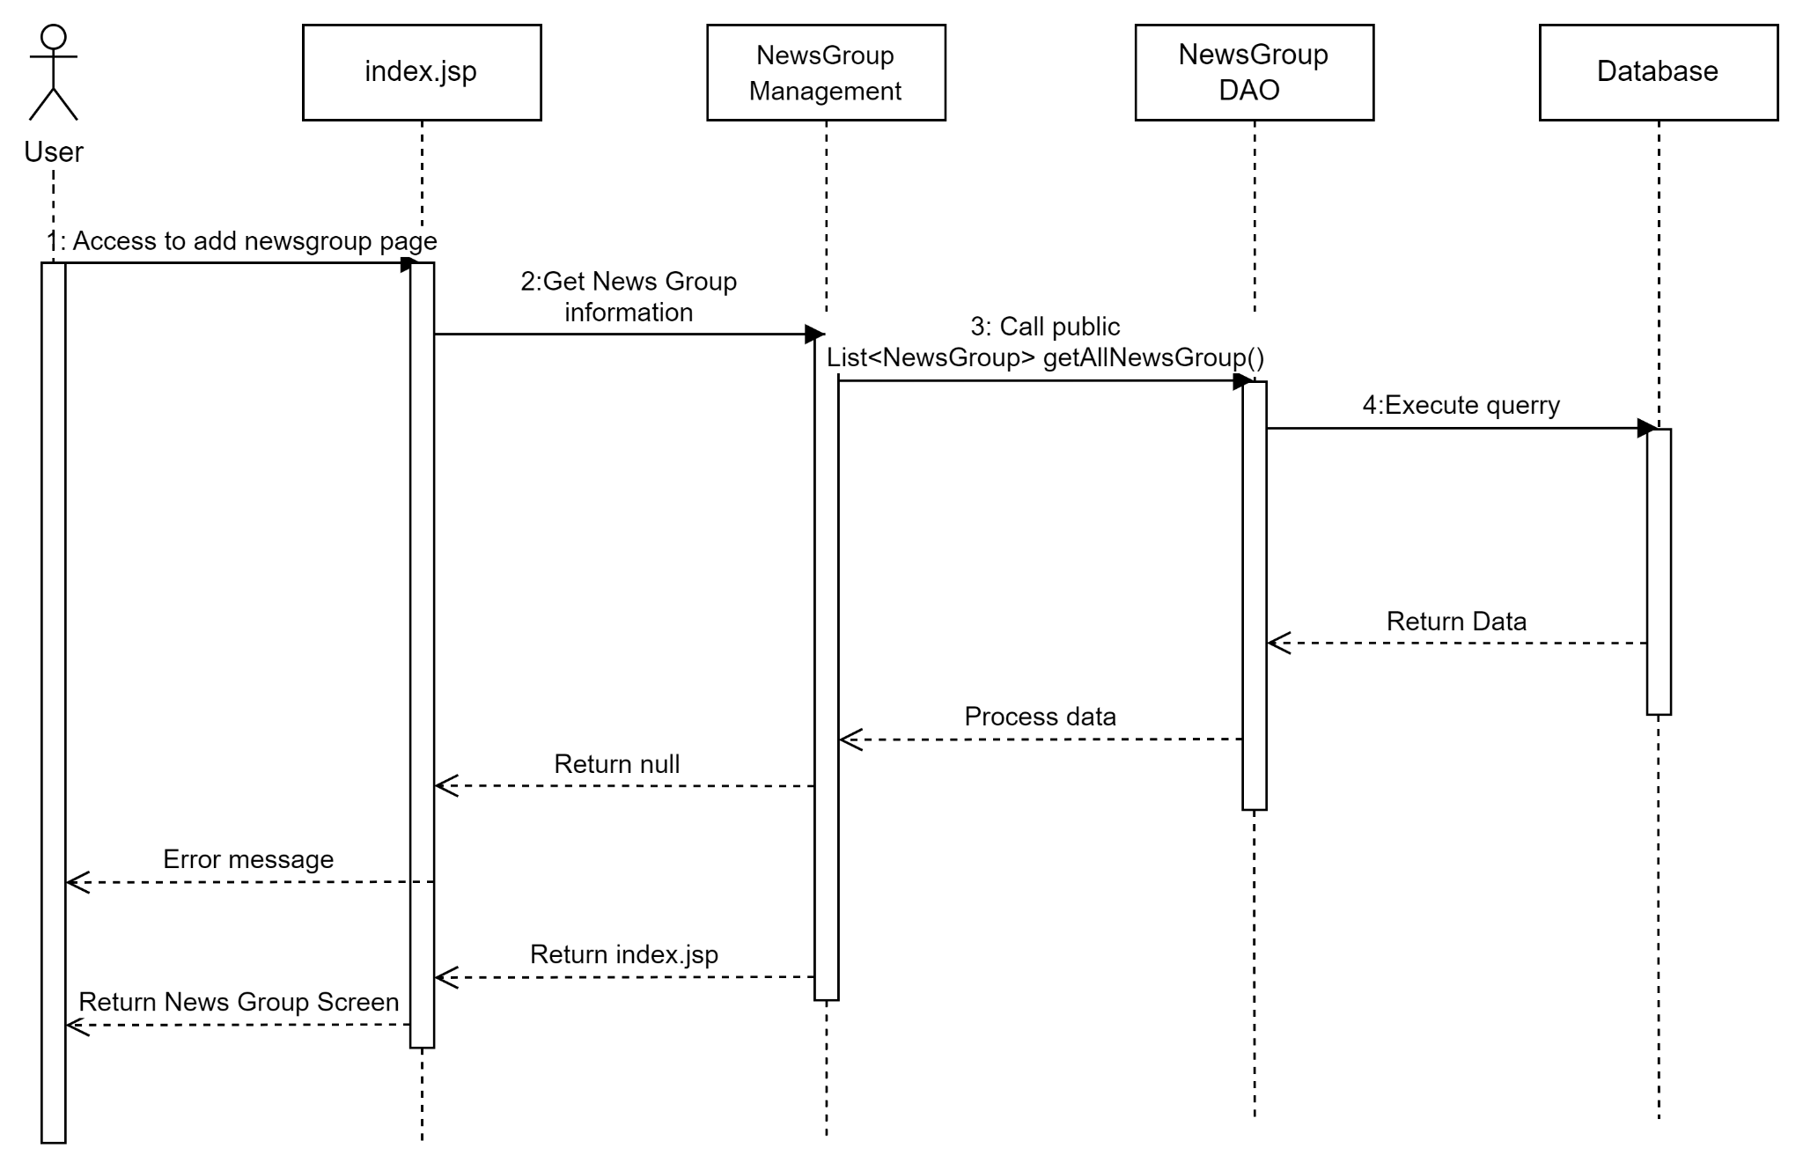

#### 

#### **Add news group**

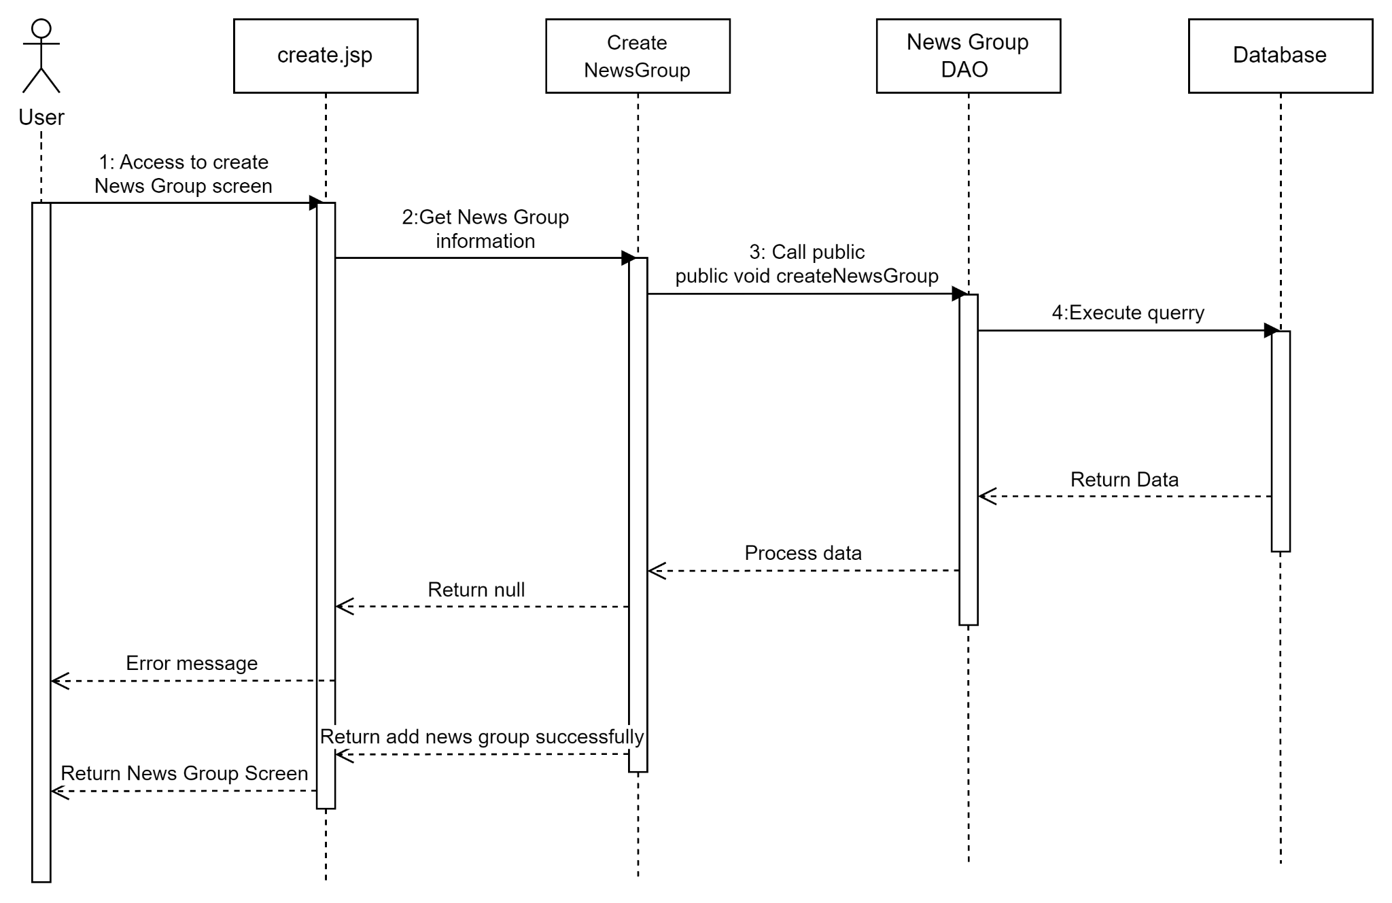

#### **Update news group**

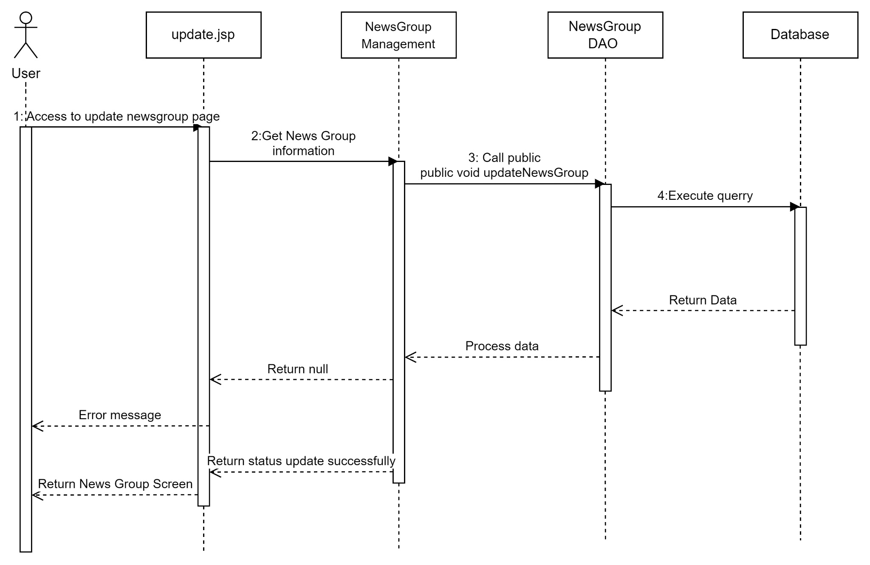

#### **Delete news group**

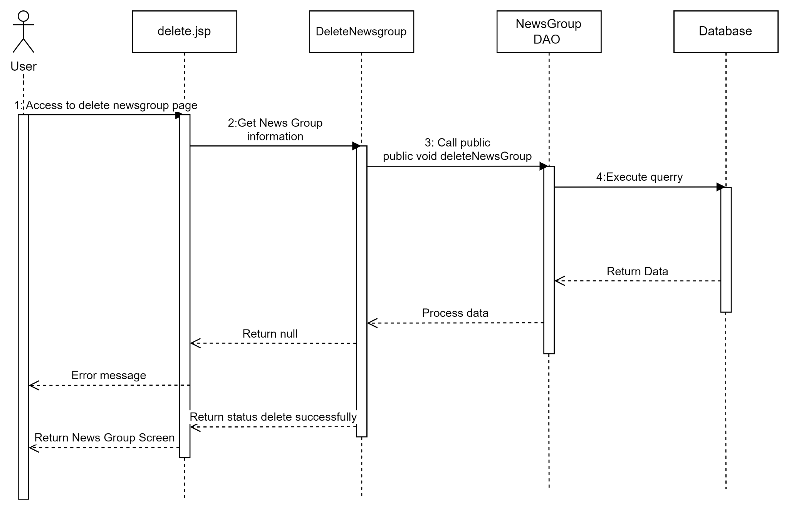

#### **Search news group**

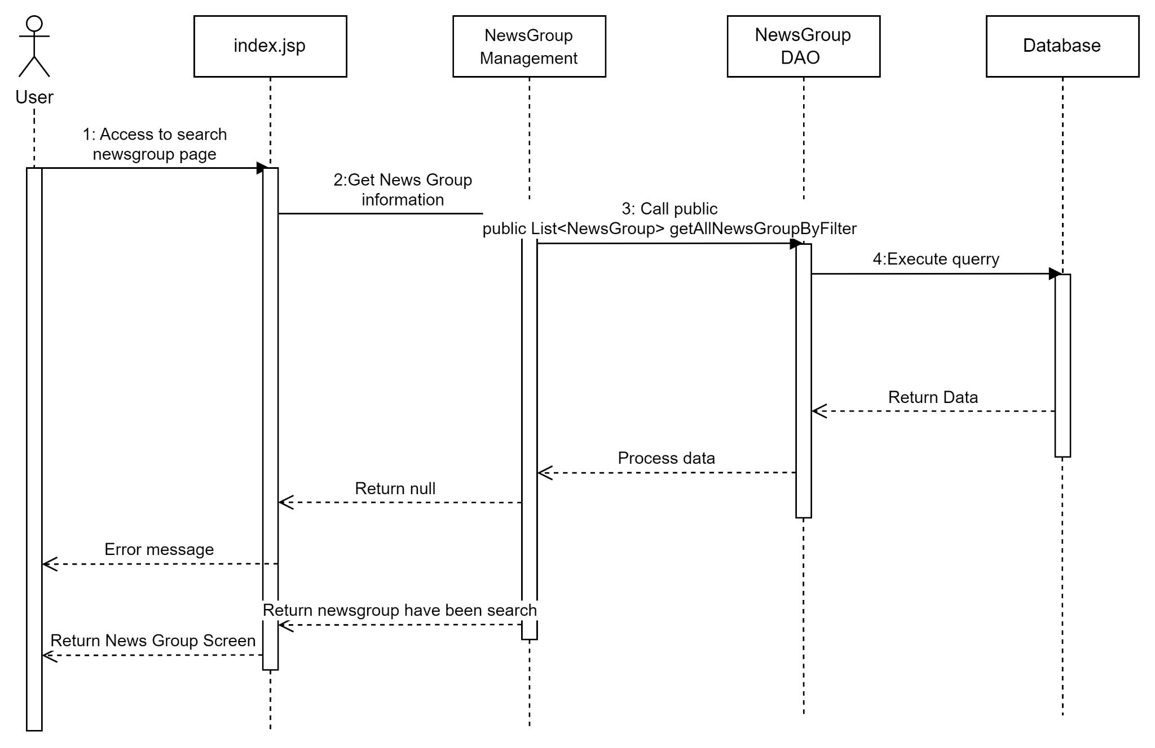

## 10.Public Error

### a.Class Diagram

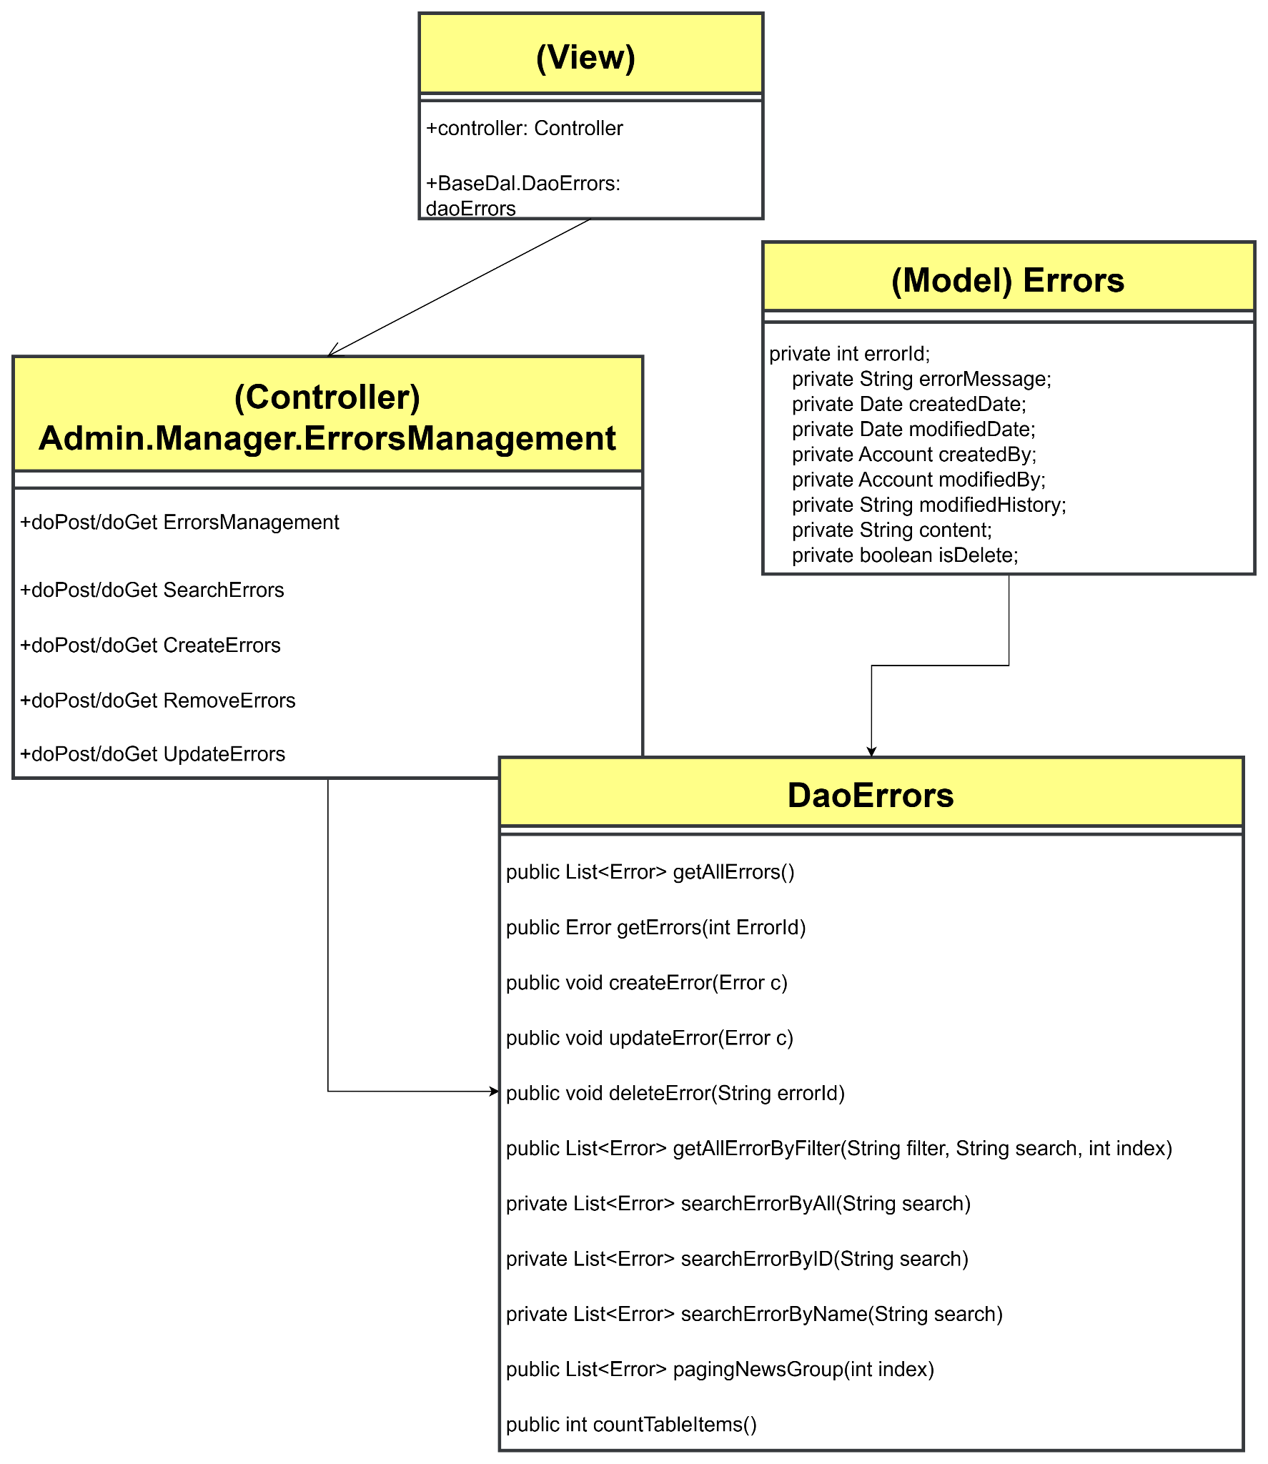

### b. Class Specifications

#### **Error DAO admin**

| **No** | **Method** | **Description** |
| --- | --- | --- |
| 01 | public List<Error> getAllErrors() | Handle request get all Error |
| 02 | public Error getErrors(int ErrorId) | Handle request get Error by id |
| 03 | public void createError(Error c) | Handle request created Error |
| 04 | public void updateError(Error c) | Handle request update Error |
| 05 | public void deleteError(String errorId) | Handle request delete Error by ID |
| 06 | public List<Error> getAllErrorByFilter(String filter, String search, int index) | Handle request search Error by filter |
| 07 | private List<Error> searchErrorByAll(String search) | Handle request search by all |
| 08 | private List<Error> searchErrorByID(String search) | Handle request search by ID |
| 09 | private List<Error> searchErrorByName(String search) | Handle request search by name |
| 09 | public List<Error> pagingNewsGroup(int index) | Handle request paging Error |
| 10 | public int countTableItems() | Handle request paging Error |

### c. Sequence Diagram(s)

#### **View list Error**

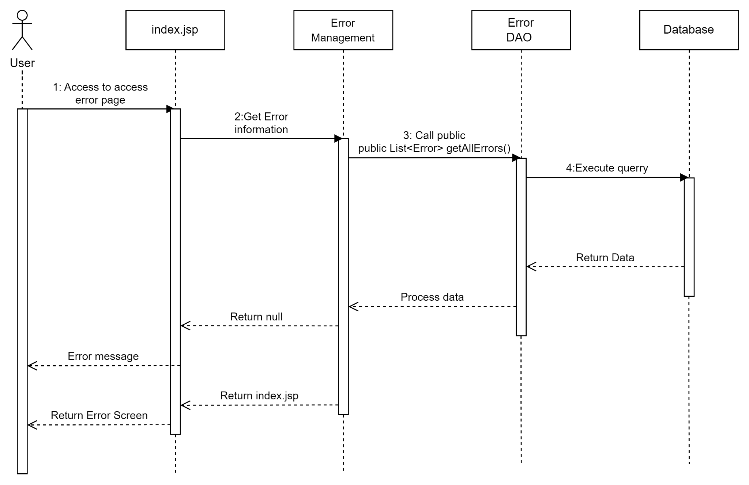

#### 

#### **Add Error**

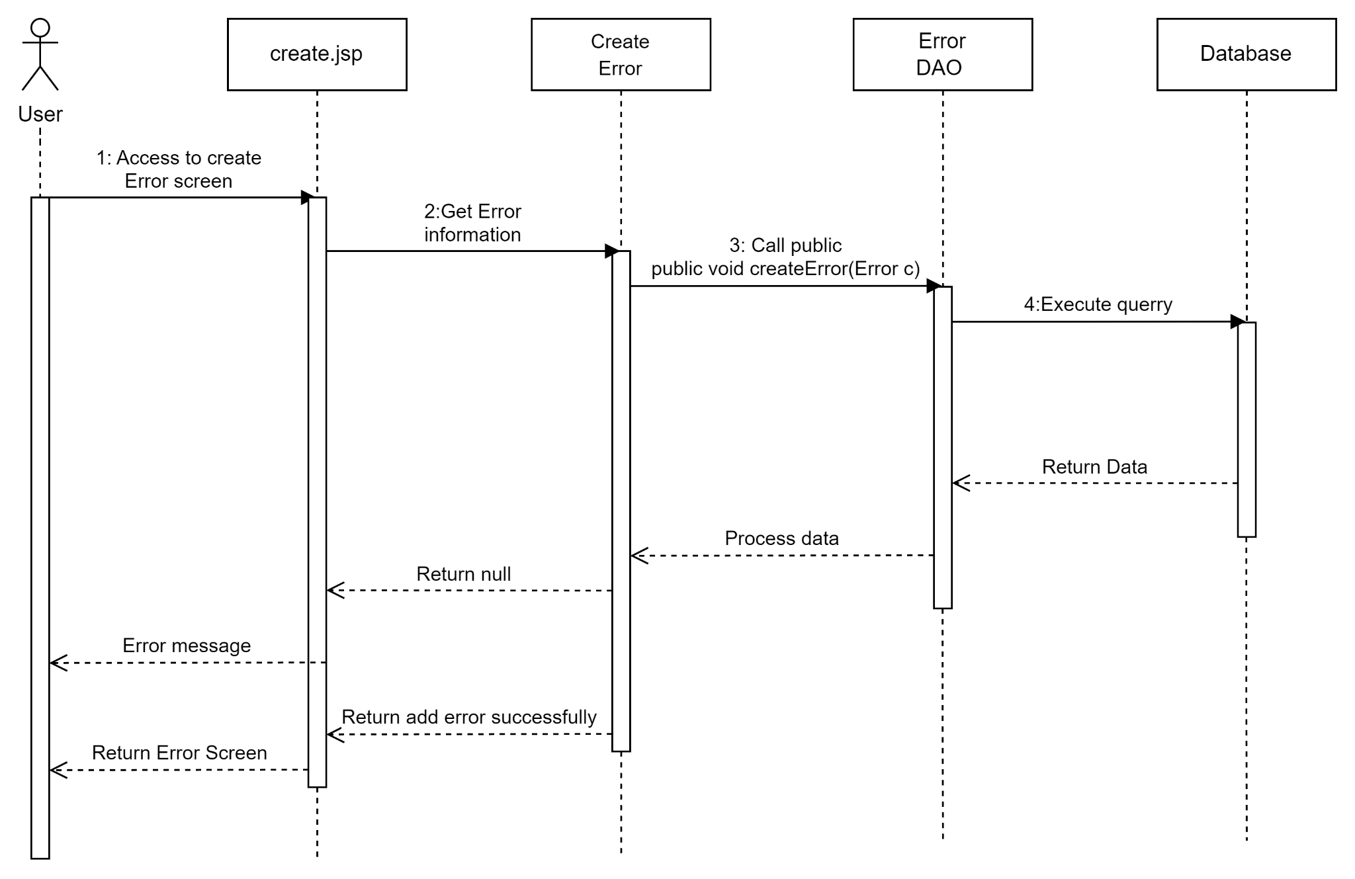

#### **Update Error**

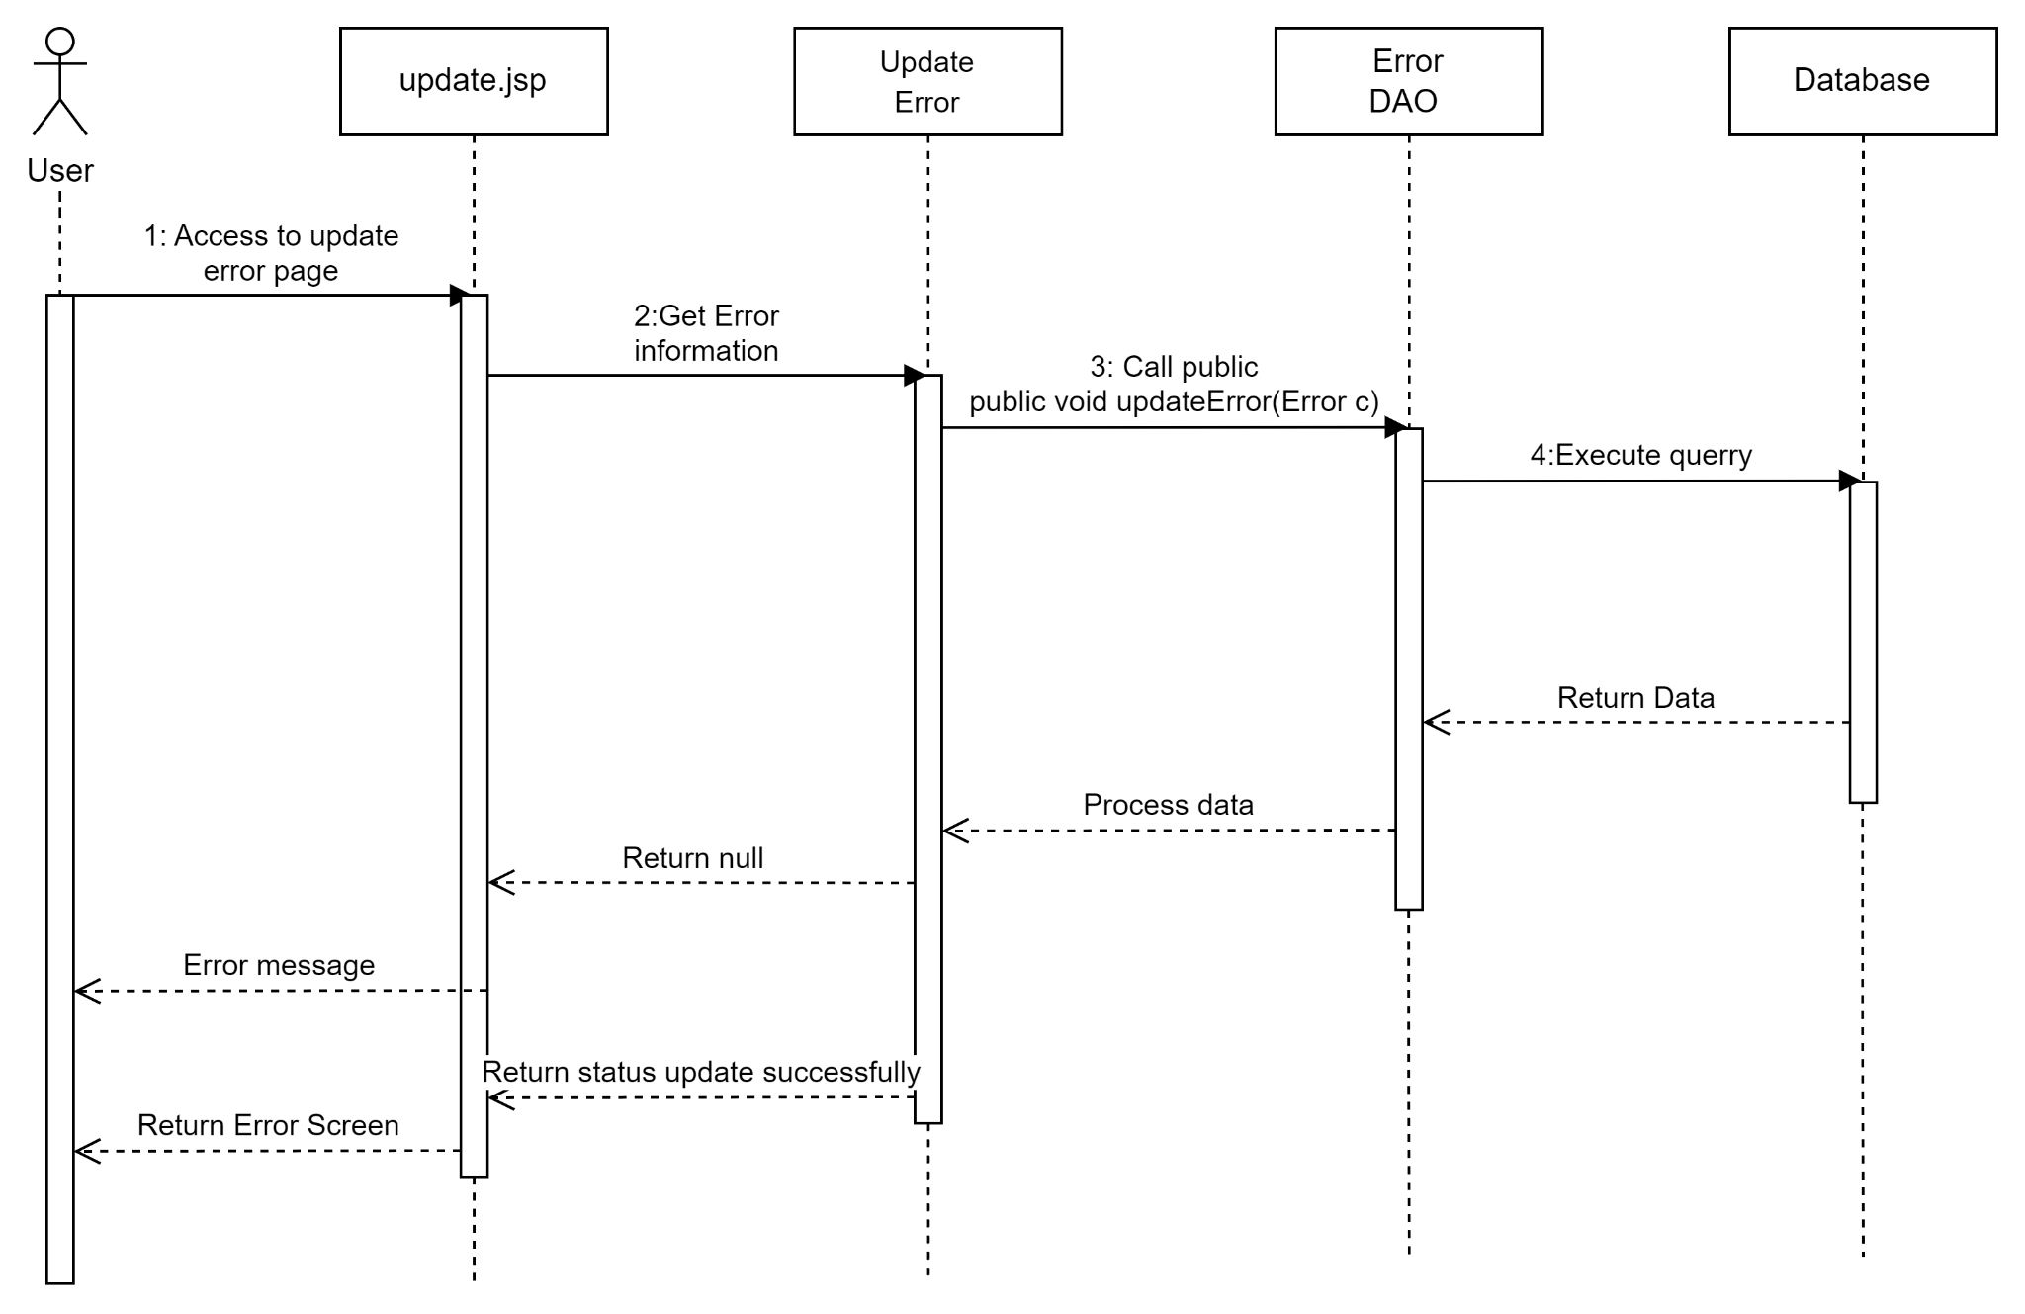

#### **Delete Error**

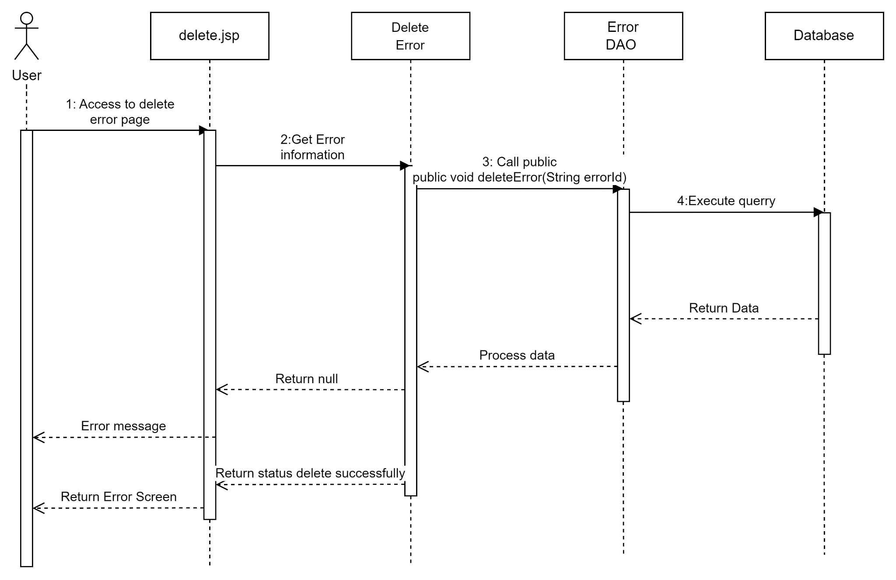

#### **Search Error**

